Guidance for Integrated Resource Plans and 202(f) Determination Requests – Comment Draft
Regulated electric and natural gas utilities in Vermont must complete an Integrated Resource Plan (“IRP”) every three years. This addendum establishes guidelines for the development of IRPs; however, the ultimate content and organization of an electric distribution utility's plan will be unique to each individual utility. The first portion of this guidance document serves to provide a general set of guidelines that should be helpful in development of utility IRPs. The second portion briefly discusses the process the Public Service Department (“Department”) uses under 30 V.S.A. §202(f) in determining whether a proposal is consistent with the Vermont Electric Plan.
The 2022 Comprehensive Energy Plan (“CEP”) incorporates the Electric Plan. Where the Electric Plan is referenced in statute, the relevant document is the 2022 CEP. IRPs and other utility actions that must be consistent with the electric plan should be consistent with the 2022 CEP broadly.
Especially relevant to electric utility integrated resource planning and consistency determinations under 30 V.S.A. §202(f) are Chapters 4 and 7, which directly address electric power. Chapters 5 and 6 are also relevant, as they discuss electrification of transportation and thermal uses. Natural gas utilities should refer to Chapter 6 for information about the Department’s approach to natural gas. All utilities should consider Chapter 3 and its recommendations on achieving CEP goals in a just and equitable manner, and Chapter 2 discussing decision-making frameworks.

Contents

Part A: Integrated Resource Planning Guidelines 4
Introduction 4
Filing and Approval Process 6
Filing Schedule and Review 6
Department Review 6
Public Utility Commission Review and Approval 6
Distribution of the IRP 7
Required Elements 7
1. Forecasts and Scenarios 8
1.1. Existing Resources 8
1.2. Alternative Scenarios 11
1.3. Data, Models, and Information 13
2. Assessment of Resources 14
2.1. Existing Resources 14
2.2. Resource Options Inventory 15
2.3. Assessment of Resources 15
2.4. Load Flexibility & Rates 16
3. Assessment of the Transmission and Distribution System 17
3.1. Overview of Systems 17
3.2. T&D System Evaluation 18
3.3. T&D Equipment Selection and Utilization 19
3.4. Other T&D Improvements 20
3.5. Vegetation Management 21
3.6. Studies and Planning 22
3.7. Emergency Preparedness and Response 22
3.8. Reliability 23
3.9. Resilience 23
3.10. Physical and Cybersecurity 23
3.11. Grid Evolution 23
4. Integrated Analysis and Plan of Action 24
4.1. Risk and Uncertainty Analysis 24
4.2. Assessment of Environmental Impact 25
4.3. Identification of Least-Cost Portfolio 26
4.4. Preferred Plan 26
4.5. Implementation or Action Plan 27
4.6. Technology Deployment Flowcharts 27
4.7. Initiative Descriptions 28
4.8. Ongoing Maintenance and Evaluation 29
5. Financial Assessment 29
5.1. Cost of Service 29
6. Attachment 1: Technology Deployment Flowcharts, Paths, and Steps 31
Part B: Consistency Determination 43
1. Process 43
1.1. Notification 43
1.2. Regulatory Response 43
2. Filing Components 44
2.1. Economic Analysis 44
2.2. Sensitivity Analysis 44
2.3. Diversity Calculations 44

Part A: Integrated Resource Planning Guidelines

Introduction

Pursuant to 30 V.S.A. §218c, each regulated electric or gas company is required to prepare and implement a least-cost integrated plan (“integrated resource plan” or “IRP”) for provision of energy services to its Vermont customers. Language in statute and Public Utility Commission (“PUC” or “Commission”) Orders, beginning with Docket 5270, define requirements that a distribution utility's complete IRP should meet in order to pass the Department's review and comply with the Commission's approval requirements.

The IRP articulates the decision-making framework that utilities undertake to meet the public's need for energy services, after safety concerns are addressed, at the lowest present value life cycle cost, including environmental and economic costs, through a strategy combining investments and expenditures on energy supply, transmission and distribution capacity, transmission and distribution efficiency, and comprehensive energy efficiency programs (30 V.S.A. §218c). The cost and benefit factors to be considered include both direct monetary costs and benefits, and indirect impacts such as environmental and other societal effects. Plans should also consider issues related to environmental justice and energy equity, particularly with regard to the distribution of environmental benefits and burdens and opportunities for meaningful participation as discussed in Act 154 of 2022.

This addendum establishes guidelines for the development of integrated resource plans; however, the ultimate content and organization of an electric distribution utility's plan will be unique to each individual utility. The IRP process is intended, in part, to facilitate information exchange among utilities, regulatory agencies, and the public. To that end, the IRP represents an opportunity for utilities to use the IRP process to address questions that are the most relevant to the utility at the time of the IRP. Where issues or considerations listed in this document are not germane to the utility, the Department and the utility should, in advance of the utility filing, discuss whether those issues should be included.

IRP planning should be conducted with other planning exercises, such as the construction work plan or Rural Utilities Service (“RUS”) requirements, in mind. Where a forecast or analysis would serve the purpose of meeting multiple planning obligations, utilities should not be obligated to perform multiple analyses. Similarly, where a relevant statewide forecast or analysis (e.g., load forecasting for the VELCO Long Range Plan) has been performed, it may make sense for the utility to adapt that forecast for the purposes of their IRP. Where a utility develops its own forecast, it should be consistent with the statewide forecast or provide a rationale for any differences. IRPs will reflect the wide range of planning capacity at Vermont’s utilities.

Utilities should use the IRP process to develop methods they will use to evaluate competing investment and purchase decisions to meet customer demand. The range of options available to utilities to balance supply and demand are expanding as new generation, load control, storage, and other “smart” technologies become available and affordable. The characteristics of supply and demand resources are changing as well. Historically, load was viewed as a fixed obligation which utilities planned to meet with dispatchable supply. Higher penetration of distributed renewable generation, controllable loads, storage, and other distributed energy resources (“DERs”) mean that utilities must begin to plan for a future in which both demand and supply have some controllable and some uncontrollable aspects, some resources can serve as both demand and supply, and the system can be “optimized” at multiple spatial and temporal levels. Grid operators must prepare for more complex grid choreography to maintain system reliability. This must be done mindful of the impacts of policy obligations such as Vermont’s Renewable Energy Standard (“RES”) for electric utilities, or other such obligations that may be placed on utilities. For example, implementation of Tier III of the RES has and will continue to result in electrification of transportation and heating, along with other measures, which will impact both overall demand and the daily load profiles of various customer classes.

In this context, utilities should use the IRP process to demonstrate the underlying methodology and a set of specific tools they will use to evaluate options for balancing supply and demand at the lowest present value life cycle cost as they arise – a utility’s “decision-making framework”. Because the operating environment is rapidly evolving, using the IRP process as an opportunity to develop, test, and demonstrate these methodologies will allow utilities to react with a greater degree of flexibility as economic and technological conditions in the industry change.

The 2022 edition of this document reflects several important changes to the IRP process:

- General reorganization and streamlining of sections, in particular Assessment of the Transmission & Distribution System;
- More fulsome integration of the Renewable Energy Standard and increased emphasis on distributed energy resources in demand forecasts and scenarios;
- Increased emphasis on distribution system planning and technology deployment initiatives (Chs. 3 and 4);
- Increased emphasis on equity considerations;
- Environmental impacts evaluated within the Integrated Analysis and Plan of Action (Ch. 4).

These guidelines are intended to highlight areas of importance to the Department and facilitate further discussion between stakeholders. Where this addendum suggests “consideration” of a topic, the topic may be addressed in the written IRP, discussed with the Department prior to submission of the IRP, or both.

Filing and Approval Process

Filing Schedule and Review

Utilities are required to complete a new IRP at least every 3 years, on a schedule directed by the PUC. The document should reference applicable background reports, analyses, and supporting materials, and the utility should hold these for public and Department review. The utility should file an IRP with the Commission that is complete and in accordance with these guidelines, any MOU conditions from the utility’s prior IRP, Commission Orders, and statute. Utilities should produce IRPs that reflect the complexity and size of their operations.

Department Review

During the year prior to the utility filing its IRP with the Commission, the utility and the Department should meet periodically and work together with the goal of the utility filing an IRP that is supportable by the Department. In addition to reviewing whether the IRP meets requirements described in state statute, Commission Orders, MOUs, the CEP, and this guidance document, the Department will review the methodologies used by the utility in undertaking least-cost integrated planning and make recommendations as to the soundness of those methodologies. The Department’s recommendation of approval or rejection of the IRP is independent of the particular conclusions of the plan, and contingent only on the efficacy of the employed methodology and consistency with statutes, Commission orders, MOUs, the CEP, and this guidance. Open communication and interaction between the Department and the utility early in the IRP process should allow the Department to evaluate and support a range of planning methodologies.

The Department’s review will encompass multiple areas of expertise. The Department’s Planning, Efficiency and Energy Resources, Finance, and Engineering divisions will meet collectively with the utility’s power supply, engineering, innovation, and other teams. This is an intentional shift away from siloed discussions between Department divisions and utility counterparts, due to the increasingly interrelated nature of these subject areas. Load and DER forecasts, for example, impact not only power supply but also distribution system planning, Tier III programs, and cost of service. The Department’s Consumer Affairs and Public Information staff may also join discussion on occasion, especially where planned agenda items intend to focus on customer offerings. Utilities should designate a point person to work with their Planning Division counterpart to schedule and plan pre-filing meetings, including suggesting agendas (usually by IRP chapter or topic), starting approximately one year in advance of the IRP filing date (unless another timeline is required by the prior IRP’s MOU with the Department). Timely review and potential support of the IRP depends on effective and engaged communication from both the utility and the Department during these conversations.

Public Utility Commission Review and Approval

PUC review will include notice and opportunity for hearing, and based on the evidence of record, a determination as to whether a utility's IRP is consistent with 30 V.S.A. §218c, Docket 5270, and other relevant PUC Orders. The Commission may approve the IRP, approve it in part and reject it in part (with or without conditions), or fully reject it. Robust proposals that include engagement with the Department will improve the likelihood of approval.

Distribution of the IRP

Utilities should file copies of the IRP and any revisions or updates with the Commission and the Department; electronically with the Department, and such filing with the Commission as it may require. Electronic copies should be made available to the Department, the PUC, and the public. Hard copies of the IRP should be made available upon request (at a price not to exceed publication and mailing costs) to parties that intervene in the IRP proceeding and interested citizens of Vermont. The most current IRP should be available on the utility’s website.

Required Elements
A robust IRP should contain at least the following elements:

- Executive Summary suitable for distribution to the public, with an overview of the major components of the IRP. It should also include information useful to understand the characteristics of the business and system such as the number of customers, retail sales, peak load, which towns the utility serves, the number of substations and circuit miles, present power supply resources, installed capacity and generation from behind- and front-of-meter resources located within its service territory, capacity and energy of other DERs, etc. Organizational features such as Table of Contents should be provided for accessibility.

- Forecasts and Scenarios which includes load and DER forecasts and alternative scenarios.

- Assessment of Resources which reviews the existing resource mix in the context of statutory requirements, identifies a broad range of supply- and demand-side options to meet those requirements, models the integration of new resources, and leads to the selection of a preferred portfolio.

- Assessment of the Transmission and Distribution System which evaluates options for improving system efficiency and reliability and presents plans for bulk transmission, grid modernization, and vegetation management.

- Integrated Analysis and Plan of Action that looks across demand, supply, finances, environmental impact, equity and environmental justice considerations, transmission and distribution, and technology initiatives, to identify a least-cost portfolio and a preferred plan of action.

- Financial Assessment which presents the utility’s business plan for the future while providing information on changes in its overall cost of service and electric rates.

The entire IRP should reflect an understanding of the distribution of benefits and burdens of actions to different demographic and geographic portions of a utility's customers and identify, where relevant, opportunities for meaningful participation of communities in decisions guided by the IRP.

Forecasts and Scenarios

IRP analysis relies on a basic understanding of the present and future demand, as represented by a load forecast, and how that demand may change depending on key variables through the development of several alternative scenarios. Load forecasting is a long-standing practice of estimating a utility’s load based on a range of economic, technological, and weather data. Scenario planning, on the other hand, considers dynamic or unexpected futures that can result from rapidly changing circumstances such as economic downturns, large-scale deployment of new technologies, or changes in customer behavior. Both forecasting and scenario planning help utilities develop tools to evaluate how they should react to changes in the electric power sector on an ongoing basis in a world where many factors influencing supply and demand are complex and uncertain.
The Department recognizes that utility load forecasts continue to evolve due to many factors including changes in overall economic growth, differential growth across ratepayer groups, distributed generation and other DERs, volatility in power supply fuel costs, and policy actions. Methodologies used to produce forecasts also continue to evolve as more tools are developed and data become available. Given that historical relationships between these assumptions have changed and are likely to keep changing, the following long-term forecasting guidelines are provided.
Economic and load forecasts should be updated on a regular basis and as significant changes in the environment occur (e.g., economic conditions or government policies that may significantly affect future demand, such as standards or taxes). Utilities should also revise forecasting methods that demonstrate poor performance. As penetration of strategic electrification increases, and as the rate of connection of distributed energy resources grows or slows, utilities should review the growth in deployment of specific devices across their service territory and, as possible, on specific feeders, as it relates to past forecasts. Any error detected between past forecasts and past growth should be accounted for in forecasting methodology to improve the prediction of future growth for those technologies.

Existing Resources

A clear and complete description of the forecast methodology and assumptions should be provided, along with a discussion of the methods and sources used to derive assumptions. If separate models are developed and used for short-term and long-term forecasting, the utility is responsible for providing adequate support for both, along with a clear explanation of methods used by the utility in combining the forecasts. The forecast should include, at least, a base case forecast and high/low case alternative scenarios. These forecasts and scenarios should, in turn, provide a basis for the utility’s engineering and operational studies.

Base Case Forecast
The utility is expected to provide long-term forecasts for energy and seasonal (winter and/or summer, as appropriate) peaks, and for the spring daytime minimum load, accounting for extreme weather possibilities, to ensure that adequate resources are available to meet customer needs. This should be informed by:
Economic Assumptions: Most IRPs will use a commercially available macroeconomic forecast to ‘drive’ the utility forecast, or at a minimum provide forecasts of key drivers in the model. In doing so, the utility should:
  - Consider referencing one or more alternative forecasts to solicit a range of future outcomes. Alternative forecasts could be averaged to generate a baseline forecast or the spread between forecasts might form the basis for a range in possible economic outcomes;
  - Consider coordinating long-term forecasts and planning scenarios by using a baseline forecast that references forecasts by ISO-NE, VELCO, the Vermont System Planning Committee (VSPC) and/or uses similar methodology;
  - Consider the relationship between statewide macroeconomic forecasts and economic activity in the utility’s service territory. In other words, consider whether there are significant differences in economic structure and performance in the service territory, such as clear and present seasonal differences from the statewide forecast. If so, the utility should develop proxies for ‘local’ economic conditions prior to estimating the load forecast;
  - Clearly identify key indicators that drive electric load; and
  - Clearly document the vintage of any macroeconomic forecast used.
Weather and Probability: The IRP should include a description for the methodology chosen to incorporate weather into the peak demand forecast. The effects of weather events are a significant factor in developing forecasts of peak demand load. For example, the utility may use historical weather data to create predictions of “average” and “extreme” weather conditions or the utility may develop or use an industry standard 90/10 forecast (a forecast with a 90 percent probability that the actual peak demand will be at or lower than the forecast).
Policy, Codes & Standards: State and federal policy has a significant impact on electric load. State and Federal building codes and appliance standards tend to reduce overall electricity consumption in the state, both annually and during peak demand periods; policies encouraging switching to electricity for transportation and thermal sector needs will have the opposite effect. Where appropriate, forecasts should incorporate the predicted effects of Federal & State policy (and funding), codes, and standards. Assumptions made should be clear and well defined.
Energy Efficiency Forecast: Since 2000, energy efficiency services in Vermont have been delivered for most utilities by Efficiency Vermont (“EVT”), a third-party program administrator. EVT forecasts its “statewide” energy and summer peak demand savings with Public Utility Commission approved planning budgets. Burlington Electric Department continues to offer its own electric efficiency services. In either case, the IRP should discuss and clearly document how it expects forecasted energy efficiency savings to materialize in the utility’s customer territory; and how much efficiency investment is already embedded in the utility’s historical data, affecting its base load forecast.
Utilities may also consider inclusion of alternate scenarios of energy efficiency that depart from the Public Utility Commission approved 20-year planning budgets.
Renewable Energy Standard Compliance for Tiers II and III: The Renewable Energy Standard (“RES”) requires that utilities acquire supply from distributed resources and engage in energy transformation projects to reduce their customers’ use of fossil fuels. Public Utility Commission Rule 4.400 specifies how utilities should implement Tiers II and III of the RES. Many of these resources will be “behind the meter” projects that impact net load on an annual, seasonal, and daily basis. For example, wide-scale deployment of behind the meter solar both reduces net demand and has shifted summer peaks to later in the day.
Under RES Tier III, utilities are obligated to help their customers to reduce their fossil fuel use through a variety of “energy transformation” projects. These projects may include some measures that could affect electricity usage, including measures designed to shift energy use in transportation and heating from fossil fuels to electric-based technology. The addition of these new technologies may drive load upward and shift consumption to different times of day or different seasons.
When forecasting load, utilities should explicitly consider how their plans for Tier II and III compliance may impact sales, the timing and magnitude of monthly and annual peaks, and hourly loads. This should include tracking the deployment of Tier II and III resources in the utility’s service territory. To the extent feasible, these impacts should be analyzed at the distribution level, taking into account a number of factors including but not limited to, historic deployment patterns, physical limits, penetrations, areas of concentration, areas of opportunity and observed spatial patterns.
Additional DERs and Load Management: While projection of the growth of in-state, distributed generation in the utility’s service territory may be accounted for by the requirements of Tier II of RES, the expectation of any additional behind the meter generation should be captured in the load forecast. In this effort, the expected hourly output of the generation should be considered. Identification of the approximate location and temporally- and seasonally dependent output of these units should be included in assessing the impact of distributed generation on the load forecast.
Similarly, DER deployment such as for Electric Vehicles (“EVs”), Cold-Climate Heat Pumps (“CCHPs”), Heat Pump Water Heaters (“HPWH”), energy storage, and other fuel-switching technologies will have drivers beyond Tier III of the RES. The impacts of this additional electrification should also be accounted for in energy and peak demand forecasts. While the magnitude of future deployment and subsequent role of these flexible resources may be uncertain, devices that are connected presently or are expected to be connected within the forecast horizon may be used to reduce electric demand at the time of a local, state, or regional peak load, or to increase load at the time of generation excess in the local area. Utility practices to manage these loads to achieve economic and reliability goals should be accounted for as a part of this load forecast process.
Regional and Municipal Energy Plans: Due consideration should be given to the enhanced energy plans of Regional Planning Commissions and municipalities in the utility’s service territory. If a regional or municipal plan has enumerated specific expectations of load growth or distributed generation deployment, the utility should endeavor to incorporate those data into the load forecast, either in the base case forecast or in a scenario analysis.
Other Variables: These variables may include electricity prices, prices and availability of fuel substitution, measures of ability to pay, demographic changes, economic output, or government policy actions

Alternative Scenarios

Alternative scenarios should explore, at least, high and low cases and the impact of disruptive exogenous forces that fundamentally reshape how electric power is generated, delivered, consumed, and paid for within the 20-year planning horizon of the IRP. Utilities should use the IRP process as an opportunity to consider not only how load will incrementally grow or shrink, but to evaluate whether and how new technologies and socio-economic forces that are uncertain and outside of the utility’s control will impact it and its customers, as well as how new kinds of utility interventions could influence when customers use electricity and how much they use.
Utilities are encouraged to choose a methodology which has sufficient flexibility to evaluate these potentially disruptive and transformative trends for both load forecasting and evaluating supply options. The specific issues the utility considers, and the methodologies it employs to do so, are left up to the utility. However, that methodology must be capable of fully addressing uncertainties in electrification, distributed generation, storage, controllable loads, and other emerging technologies that may radically change load, supply, and financial solvency of the utility.
One potential method utilities could employ is scenario planning. Scenarios are not predictions of what will happen, but plausible futures that may happen. Utilities can use scenario planning to consider how some of these possible futures may play out and develop tools that will help them react to changing circumstances as they evolve, and actively shape the conditions they will face. Each utility faces a different set of concerns, so scenarios developed by that utility should reflect its unique characteristics.
As utilities consider possible alternative futures, the Department is interested in knowing not necessarily how exactly the utility might respond, but what tools and methods it will use to decide how to respond. These tools will likely include modeling as well as decision-making processes, customer/member engagement, and new innovative programs and rates.
Sources of Uncertainty: There are many sources of uncertainty for utilities across the 20-year planning horizon. Some are related to emerging technologies and others are related to exogenous economic forces, weather, demographics, policy measures, etc. Methods developed by utilities should include ways to evaluate sources of uncertainty. Scenario planning is one such method, but not the only one.
Because the Comprehensive Energy Plan and the Climate Action Plan (“CAP”) call for significant electrification in transportation and heating, utilities should use their IRPs to consider how these state-level policies will impact load and supply, as well as the utility’s own role in shaping and managing load. Therefore, methods chosen by the utility to forecast load and compare supply options should be capable of considering the best course of action for the utility under a “high electrification scenario” that meets Climate requirements. The scenario analysis should look to make use of the resources provided in the CEP and the CAP to assess what level of electrification might occur in the utility service territory if the goals of these plans are met, and to assess how the utility would adjust to (or bring about) this outcome.
Methods developed by the utility should also consider areas of particular relevance to that utility. Considerations for scenario development could include (not a comprehensive list):
- The cost of energy, capacity, and Regional Network Service (“RNS”) charges that are either significantly greater or significantly less than current levels.
- Small-scale solar generation continues to rapidly deploy, constituting an accelerating percentage of the utility’s supply (or reduction in load); or changes in various incentives cause a significant slow-down in solar development.
- The value proposition for energy storage, at either the utility scale or for end-users, improves significantly such that it and can be used to more closely coordinate intermittent supply with demand; or electric storage for end-users remains out of reach.
- Customers can significantly reduce their net load to the grid by procuring their own generation and storage and they do so in increasing numbers; or customers continue to purchase the vast majority of their needs from the grid, but play a larger role in supply, load control, and/or storage. Note that this could vary significantly by rate class.
- Electric load grows significantly as transportation and heating are electrified; or penetration of electric cars and heat pumps remains low.
- Socio-economic forces cause a dramatic increase or decrease in load because of either economic boom or bust.
- There is an increase in dramatic weather events which cause many more outages and require greater emergency response from the utility.
Impacts to Utility Operations: After relevant future scenarios are identified, the utility should develop methods to consider how it will balance supply and demand to maintain or enhance power quality and reliability. Unlike incremental changes to load, disruptive circumstances will impact the timing and scale of system peak and total energy usage.
Depending on how these sources of uncertainty play out, the least-cost path to balancing demand and supply while ensuring safety, reliability, and power quality could require the utility to acquire a different portfolio of resources (broadly defined). To balance supply and demand, utilities should consider both traditional centralized supply solutions as well as distributed energy resources. Utilities should take an integrated look, considering not only the cost of the resource, but the impact of that resource on the grid including any necessary or avoided upgrades.
The IRP should present strategies to address the impact of future scenarios on the following aspects of utility operations:
- Seasonal load profiles for different types of rate classes;
- Power supply portfolios on summer and winter peaking days; as well as shoulder-season light load days;
- Timing and magnitude of system peak;
- Transmission and distribution system upgrades;
- Recovery of sunk costs;
- Rates;
- Total load and supply;
- RES compliance.
Ongoing Application: The utility should develop methods to consider the various possible futures they develop which can be deployed between IRP cycles to evaluate demand, supply, business model, and infrastructure options as they are evolving. These tools might include cost of service models, decision trees for selecting least-cost options, methods for considering attributes such as resilience or microgrids, methods and metrics to evaluate geographic and demographic distribution of environmental burdens and benefits of choices, and geo-targeting of efficiency or other DER measures. These methods and tools should be deployed when utilities make major decisions about power supply, load control, and system upgrades.

Data, Models, and Information

- Data and Models: In developing forecasts and scenarios, utility should utilize relevant historical data. To aid in review, numerical data should be made available in electronic formats usable by the Department and Commission. The development of forecasts for the 20-year planning period should include consideration of the following information:
- Customer counts, by class;
- Total sales of electricity by customer class (annual or by season, as appropriate) and coincident peak contribution for each major customer class;
- Peak load (annual or by season, as appropriate); and
- Spring daytime minimum load;
The IRP or its technical appendices should also document:
- Source and vintage of independent economic models employed:
- Description of the forecast model including the relevant variables, coefficients, and the form of the final model;
- All historic values used in estimating model coefficients;
- Summary statistics and diagnostics performed on the final model;
- Characterization of the process used in the development of the final model including variables considered and rejected;
- Description, including sources, for assumptions including end use detail where applicable;
- Reason(s) for including any qualitative (dummy) variables, composite variables, and trend variables used in the model; and
- Historic and forecast values for independent drivers of the forecast, fully documenting the basis for projecting them.

Assessment of Resources

The assessment of resources provides an inventory of existing resources and presents supply options along with relevant information about the characteristics of that supply. It should also describe the utility’s decision-making processes for obtaining supply, including its hedging policy or strategy. Throughout the resources section of the IRP, utilities should plan to meet RES obligations under Tiers I, II, and III. Utilities may also present additional supply option scenarios informed by their assessment of demand and other factors affecting supply options in the future, e.g., regional market dynamics and emerging technologies such as offshore wind.

Existing Resources

A complete assessment of the utility’s existing resources should include an evaluation of the following:
  - Existing and committed base case renewable and non-renewable generating capacity, firm power transactions, and/or RECs currently owned or under contract, including but not limited to power and RECs associated with:
    - Purchases through the Standard Offer program;
    - Purchases to satisfy utility RES obligations;
    - Purchases from independent power producers;
    - Purchases from other utilities;
    - Customer-owned generating capacity;
    - Resources developed through pooling, wheeling, coordination arrangements, or through other mechanisms; and
    - Any other Commission approved bid solicitation programs.
  - Potential changes to existing resource commitments, including, but not limited to, re-powering, fuel switching, and life extension of power plants or power contracts;
  - For resources owned and/or maintained by the utility, describe the plan to maintain and operate the resource and the impacts on efficiency and reliability over time.
  - Loss reduction in transmission and distribution systems, and improvements in generation and/or T&D areas;
  - Utility construction and jointly developed projects;
    - Purchases through the Standard Offer program;
    - Purchases to satisfy utility RES obligations under Tiers I and II;
    - Purchases from independent power producers;
    - Purchases from other utilities;
    - Customer-owned generating capacity;
    - Resources developed through pooling, wheeling, coordination arrangements, or through other mechanisms; and
    - Any other Commission approved bid solicitation programs.

Resource Options Inventory

In describing supply options to consider over the planning period, the utility should identify options in some or all of the following classes:
- Existing utility owned resources that will serve as future resources should be described, including potential costs of maintaining operation.
- New supply resources that a utility has considered should be discussed, including construction cost, construction schedule, and expected in-service date.
- Opportunities to purchase energy and/or capacity from other utilities or entities should be identified, including a description of the resource potential and costs.
- Short-term market purchases or sales that reduce exposure to short-term volatility, including such short-term purchase and sales strategy options.
- Existing non-utility generation in the utility’s service territory, including customers with generation capability for self-generation, peak shaving, or emergency back-up, which may reduce the need for new capacity.
- New non-utility owned generating facilities or technologies available or expected to be available during the planning period.
- Load Control and Management programs (see Section 2.4).
- Off-system sales contracts when the utility has excess capacity. When a utility has excess capacity, analysis should be provided in the IRP concerning how it intends to increase efficiency and pursue least-cost service through management of off-system sales.

Assessment of Resources

For potential resources, including generating facilities, technologies, and load management resources identified as credible options for meeting load during the planning period, the utility should provide the specific information below.
- Description of supply resource: Where available, the name and location of each station, unit number, type of unit, installation year, heat rate, rated capacity and net capability, capacity factors, net summer and winter capability, RES Compliance eligibility, and installed environmental protection measures. Where projected, the energy, capacity potential/availability, and estimated cost for the resource(s) type.
- Availability of resource: Delineate the planned and unplanned outage rates and capacity factors of the units or technologies, i.e., how much can the utility rely on the resource to be available when needed?
- Operating costs: Describe the expected costs to acquire, operate, and maintain the technology (in addition to fuel costs). The utility should identify historic, fixed, and variable costs for producing energy over recent relevant timeframe, and projected fixed and variable costs of producing energy over the planning horizon.
- Maintenance requirements: Identify expected remaining useful life, maintenance requirements and outages for all types of resource, and detail how utility will ensure comprehensive maintenance of the resource.
- Fuel supply: Specify and describe fuel types, fuel procurement policies, and potential for fuel switching/substitution, and a contingency plan regarding potential supply disruptions, and strategy to ensure reliable fuel supply.
- Fuel prices: Describe relevant historical fuel prices and projected fuel prices over the planning horizon (the fuel forecast should be consistent with the range of load forecasts). The price forecast methodology should be clearly stated and defined.
- Environmental Impacts: Identify the environmental impacts of all resources, including where applicable the quantities of air pollutants (including but not limited to greenhouse gases), liquid wastes, and solid wastes. Environmental costs should be assigned a monetary value.
- Equity and environmental justice: Identify what communities may be most impacted by the resource, including how any benefits and/or burdens associated with the resources may be distributed. Note any efforts that could be made to mitigate burdens associated with the resources particularly those on frontline and impacted communities. Describe how the utility has or would engage with impacted communities and any data or metrics they intend to use to evaluate such impacts.

Load Flexibility & Rates

IRPs should explain current rate designs for each major customer class and consider whether and how potential future changes in rate design could impact total demand, peak demand, the relationship between components in a power supply portfolio, and the necessary transmission and distribution infrastructure to deliver the required energy to customers. Changes in rate design could include increased use of time-of-use rates (whole home or end-use specific), critical peak pricing, dynamic peak pricing, peak-time rebates, and real-time pricing. Plans for implementing such rate design changes should be described including description of any needed investment to facilitate rate design, such as installation or upgrade of advanced metering infrastructure. Additionally, IRPs should report on utility progress toward implementing electric vehicle rates (as required by Act 55 of 2021) and any implementation of pilot rates under Act 13 of 2021.
Load control and management programs should be treated as a comparable resource to traditional supply (and similarly assessed consistent with Section 2.3). IRPs should address the degree to which load flexibility measures have been implemented in the utility service territory. For strategic electrification devices, such as heat pumps, water heaters, and particularly electric vehicles, utilities should explain the strategies being pursued to enable the controlled reduction of load or injection to the grid and the percentage of all devices connected within the last year (and overall) in the service territory with such capabilities enabled.

Assessment of the Transmission and Distribution System

30 V.S.A. §218c(a)(1) defines a “least cost integrated plan” (i.e., an “integrated resource plan” or “IRP”) “for a regulated electric or gas utility” as “a plan for meeting the public’s need for energy services, after safety concerns are addressed, at the lowest present value life cycle cost, including environmental and economic costs, through a strategy combining investments and expenditures on energy supply, transmission and distribution capacity, transmission and distribution efficiency, and comprehensive energy efficiency programs.” In addition, 30 V.S.A. §202a(1) provides that the energy policy of the State is “[t]o ensure to the greatest extent practicable that Vermont can meet its energy service needs in a manner that is adequate, reliable, secure, and sustainable; that ensures affordability and encourages the State's economic vitality, the efficient use of energy resources, and cost-effective demand-side management; and that is environmentally sound.” Furthermore, other sections of Title 30 require utilities to furnish “adequate service” (e.g., §§ 219 and 251) and “adequate and efficient service” (e.g., §§ 225, 226, and 248). In summary, for the purposes of this section on transmission and distribution (“T&D”) infrastructure:
Title 30 requires regulated electric and gas utilities to meet the public’s need for energy services by providing transmission and distribution services that are adequate, reliable, safe, secure, efficient, and environmentally sound at the lowest present-value life-cycle cost.
In the T&D section of its IRP, each electric and gas utility should describe its plans, programs, and philosophies for operating and maintaining its transmission and distribution systems consistent with the above requirements. In addition to providing an overview of its system, each utility’s IRP should include, at a minimum, a discussion of the following items and how they are (or will be) implemented at least cost:

Overview of Systems

To the extent not covered in other sections of its IRP, each utility should provide a brief overview of its transmission (if applicable) and distribution systems. This should include the number of miles of transmission (if applicable) and distribution lines, and the number of substations (electric) or gate stations (gas). Electric utilities should provide a description of each substation including transformer capacity, high- and low-side voltage of the transformer(s), number of feeders, and, for each feeder, the length in miles and the number of customers served. Gas utilities should include a description of each gate station including inlet and outlet pressures, number of mains, length in miles of each main, and number of customers on each main. This information can be provided in narrative or tabular form.

T&D System Evaluation

Each electric utility should plan and conduct a comprehensive study evaluating options for improving T&D system efficiency and reliability. Based on the findings of that study, it should then implement a program to bring its T&D system to the level of electrical efficiency that is optimal on a present value of life cycle cost basis within a reasonable period of time. These studies and action plans should be reviewed and updated at reasonable intervals. Finally, each utility should implement a program, as part of its IRP, to maintain T&D efficiency improvements on an ongoing basis.

Each utility should evaluate individual T&D circuits to identify the optimum economic and engineering configuration for each circuit, while meeting appropriate reliability and safety criteria. The IRP should contain a detailed description of how and when the utility will carry out these evaluations. As individual circuit evaluations are completed, utilities should schedule the implementation of all cost-effective measures within a reasonable period of time. A utility's IRP should note any progress to-date in the evaluation of circuits, the development of implementation plans for circuits in which evaluations have been completed, and the completion of efficiency measure installations.

Decisions regarding some facilities may affect more than one utility. In such instances, utilities should work together so that their evaluations reflect not only their individual interests, but also the interests of ratepayers generally.

The standard for establishing optimum T&D system configurations and for selecting transmission and distribution equipment is the net present value of life cycle cost. This life cycle cost should be evaluated on both a societal and utility/ratepayer basis. This standard requires consideration of a project's capital costs and life cycle operating costs, as well as benefits resulting from the construction of enhanced system configurations and the installation of energy efficient T&D components. These benefits may include avoided operation and maintenance costs, avoided energy and capacity costs, and increased reliability.

Avoided energy costs include the direct costs for energy, the costs for energy consumed as line losses, and T&D delivery costs. Avoided capacity costs include fixed costs and capacity charges for power including on peak line losses, fixed costs and capacity charges for T&D, the cost of Capability Responsibility reserve obligations, the deferral of T&D investments. Other benefits of T&D system efficiency include reduced environmental externalities and reduced market prices due to reduced demand for energy and capacity.

Evaluations should identify and compare all technically feasible investments to improve system reliability and efficiency. At a minimum, evaluations should include (and assess the economics and technical feasibility where appropriate) the following:

- Power factor goal(s), the basis for the goal(s), the current power factor of the system, how the utility measures power factor, and any plans for power factor correction;
- Distribution circuit configuration, phase balancing, voltage upgrades where appropriate, and opportunities for feeder back-up;
- Sub-transmission and distribution system protection practices and philosophies;
- Planned or existing “smart grid” initiatives such as advanced metering infrastructure, SCADA, or distribution automation (see Section 3.11);
- Re-conductoring of lines with lower loss conductors;
- Replacement of conventional transformers with higher efficiency transformers;
- Distribution voltage settings (on a 120 V base), and whether the utility employs, or plans to employ, conservation voltage regulation or volt/VAR optimization;
- A list of the locations of all substations that fall within the 100- and 500-year flood plains, and a plan for protection or relocation of these facilities;
- A discussion of whether the utility has an underground Damage Prevention Plan (DPP), or plans to develop and implement a DPP, if none exists;
- The location criteria and extent of the use of animal guards;
- The location criteria and extent of the use of fault indicators, or the plans to install fault indicators, or a discussion as to why fault indicators are not applicable to the specific system;
- A pole inspection program, plans to implement a pole inspection program, or a discussion as to why a pole inspection program is not appropriate;
- The impact of distributed generation on system stability;
- The impact of newly installed electrification measures including but not limited to electric heat pumps, heat pump water heaters, electric vehicle charging infrastructure and electric vehicles (either for personal transportation or commercial fleets).

T&D Equipment Selection and Utilization

Each utility should describe the process(es) used to select all major equipment (not limited to transformers) according to least-cost principles. Utilities should develop and adopt any necessary procedures to meet the following standards:

- All transformer selection and purchase decisions fully reflect the economic and environmental value of projected capacity and energy losses avoided over the equipment lifetime with due regard for expected loadings and duty cycles;

- When equipment is selected for replacement, due consideration is taken of expected, likely, or potential future loading as informed by load forecast scenario analysis, and commensurate oversizing of equipment considered, in a manner consistent with least-cost planning principles, to avoid future construction costs;

- Inventory of transformers in use and on hand is to be managed to match transformer loss characteristics with customer load factors; and

- An ongoing system to monitor and adjust transformer loading for optimal economic benefit is in place.

Other T&D Improvements

In addition to the improvements outlined above, utilities should comply with the following T&D- related improvements, which address several areas important to T&D least cost planning and system reliability:

Bulk Transmission: VELCO, as the responsible planner for Vermont's bulk transmission system on behalf of Vermont ratepayers and utilities, should give special consideration not only to the efficiency of its own facilities but also to the impact its actions may have on the efficiency of sub-transmission and distribution. Where appropriate, VELCO should support and cooperate with others, including the state’s electric distribution utilities, in undertaking regional T&D optimization studies. The societal test coupled with suitable reliability analysis and attention to strategic planning issues should form the basis for planning and technical evaluation, with due consideration provided to equity and environmental justice impacts. Where additional transmission capacity is determined to be required following consideration of all non-transmission alternatives, the preferred method for increasing transmission capacity should be upgrading existing facilities within existing transmission corridors (unless it can be demonstrated that such a measure would have a substantial adverse impact on the electric system or societal costs). Each distribution utility’s IRP should describe the process undertaken to facilitate inter-utility coordination relative to transmission planning. The Vermont System Planning Committee established pursuant to the Public Utility Commission Docket 7081 should provide one (but not the only) venue for utility participation and information sharing.

Sub-Transmission: Sub-transmission planning should take into account broader interests than those of individual utilities. Where appropriate, integrated regional reliability improvements and sub-transmission system optimization should form the basis for the basic planning and technical evaluation criteria. Utilities should cooperate as needed to assure efficient operation and installation of sub-transmission plant while also assuring an acceptable level of reliability, justified by suitable probabilistic analysis. If necessary, joint utility or utility-regulatory processes should be established to coordinate this activity; collaboration under the auspices of the VSPC may facilitate this coordination. Each distribution utility’s IRP should describe the actions taken facilitate inter-utility coordination relative to sub-transmission planning.

Distribution: The Commission is authorized by statute (30 V.S.A. § 249) to designate exclusive service territories for electric utilities to reduce or eliminate the existence of duplicate electric facilities. Where duplicate electric facilities exist, the companies responsible should seek to eliminate the duplication to the extent possible and economic.

In the process of building, rebuilding, or relocating lines to a roadside, electric utilities should coordinate with the appropriate telephone and cable TV companies during the planning and construction phases to ensure that, wherever possible, no permanent duplicate facilities are installed along the same road and that the transfer of existing facilities to new or replaced poles is done in an expeditious manner.

The Department encourages all utilities to use the NJUNS software to track transfer of utilities and dual pole removal. The utility’s IRP should describe the efforts undertaken to ensure coordination with relevant telephone and cable companies relative to transmission and distribution planning.

While there can be significant benefits from roadside relocation of distribution lines, this activity can have a significant adverse impact on Vermont's scenic landscape. Therefore, companies proposing extensive roadside relocation programs should work with all interested stakeholders (including ANR Department of Forests, Parks and Recreation; Public Service Department; Regional Planning Commissions; local governments; and the Agency of Transportation, as appropriate) to address aesthetic concerns, including techniques or approaches that mitigate the impact on aesthetics. Where the relocation would have only a minimal impact on visual resources, little or no mitigation may be required. However, for projects in areas with high-value visual resources more extensive mitigation procedures should be considered including:

- Relocation to the less sensitive side of the road;
- Use of alternative construction techniques such as spacer cable, armless construction, and relocation underground;
- Development of a site specific vegetation management plan; and
- Alternative routing.
These discussions should also consider other important factors such as cost, reliability, and worker and public safety. An IRP should describe efforts taken to ensure coordination with relevant stakeholders regarding roadside relocation of distribution lines.

Vegetation Management

Vegetation Management: Each utility should describe its current vegetation management program (including both cyclic ROW trimming and hazard/danger tree removal) for ensuring that vegetation management in its service territory is undertaken in a least-cost manner.

A utility may find it useful to work with the Department of Forests, Parks and Recreation to improve the utility's line clearing standards, train utility clearing crews, and update its vegetation management program. Public information and education is an area in which materials developed by one utility could be shared by other utilities, thus reducing costs. It is important for utilities to make their customers aware of the dangers of trimming near utility lines and the importance of planting low-growing species beneath power lines.

In describing its current vegetation management program, each utility should provide the information specified in the table below. In addition, the utility should provide a detailed explanation of why its current vegetation management program represents the least cost program, including details on the relative composition of tree species present in its service territory, the annual growth rates of these species, and the vegetation management techniques used (including when, where, and how herbicides are used). Each utility should discuss in its IRP the means used to evaluate the effectiveness of the vegetation management program, including monitoring the number of tree related outages as compared to the total number of outages, and analyzing and comparing the cost of proactive vegetation management versus the cost of responding to storms.

 |  | Total Miles |  |  | Miles Needing Trimming |  | Trimming Cycle (years)
Sub-transmission
Distribution
 | Y-2 |  | Y-1 | Y |  | Y+1 | Y+2 | Y+3
Amount Budgeted
Amount Spent
Miles Trimmed
Note: Y = the last full calendar year.

Studies and Planning

Each utility should include a description of all engineering and operational studies conducted since its last IRP, and all studies planned for the next three years. These descriptions should reference the data sources in the forecast utilized, whether corresponding to the base case or to a forecast scenario. The utility should also include a list of all capital projects completed since its last IRP or in progress. Capital projects planned for at least the next three years should be included in the action plan (see Section 4.5).

Emergency Preparedness and Response

In its IRP, each utility should describe storm/emergency procedures, such as securing contract crews, dispatch center, participating in utility conference calls, and updating vtoutages.org. This should include a discussion regarding how often vtoutages.org is updated, and, if applicable, what could be done to update it more frequently; the utility's operating procedure for internal and external public notifications of planned and unplanned outages; and OP-4 and OP-7 procedures. This discussion should contain consideration of weather or other conditions under which such measures may be necessary, and any corollary preparation the utility may take, as well as the coordinating operation and communication that is planned to take place between other utilities, as appropriate.

Reliability

Each utility should provide in its IRP the data for the last five full calendar years for CAIDI and SAIFI as reported pursuant to PUC Rule 4.900 (i.e., without major storms excluded). These data may be presented in either tabular or graphical format. The utility should discuss the trends of these data, and, if applicable, what additional actions may need to be taken.

Resilience

Each utility should describe any resilience-related efforts it is undertaking, with reference to Chapter 4 of the CEP and the NERC definition of resilience: “The ability to withstand and reduce the magnitude and/or duration of disruptive events, which includes the capability to anticipate, absorb, adapt to, and/or rapidly recover from such an event.” The focus of any resilience initiatives should be low-probability, high-impact events, typically impacting large geographic areas, lasting more than 24 hours, and classified as “Major Events” according to IEEE 1366.

Physical and Cybersecurity

Each utility should describe, at a high level and without divulging any critical or sensitive information, its physical and cybersecurity programs, including any planned improvements to those programs.

Grid Evolution

Grid evolution encompasses terms and concepts including grid modernization, grid optimization, smart grid, and distribution system planning. It describes transformational changes to the way electricity is generated, delivered, and used, and the integral and expanding role of the grid in those activities. It encompasses a wide array of functions and technologies, from real-time visibility through sensors and meters to orchestration of DERs with control platforms and even artificial intelligence.

A primary goal of grid evolution for the purposes of IRPs is to make the grid more resilient, responsive, and interactive. Through strategic distribution planning initiatives, utilities and their customers will be able to – for example – a track and manage the flow of energy more effectively (including the cost of electricity at a given time), curb peak demand, lower energy bills, reduce blackouts, and integrate and utilize high penetrations of renewable energy, storage, and other DERs to the grid (including electric vehicle batteries).

The Grid Evolution chapter (Chapter 4) of the CEP provides additional goals, definitions, technologies, and action steps toward implementation of a secure and affordable grid that can efficiently integrate and optimize high penetrations of distributed energy resources to enhance resilience and reduce greenhouse gas emissions. Utilities should develop and incorporate into their IRPs a strategic distribution system plan for implementation of cost-effective grid modernization technologies and strategies.

Integrated Analysis and Plan of Action

The IRP should integrate its consideration of existing and planned supply resources, T&D improvements, and demand-side resources into a consistent plan that meets the need for safe, reliable, affordable, and environmentally sound service to customers. The plan should minimize total costs relative to benefits, showing all financial, regulatory, and other significant assumptions including those related to how environmental externalities and equity-related issues were considered. Utilities should, to the extent feasible, report the results of their IRPs in at least the following areas:
    - Expected capital and operating costs of the resource plan and its effect on utility revenue requirements;
    - Impact on costs passed to customers;
    - Impact on the environment, including greenhouse gas emissions and other pollutants;
    - Effects on fuel and technology diversity;
    - Coordination between T&D planning and power portfolio planning;
    - Impact on reliability of the system;
    - Impact on the utility's financial condition, and on state and local economies, to the extent feasible; and
    - Use of renewable resources and trajectory for achieving statutory and other requirements or goals.

Risk and Uncertainty Analysis

IRP analysis should characterize the principal sources of uncertainty and the associated risks to utilities and their customers. Where analysis reveals unacceptable levels of risk to the utility and its customers with its present portfolio, the utility should characterize avenues for addressing such concerns.

The IRP should discuss such analyses which are particularly informative to the development of the action plan. Discussion with the Department during the preparation of the IRP may include discussion of risks not included in the final IRP document. Risks and uncertainties to be considered include, but are not limited to:

- Demand fluctuations – large increases or decreases (see also Section 1 discussing load forecasting);
- Fuel prices for electricity production and for customer end-uses;
- Assessment of current economic conditions and a range of economic futures;
- In service dates of large supply and demand resources;
- Supply availability, from single generating units to regional fuel supply availability;
- Demand-side management program innovation, availability, and technological penetration;
- Inflation in plant construction costs and the cost of capital;
- Weather related events or other major events that impact infrastructure;
- Value of Carbon or carbon equivalent emissions;
- Possible federal or state legislation or regulation;
- New technological developments; and
- Unit decommissioning or dismantlement costs.

Assessment of Environmental Impact

The IRP should demonstrate an understanding and due consideration of any significant environmental attributes and/or impacts of the resource portfolio, current or planned. These impacts should be quantified where possible, recognizing environmental costs that are embedded in the price of energy (such as may result from the RES, to some extent) and those that are externalized from that price. This should include consideration of greenhouse gas emissions, NOx, and SOx, along with any other environmental impact such as waste disposal that are material to the disposition of the IRP and its Action Plan. 30 V.S.A. §218c requires due regard of the financial risks associated with greenhouse gas emissions; the valuing of environmental impact risks should be incorporated into least cost planning and the IRP.
In doing so, the utility should clearly demonstrate the derivation of the values used to estimate environmental impacts, including emissions rates, lifetime emissions, and the dollar value of emissions or other environmental costs.
One such derivation for greenhouse gas emissions is a stream of values that estimates avoided damages of emissions associated with greenhouse gas mitigation measures – the “Social Cost of Carbon”, which has been used by the Public Service Department and the Vermont Climate Council to value greenhouse gas emissions impacts. Other approaches may be reasonable, but if used in the IRP the utility should explain their choices.

Identification of Least-Cost Portfolio

Utilities should evaluate a variety of portfolio strategies, noting the uncertainty and sensitivity of each. Strategies that deliver the lowest cost under optimal conditions, but are highly sensitive to the operating environment, may not be the most appropriate choice. Strategies that achieve a relatively low cost under a variety of contingencies may be preferable. Utilities should explicitly account for the critical interactions among potential supply options.

The critical requirement in developing a least cost portfolio of resources is to maintain an unbiased evaluation of options to increase supply and modify demand and to fairly balance estimated ratepayer and societal costs and risks. Given the uncertainties inherent in this process, there may be a variety of projects available with identifiable costs and benefits that do not differ widely. Benefits and costs should be evaluated using both a societal test and a utility or ratepayer test; other tests or metrics (such as rate impacts or robustness to uncertainty) may also be appropriate to include and should be clearly identified.

The integration section of a complete and robust IRP includes a thorough discussion of:

- The optimal portfolio of supply and DERs, bulk transmission, T&D (including technology deployment and other initiatives), and load management projects (including rate design), with a summary of the expected annual energy, capacity, and environmental costs or savings contribution of each selected option over the planning horizon. Significant concerns of managing the optimal portfolio that relate to financing, project timing, line loss and reserve requirements, and organizational factors should be identified along with any critical externalities that influenced inclusion of the option.

- The methodology and assumptions used to derive the optimum portfolio, with discussion of the sensitivity of results to important assumptions and key variables.

- Reasonably competitive projects not included in the optimum portfolio, including reasons for exclusion, and whether or not projects will be available for consideration if the strategic environment changes.

- Contingency plans associated with the higher risk components of the selected portfolio, including events that would alter the portfolio and trigger a utility's decision to either adopt or terminate a measure.

Preferred Plan

A complete IRP develops a preferred least-cost plan that fully explains, justifies, and documents the way it was developed, including an explanation of how it ensured internal consistency in avoided costs and retail electricity prices. Where the utility's preferred plan does not minimize net societal costs, the IRP should discuss the utility’s reasoning for pursuing the plan selected.

Implementation or Action Plan

A complete IRP includes effective strategies for implementing the least-cost integrated portfolio identified in the preferred plan. Provisions for research and data collection necessary to improve planning performance (e.g. saturation surveys, supply and demand marketing studies, distribution system mapping) can also be included as action items.
A sound and complete implementation plan should include the following:
- An overview of the preferred least cost portfolio, briefly discussing how it will be administered and updated.
- For each near-term program, project, or initiative identified in the preferred plan and scheduled for implementation within three years, provide the following:
- General procedures for implementing, monitoring, and evaluating the program, project, or initiative;
- General work plan for the program, project, or initiative; and
- Identification of important contingencies that may arise programs, projects, and initiatives evolve, including adjustment to plans that should be made to minimize adverse impacts.
- For any program, project, or initiative identified in the preferred plan and scheduled for implementation after three years, provide a list of expected decision points.

Technology Deployment Flowcharts

As demands on the electric system change and expand over the coming years, utilities will need new capabilities to reliably serve customers at lowest cost while simultaneously meeting new performance criteria. These capabilities range from analysis tools to utility policy, and will require long-term planning to ensure adequate implantation. To best document the progress that has been made in a variety of categories of software and technology to implement a utility’s distribution system plans, the flowcharts in Attachment 1 (with steps and progress arrows filled in as an example) should be incorporated in each utility’s IRP and populated to correspond to the utility’s current situation. Description of the steps associated with each chart’s paths are also provided in Attachment 1. Arrows between steps and software dependencies indicate pre-requisites for any given step to completed.
Utilities should reference and populate their own versions of the Technology Deployment Flowcharts templates found in Attachment 1 and include them as attachments to – or integrated within – their IRPs. They should be accompanied by initiative descriptions per the instructions below.

Initiative Descriptions

For any effort that aligns with one or more of the steps found in the Technology Deployment Flowcharts, or for other efforts undertaken that may lead to cost savings or increases, greenhouse gas reductions, or that have Tier III eligibility, the categories of information listed below should be documented. If this information would be duplicative of other information as found in the rest of the IRP, that information can be listed, with reference to this documentation in the body of the Plan.

- General information
  - Title: A step from provided paths, or any other effort that merits documentation
  - Timelines: Respective periods of time over which the initiative is expected to be implemented and to be in effect
  - Barriers: Any definite technological or procedural obstacles that must first be addressed, as shown in the corresponding topic flowchart or as otherwise constructive
  - Enablers: Any steps or other initiatives for which the initiative in question is a barrier, and for which the completion of the initiative would enable engagement of that effort
  - Related initiatives: Any initiatives that are to be undertaken either simultaneously or sequentially to enable this initiative, or that this initiative would enable
- Description of work
  - Preceding steps: Brief summary of work already completed in the same path or as otherwise relevant to have enabled the initiative
  - Description: Narrative on the expected benefits of and difficulties in implementation and upkeep of the initiative
  - Future steps: Brief summary of planned work and philosophy for next steps
- Cost information
  - Implementation cost: Net cost to execute the initiative in nominal dollars
  - Average annual upkeep cost: Net cost to maintain the initiative in nominal dollars
  - Payback period: Year in which the initiative is expected to have first produced a net profit
  - Rate impact: Expected one-year average, five-year average, and ten-year average impacts on rates relative to today expressed as a percentage
- RES/GHG (if applicable)
  - Tier I eligibility: Whether or not initiative qualifies for Tier I compliance
  - Tier II eligibility: Whether or not initiative qualifies for Tier II compliance
  - Tier III eligibility: Whether or not initiative qualifies for Tier III compliance
  - Tier III requirement/ACP equivalent: If initiative has a net cost higher than current Tier III measures, the Tier III requirement or ACP at which the initiative would be pursued
  - Greenhouse gas emission reductions: Expected lifetime net reduction in greenhouse gas emissions expressed in metric tons of CO₂e
  - Cost rate of greenhouse gas emission reductions: Cost in nominal dollars of expected lifetime net reduction in greenhouse gas emissions (as determined by the sum of the implementation cost and average annual upkeep cost) per metric ton of CO₂e
  - Social cost of carbon emissions avoided: Expected cost in nominal dollars of avoided greenhouse gas emissions based on social cost of carbon as designated by the Vermont Climate Council
  - Net cost of greenhouse gas emission reductions: Net cost in nominal dollars of expected lifetime net reduction in greenhouse gas emissions (as determined by the social cost of carbon emissions avoided subtracted from the sum of the implementation cost and average annual upkeep cost)
  - PUC Rule 4.410(3) requires each Tier III energy transformation project to “meet the need for its goods or services at the lowest present-value life-cycle cost, including environmental and economic costs.” The analysis of Tier III projects must also include an analysis of alternatives that do not increase electric consumption. In addition to the Utility Cost Test normally used by the DUs, the Societal Cost Test should also be factored into the analysis for Tier III Programs. The Department’s preference is that this analysis be included in the utility’s IRP and referenced in each Tier III annual plan. Otherwise the analysis will need to be included in each Tier III annual plan.

Utilities should provide Initiative Descriptions that correspond to the Technology Deployment Flowcharts based on templates in Attachment 1.

Ongoing Maintenance and Evaluation

After its IRP is approved, a utility is responsible for administering approved programs, projects, and initiatives, evaluating and reporting on progress, and effectively maintaining its IRP.

Financial Assessment

The financial assessment remains optional for IRPs completed under this guidance document, although utilities are strongly encouraged to submit a financial assessment as part of their IRPs. Should utilities choose to complete a financial assessment, it should present a strategic direction for business. It should consider the impact of the utility’s preferred action plan (see Section 4) on revenue, expenses, income, and financing. The financial assessment should describe the utility’s expected cash flow and describe its financing plan for any capital expenditures. It should also present the expected financial results of the utility’s business plan while providing information on changes in its overall cost of service and electricity pricing.
Relatively simple 5-year financial projections can be made by applying an inflation rate to known, current business expenses and adding in the cost of any known new capital expansions.

Cost of Service

A utility has an obligation to its ratepayers to manage risk and minimize its system cost. Utilities should evaluate and balance the expected costs, business risks, and long‐run public policy goals in developing and selecting a business model portfolio.
A utility’s cost of service model should recognize a utility’s financial objectives while meeting energy resource needs through a balanced, lowest cost portfolio, with supply, demand, energy transformation (Tier III) and energy efficiency options.
The Financial Assessment within a utility’s IRP filing should articulate its expected revenue requirement and cost of service for the next 5 years. Relatively simple 5-year financial projections can be made by applying an inflation rate to known, current business expenses and adding in the cost of any known new capital expansions. The revenue requirement and cost of service could include (but not be limited to) reporting on:
- Power Supply, including purchase power, operational & maintenance costs for owned facilities, RES compliance costs, including incentive and program costs for Tier III, transmission, and distribution;
- Customer accounts and total sales (including lost sales associated with efficiency or other behind the meter generation);
- Administration & general;
- Depreciation;
- Taxes, including income taxes and Taxes other than income taxes;
- Other interest expense;
- Cost to finance rate base;
- Total cost of service;
- Expected rate revenues;
- Rate base;
- Financing plans including cash flows and planned capital expenditures.

Information on the utility’s financial metrics and ratios over the IRP planning horizon should also be provided. The financial ratios could include but would not be limited to:
- Interest coverage ratio (operating income plus depreciation, divided by interest expense);
- Debt service ratio (operating income plus depreciation, divided by interest expense plus principal payments);
- Equity to debt ratio (total equity divided by the total debt outstanding);
- Return on equity and weighted average cost of capital;
- Credit rating; and
- Each of its outstanding debt instruments.

Attachment 1: Technology Deployment Flowcharts, Paths, and Steps

Provided below are descriptions of the steps included on each flowchart to serve as guidance for utilities in completing the flowcharts. In determining the status of the utility for each path (labeled a.-e.), the descriptions for each step (labeled i.-iv.) should serve as milestones. If the utility is engaged in an initiative to progress to the next step on a path, a rough estimate of the percentage progress should be included on the corresponding arrow and filled accordingly. It should be noted that the thin arrows connecting steps or software are likely prerequisites to the indicated step, and so it is expected that a utility would first complete that prerequisite. The flowcharts in question (with example progress included) are found below these descriptions and attached as a separate file for editing as well.
- Load and Generation Distribution Hosting Capacity Analysis (DHCA)
  - Spatial Resolution
    - Substation: Hosting capacity for all locations served by one or more substations is based on the capacity of equipment at the substation(s)
    - Circuit: Hosting capacity for all locations served by one or more circuits is based on the capacity of the circuit(s) or the equipment at the originating substation(s)
    - Town: In addition to circuit-based capacity, hosting capacity for a town determined based on the aggregate of circuits that feed that town
    - Customer: Hosting capacity determined as limited by substation, circuit, pole top service transformer, or other equipment
  - Temporal Resolution
    - Snapshot: Analysis is conducted using single hour peak and light loads
    - Load curves: Analysis is conducted using 24-hour load curves of annual peak and light load days
    - Seasonal: Analysis is conducted using 24-hour load curves of seasonal peak and light load days
    - Hourly: Analysis is conducted using an 8760-hour time series
  - Update Frequency
    - Annual: Analysis is conducted annually
    - Semiannual: Analysis is conducted semiannually
    - As needed: Analysis is conducted as determined to be prudent or as requested
    - Real-time: Analysis is conducted with interconnection of each distributed energy resource
  - Map Data Access
    - Request: Map data is publicly accessible upon request
    - Public: Map data is posted on the utility’s website
    - Overlay: Map data is overlaid with map data of other utilities
    - GIS layer: Map data is publicly available as a GIS layer
  - Headroom Precision
    - Phase count: Capacity information consists of phase count
    - Binary: Capacity information consists of whether DER interconnection is permitted
    - Proportional: Capacity information consists of remaining available percentage of system equipment rating
    - MW value: Capacity information consists of MW value of remaining headroom
- System Visibility and Data Availability (SVDA)
  - Operational Capability
    - Status: System operator can see whether system is online or offline
    - Topology: System operator can see which circuits and substations are in or out of service
    - Quantities: System operator can see MW, MVAr, voltage, and current values as measured by system equipment
    - Control: System operator can remotely operate system equipment
  - Fiber Rollout
    - Pilot: Utility has engaged in a pilot of fiber deployment
    - Substations: Utility has fiber connection to all substations
    - Circuits: Utility has fiber connection on all circuits
    - Last mile: Utility has fiber connection (or equivalent communication capabilities) to all customers
  - AMI Deployment
    - Pilot: Utility has engaged in a pilot of AMI deployment
    - Rollout: AMI is made available to all customers
    - DG/BTM: AMI is deployed at all DER installations
    - AMI 2.0+: Next generation metering capability is available at all points of connection
  - Historical Timescale
    - Hourly: Data stored and archived is on an hourly basis
    - 15 minutes: Data stored and archived is on a 15-minute basis
    - 60 seconds: Data stored and archived is on an hourly basis
    - 1 second: Data stored and archived is on a 1-second basis
- Behind the Meter Device Deployment and Management (BTMM)
  - Distributed Generation
    - Net-metering: Net-metering of distributed generation is permitted
    - IEEE 1547: Distributed generation connected must comply with IEEE 1547 and UL 1741 supplement B
    - Off-grid: Customer separation from the grid is permitted
    - Curtailment: Means exist to curtail distributed generation
  - Flexible Load Management
    - Pilot: Utility has engaged in a pilot of flexible load management
    - New devices: All new suitable devices have flexible load management schemes implemented
    - Markets: Flexible load management resources may participate in market structures
    - Reliability: Flexible load management resources are utilized for transmission or distribution equipment deferral or maintaining reliability
  - Customer-sited Batteries
    - Pilot: Utility has engaged in a pilot of customer-sited battery storage
    - BYOD: Connection of customer-owned battery storage is permitted
    - Utility-sold: Customers are able to purchase or lease batteries from utility
    - Payback: Purchase or lease of battery storage is cost-effective for customer and utility
  - Aggregation Participation
    - Pilot: Utility has engaged in a pilot of aggregation of distributed energy resources
    - Markets: Aggregations are able to participate in markets
    - Data sharing: Data of aggregations relevant to system operation is transmitted to utility
    - Dispatch: Utility possesses direct or indirect dispatch control of aggregations
- System Planning, Engineering, and Interconnection (SPEI)
  - System Parameters
    - Transformers: Ratings for all substation and pole top transformers are documented
    - Substations: Ratings for all substation equipment is documented
    - Conductors: Ratings for all conductors are documented
    - Impedances: Impedances for all equipment is documented
  - Distribution Right-sizing
    - Limitations: Low-cost equipment is upgraded if it would limit the capacity of the path when a relevant project is already planned to be underway
    - Queue project: Low- to medium-cost equipment is upgraded if it would limit the capacity of the path when a queued project would interconnect
    - Modification: Low- to medium-cost equipment is upgraded if it would limit the capacity of the path as part of a program of equipment replacement and need has been demonstrated
    - Upgrade: Medium- to high-cost equipment is upgraded if it would limit the capacity of the path as part of a program of equipment replacement and need has been demonstrated
  - Generation Constraints
    - Identification: Study is undertaken to identify constraints, and definition of constraint is made public
    - Fixed fee: Generation resources connecting within a constrained area are made subject to a fee based on size
    - Fixed tariff: Generation resources connecting within a constrained area are made subject to a fee based on stipulations of a tariff, including but not limited to such aspects as size, duration, rate impacts, and subsequent upgrades
    - HCA tariff: Generation resources connecting within a constrained are made subject to a fee based on stipulations of a tariff informed by results of the latest hosting capacity analysis, including but not limited to such aspects as size, duration, rate impacts, and subsequent upgrades
  - Electrification Planning
    - Forecast: Long-term electrification is included in forecasts
    - Scenarios: Long-term electrification scenarios accounting for varying rates of electrification growth by technology type are included in forecasts
    - Prescription: Long-term electrification growth is included in forecast scenarios as calculated based on state goals
    - Alignment: Long-term electrification growth is included in forecast scenarios as aligns with Vermont Climate Council and VELCO Long-Range Transmission Plan modeling
- Right-of-way and Vegetation Management (ROWVM)
  - Pole Location Tracking
    - Institutional: Pole and equipment location is known to utility staff
    - Spreadsheet: Pole and equipment location is documented in utility files
    - Map: Pole and equipment location is documented in utility maps
    - GIS: Pole and equipment location is documented in utility GIS tools
  - Line Relocation
    - Legacy: Line locations exist as originally constructed
    - Tree wire: Lines are upgraded to tree wire as risks or savings make prudent
    - Roadside: Lines are relocated to roadsides as risks or savings make prudent
    - Underground: Lines are undergrounded as risks or savings make prudent
  - Danger Tree Assessment
    - Ground visual: Danger trees are identified visually on ride of right-of-way
    - Flyover: Danger trees are identified visually by drone or helicopter flyover
    - Lidar: Danger trees are identified by Lidar scan
    - 3D model: Rights-of-way and danger trees are modeled in 3D tracking tool
  - Pole Treatment
    - Penta: Wood poles are treated with pentachlorophenol
    - CCA: Wood poles are treated with chromated copper arsenate
    - Other: Wood poles are treated with other non-toxic, environmentally sustainable chemicals
    - Steel/other: Wood poles are replaced with poles constructed from steel or other materials
- Power Supply and Electrification (PSPE)
  - Power Supply Renewability
    - System mix: Power supply portfolio after environmental attribute accounting consists largely of ISO-NE system mix
    - Clean: Power supply portfolio after environmental attribute accounting consists of both ISO-NE system mix and clean resources
    - Carbon-free: Power supply portfolio after environmental attribute accounting consists of 100% carbon-free resources
    - Renewable: Power supply portfolio after environmental attribute accounting consists of 100% renewable resources
  - Attribute Accounting
    - Annual: Environmental attributes are accounted on an annual basis
    - Seasonal: Environmental attributes are accounted on a seasonal basis
    - Monthly: Environmental attributes are accounted on a monthly basis
    - Hourly: Environmental attributes are accounted on an hourly basis
  - Rate Design
    - EVs: Rates for EV loads are offered that incentive charging in off peak periods
    - Whole home: Rates are offered for whole home load control of multiple flexible resources
    - Opt-out: Load control rate programs are offered to customers by default
    - Import limit: Customers may enter an operational agreement to meet a demand limit during critical peaks
  - Electrification Incentives
    - EEJ: (Equity and Environmental Justice) Additional customer incentives are offered to support equitable distribution of benefits associated with electrification, including but not limited to customer incentives for low-income or other segments of the population for the purchase of new technologies, as well as for mitigation of rate increases.
    - EVs: Customer incentives are offered for purchase or lease of new or used AEVs and PHEVs and for home EV charging equipment
    - Heat pumps: Customer incentives are offered for purchase and installation of home heating and cooling heat pumps of varying technology and hot water heat pumps
    - Storage: Customer incentives are offered for purchase or lease of home energy storage
  - Electrification Penetration
    - Early adopters: 16% of heating and transportation energy consumption is supplied by electricity
    - Early majority: 50% of heating and transportation energy consumption is supplied by electricity
    - Late majority: 84% of heating and transportation energy consumption is supplied by electricity
    - Late adopters: 95% of heating and transportation energy consumption is supplied by electricity

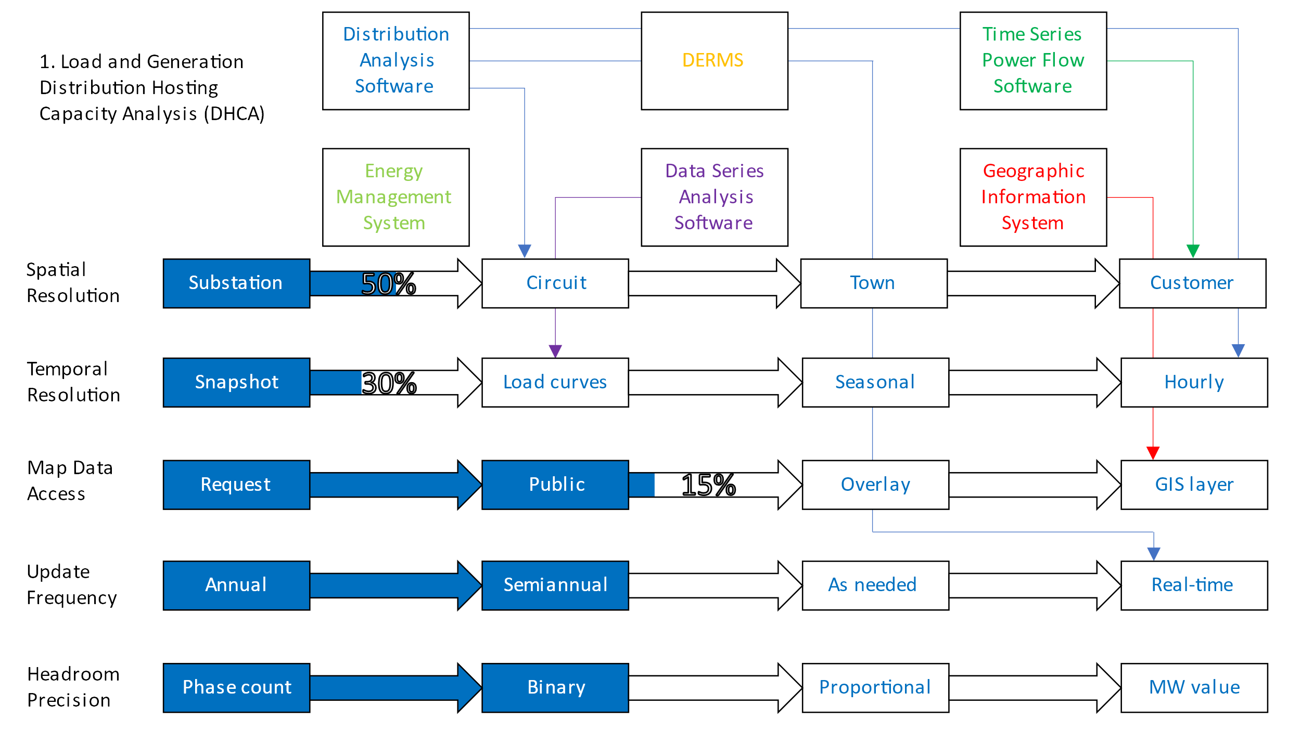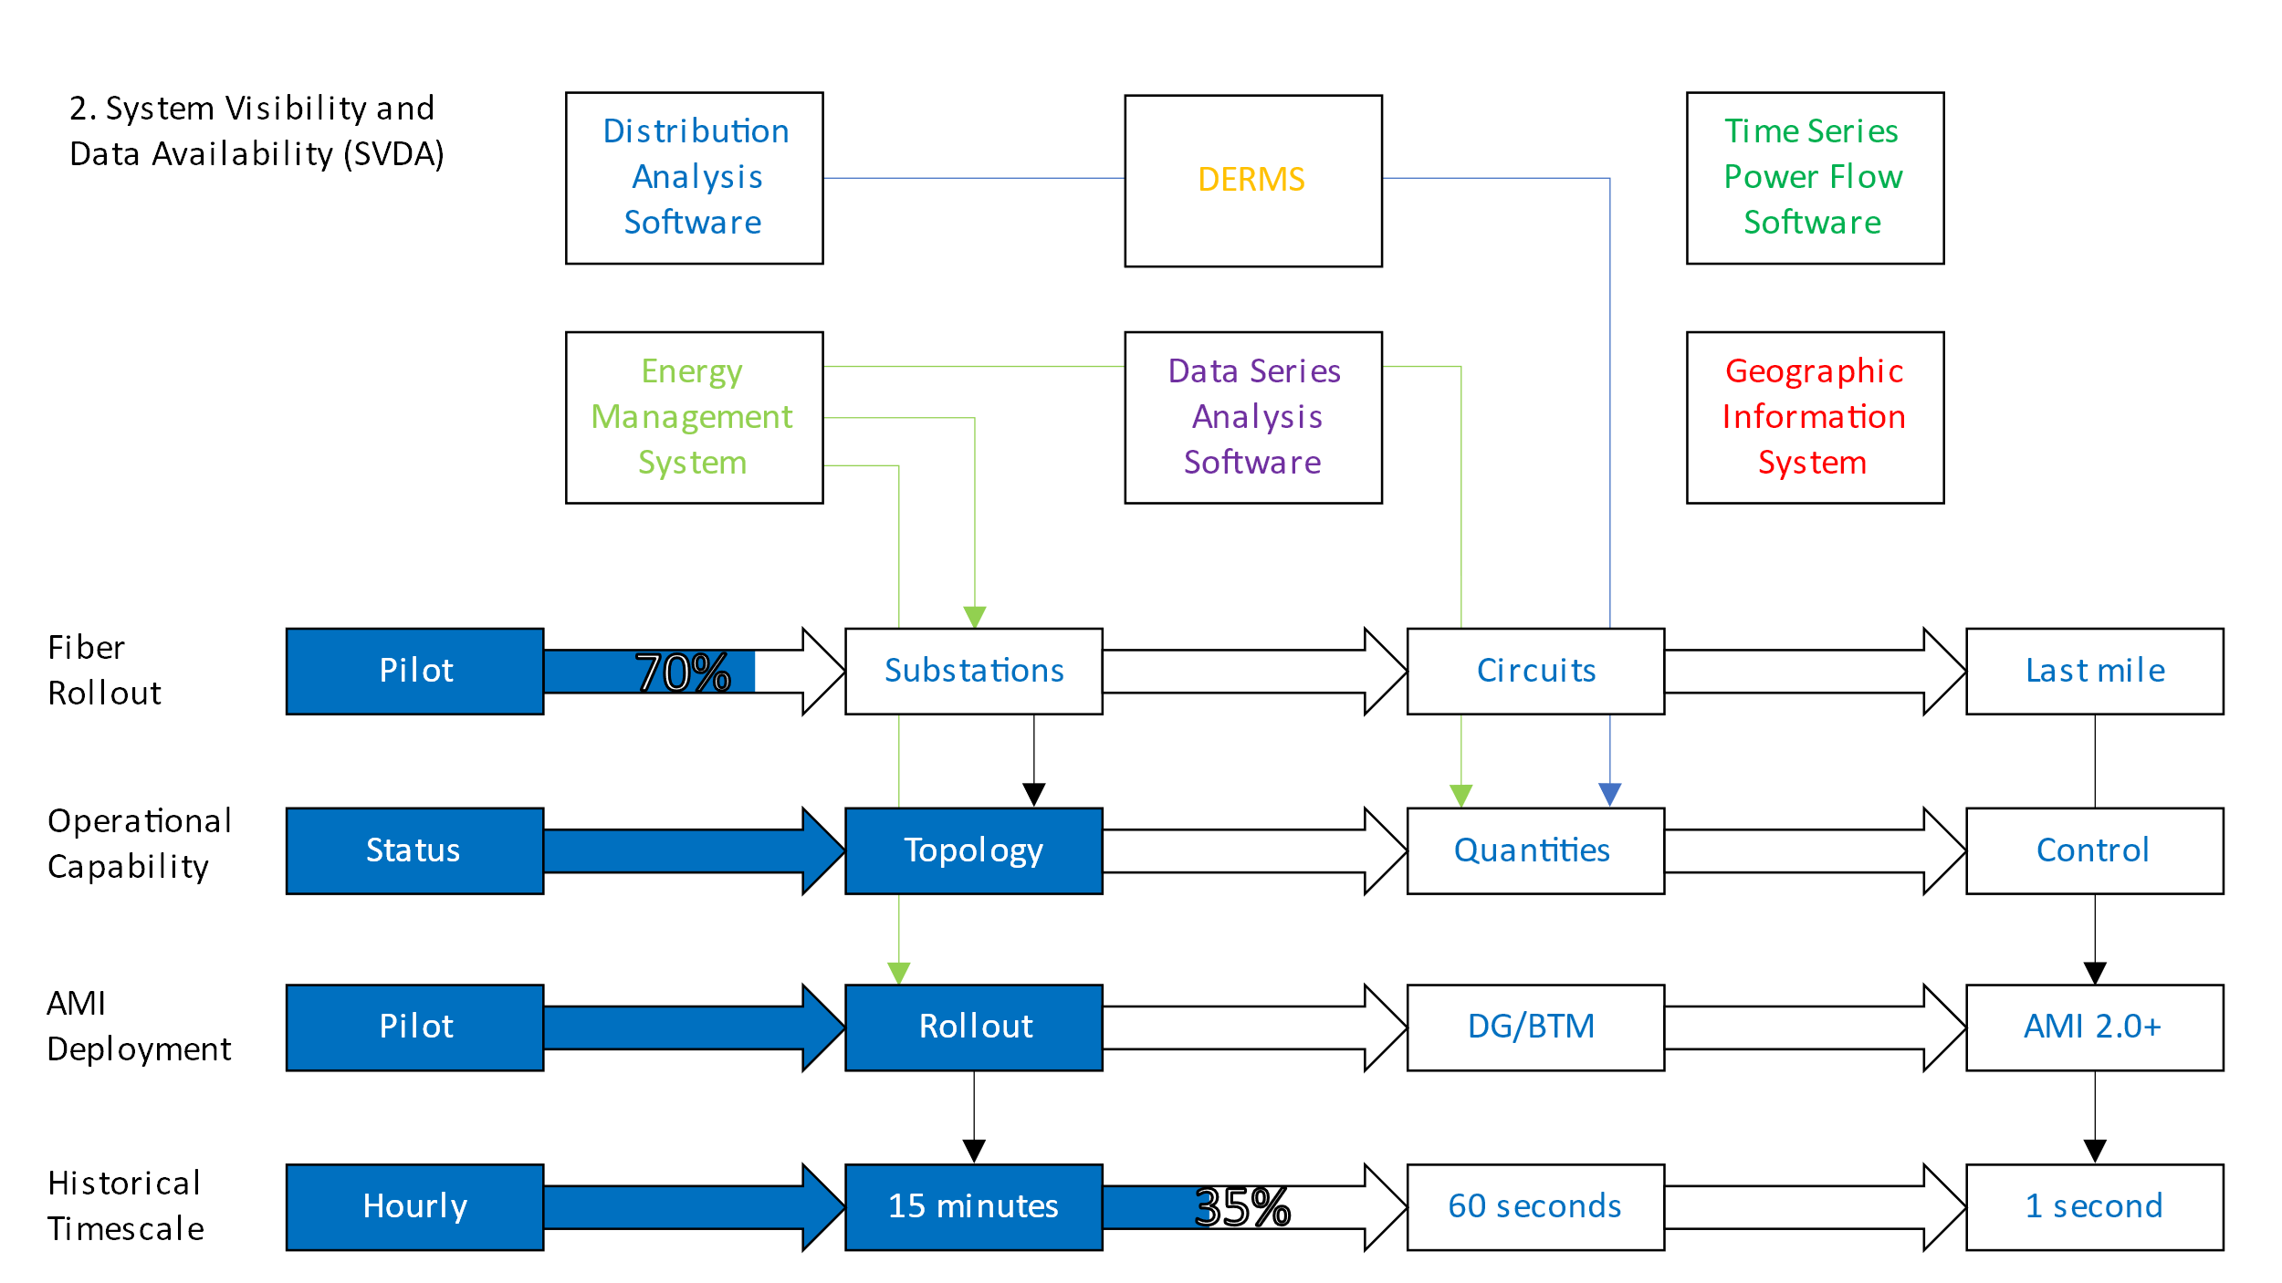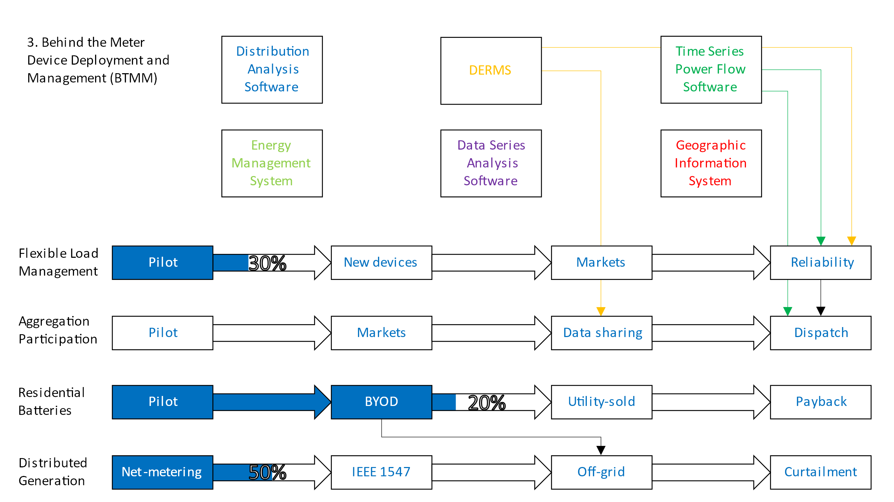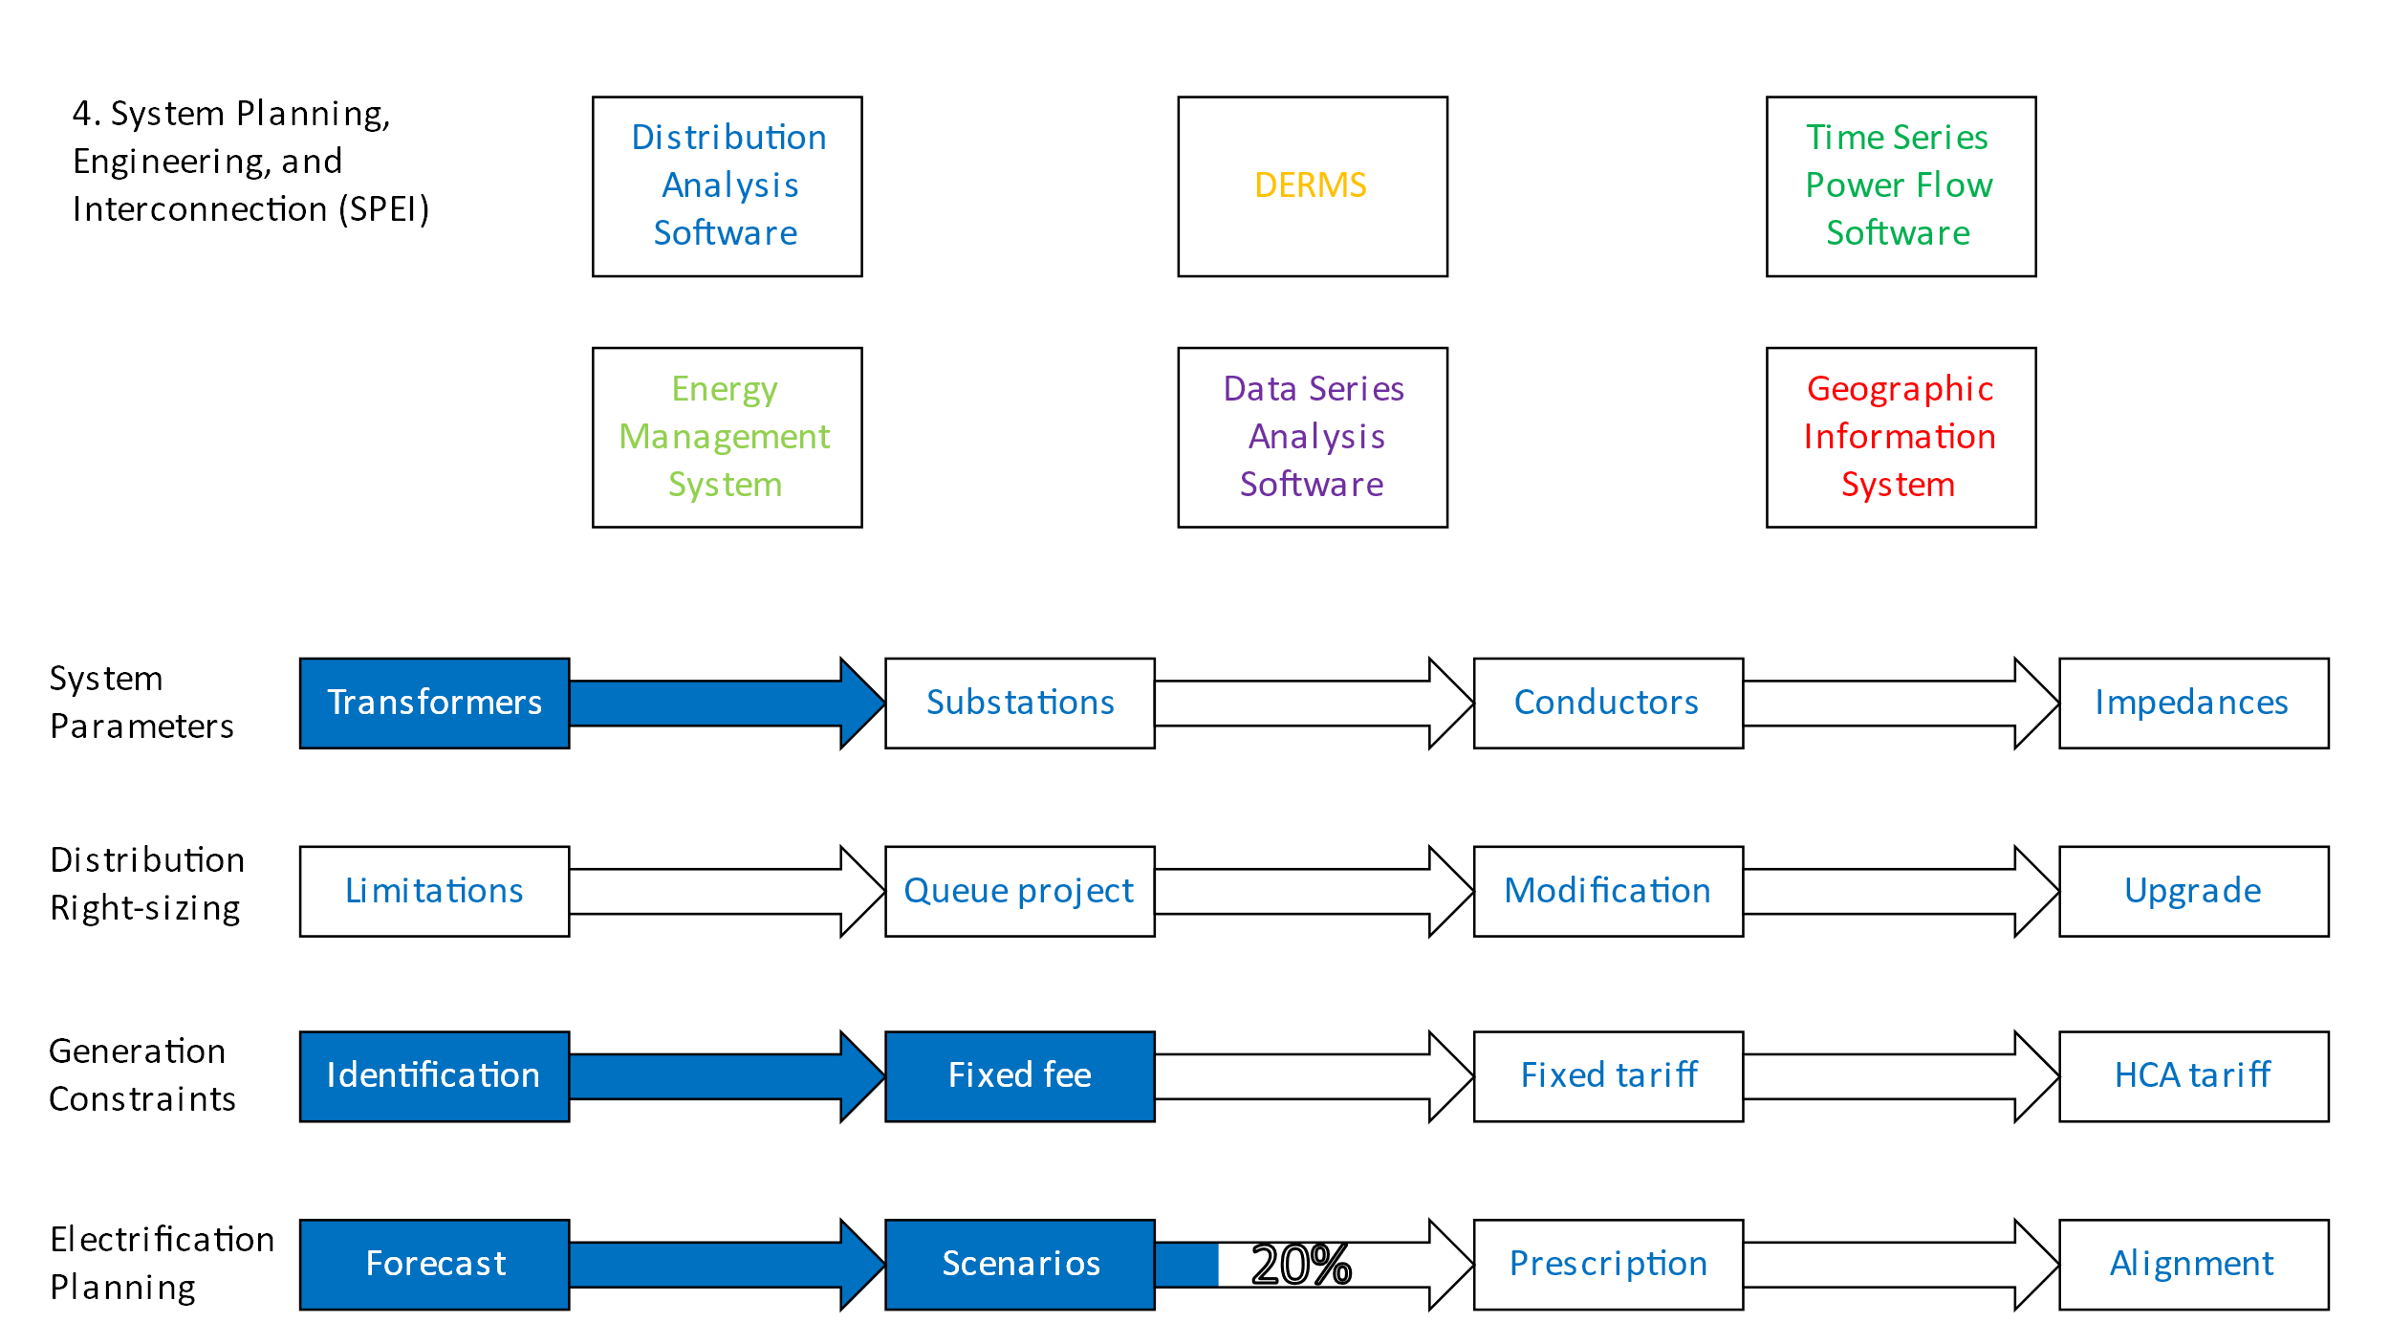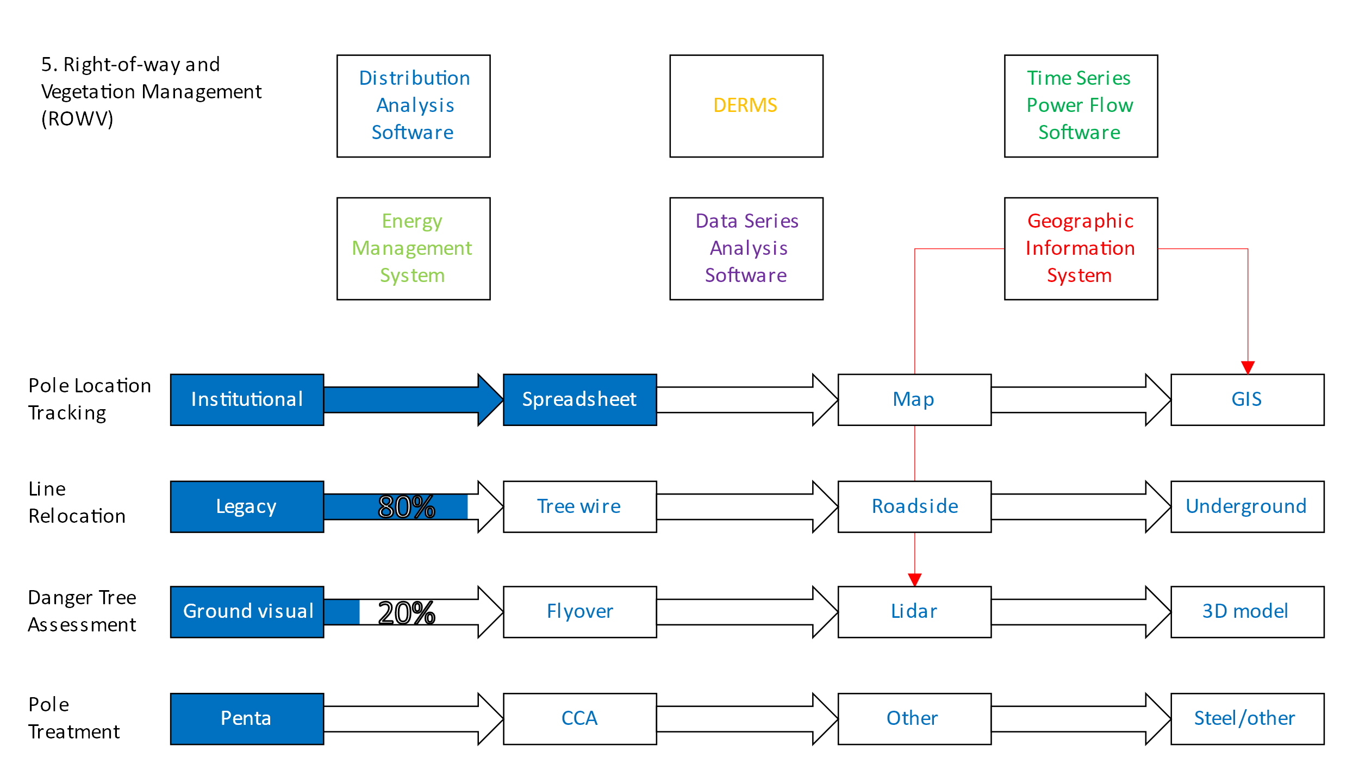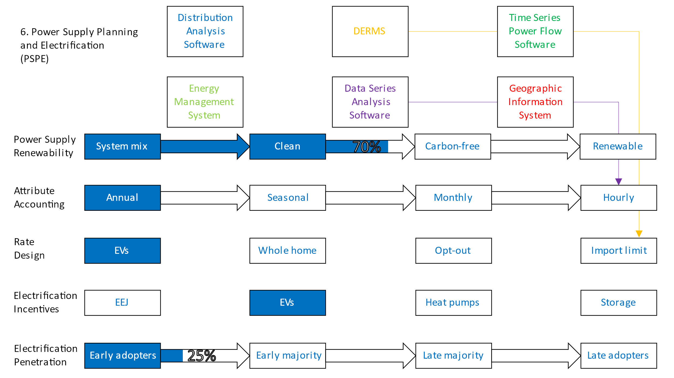
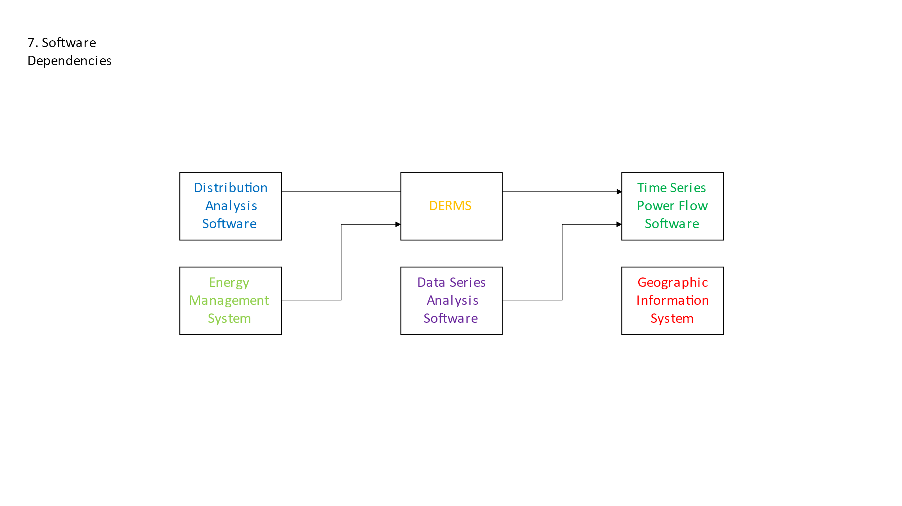
Note: To change the fill of an arrow, right click on it and select “Format Shape.” Then, in the menu that appears on the right side of the screen, click the paint bucker icon, then expand the “Fill” drop down. Fourth from the bottom is a field called “Position;” first, enter the new desired percentage. Then, click on the tab marker that was not changed (in the item sixth from the bottom) and again enter the desired percentage in the “Position” field. To change the label on an arrow, simply double click it as if it were a textbox.

Part B: Consistency Determination

The Department under 30 V.S.A. §202(f) reviews certain proposed actions by electric utilities to determine the consistency of those actions with the current adopted version of the Vermont Electric Plan, which is the 2022 Comprehensive Energy Plan (“CEP”). Companies contemplating proposals for actions subject to PUC approval under 30 V.S.A. §108 or §248(b) should also request a determination in writing from the Director of Regulated Utility Planning under 30 V.S.A. §202(f).

In addition to determining consistency with the specific text of the CEP, the Department will look for consistency with statutory state policies, goals, and requirements, including the goals and policies established in 30 V.S.A. sections 202a(1), 202a(2), 218c, 218e, and 8001-8011 as well as 10 V.S.A. § 578.

Process

Notification

Any company making such a proposal should notify the Director at least 60 days in advance of the proposed action and include, at a minimum, the following information:
- A description of the proposed action;
- The nature of the arrangements being proposed;
- The capacity and/or energy and the terms of the arrangements being proposed;
- An explanation of the objectives the company seeks to accomplish with the proposed action;
- How it relates to the company's short and long-range power supply plans;
- How it relates to the 2022 CEP; and,
- Any other relevant information.

Regulatory Response

The Department will advise the company if additional information on the proposed action will be needed. If so, the Department will make appropriate information requests. The Department will issue the resulting determination as quickly as feasible following the receipt of requested information.
The Department wishes to expedite the review and determination process in every way compatible with its responsibility to conduct a thorough review of proposed actions. For that reason, companies are encouraged to initiate discussion of major proposed actions at an early date.

Filing Components

Typical information needed for utility power supply projects or purchases includes the following components. Other actions are likely to require different kinds of information.

Economic Analysis

Calculation of the societal costs and benefits of a proposed supply action and of the supply and demand-side alternatives the utility has considered. The underlying data, including production simulations and demand-side program data, should be included. Submitted analysis should also include discussion (and where possible, calculation) of the opportunity cost of the proposed action.

Sensitivity Analysis

Since the results of societal test analyses are highly sensitive to key assumptions that may be hard to predict, it is necessary to determine how varying those assumptions may alter the competitiveness of the proposed action. For this reason, the utility should conduct additional studies incorporating variations of those assumptions (utilizing tools such as Monte Carlo or scenario analysis and including correlations among variables where practicable). All assumptions subject to changes that would have a significant impact on the analysis results should be reviewed. The variations to be studied may be developed with the Department in advance of filing.

Diversity Calculations

To help gauge the degree of dependence on the proposed project, a utility's analysis should show the percentage of its energy and capacity requirements the proposed action will provide during the project's life, based on production simulation results.

Similar calculations should be shown for the aggregate energy and capacity from the proposal plus all other entitlements of the utility that use similar technology and fuel.

The 2022 Comprehensive Energy Plan is available on the Department’s website at https://publicservice.vermont.gov/content/2022-plan
30 V.S.A. §218c. Least cost integrated planning (a)(1) A “least-cost integrated plan” for a regulated electric or gas utility is a plan for meeting the public’s need for energy services, after safety concerns are addressed, at the lowest present value life cycle cost, including environmental and economic costs, through a strategy combining investments and expenditures on energy supply, transmission, and distribution capacity, transmission and distribution efficiency, and comprehensive energy efficiency programs. Economic costs shall be assessed with due regard to: (A) the greenhouse gas inventory developed under the provisions of 10 V.S.A. § 582; (B) the State’s progress in meeting its greenhouse gas reduction goals; (C) the value of the financial risks associated with greenhouse gas emissions from various power sources; and (D) consistency with section 8001 (renewable energy goals) of this title. (2) “Comprehensive energy efficiency programs” shall mean a coordinated set of investments or program expenditures made by a regulated electric or gas utility or other entity as approved by the Commission pursuant to subsection 209(d) of this title to meet the public’s need for energy services through efficiency, conservation, or load management in all customer classes and areas of opportunity which is designed to acquire the full amount of cost-effective savings from such investments or programs. (b) Each regulated electric or gas company shall prepare and implement a least-cost integrated plan for the provision of energy services to its Vermont customers. At least every third year on a schedule directed by the Public Utility Commission, each such company shall submit a proposed plan to the Department of Public Service and the Public Utility Commission. The Commission, after notice and opportunity for hearing, may approve a company’s least-cost integrated plan if it determines that the company’s plan complies with the requirements of subdivision (a)(1) of this section and of sections 8004 and 8005 of this title and is consistent with the goals of the Comprehensive Energy Plan issued under section 202b of this title
Natural gas utilities (of which there is only one in Vermont at this time) are also subject to §218c, but not to §202, which establishes the Electric Plan.
For a description of scenario planning in the context of electric utilities, see NARUC’s Scenario Planning in a Utility Regulatory Context. Available at http://www.naruc.org/Publications/FINAL%20Full%20Colorado%20SERCAT.pdf.
For consideration of a generic resource and technology (e.g., solar PV, utility-scale wind, natural gas combined cycle, or market purchases) rather than consideration of a particular facility, generic assessments of these characteristics may be appropriate.
In this section, the term “transmission” as it pertains to the electric sector will be understood to encompass both subtransmission systems (<115 kV; typically 34.5, 46, or 69 kV), and bulk transmission systems (equal to or greater than 115 kV).
The remainder of Section 3 guidance pertains to only electric utilities. The Department will provide guidance to gas utilities in the near future.
Grid Resilience in Regional Transmission Organizations and Independent System Operators, Order Terminating Rulemaking Proceeding, Initiating New Proceeding, and Establishing Additional Procedures, 162 FERC ¶ 61, 012 at P 23 (January 8, 2018).
Please see Chapter 2.2.2.1 of the Comprehensive Energy Plan, page 42 for more discussion of the Social Cost of Carbon.

