
Freeman, Sullivan & Co.
101 Montgomery St., 15th Floor
San Francisco, CA 94104
Benefit-Cost Analysis for Advanced Metering and Time-Based Pricing
Final Report
March 26, 2008
With assistance from:
MWConsulting

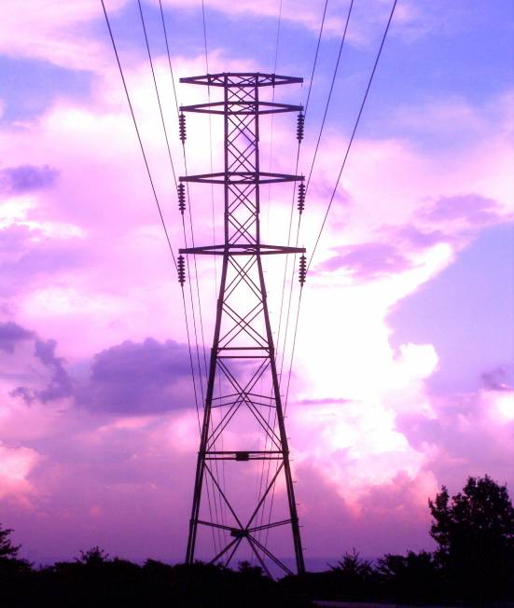
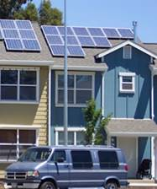
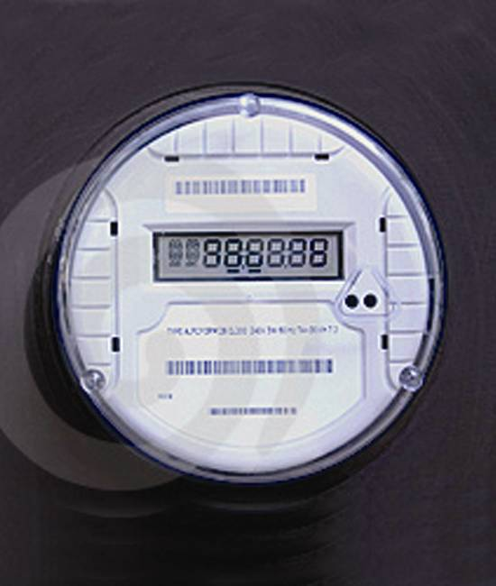
Prepared for:

Vermont Department of Public Service
112 State Street
Montpelier, VT 05620-2601

Prepared by Freeman, Sullivan & Co:
Stephen S. George, Ph.D.
Josh Bode, MPP

and MWConsulting:
Michael Wiebe

1. EXECUTIVE SUMMARY 1
1.1. Analytical Framework 1
1.2. Results 3
1.3. Recommendations 5
1.3.1. AMI Technology Implementation 5
1.3.2. Ancillary Capabilities Enabled Through Advanced Meters 6
1.3.3. Date Management to Support Time-Based Pricing 6
1.3.4. Rate Design 7
1.3.5. Regulatory Concerns 7
1.4. Report Structure 8
2. STUDY OBJECTIVES AND OVERVIEW OF ADVANCED METERING AND TIME-BASED PRICING 9
2.1. Procedural History 9
2.2. Recent Developments in AMI 10
2.2.1. What is AMI? 12
2.2.2. Where Has AMI Been Deployed? 14
2.2.3. Technology Developments 16
2.3. Trends in Time-Based Pricing 18
2.3.1. Residential Customers 20
2.3.2. Non-residential Customers 23
3. TECHNOLOGY OPTIONS 26
3.1. Meter Options 26
3.2. Data Collection and Communication Options 26
3.2.1. Power Line Carrier 27
3.2.2. Radio Frequency Systems 28
3.2.3. Broadband Over Powerline 31
3.2.4. Public Networks 31
3.3. Meter Data Management System 32
4. BENEFIT COST ANALYSIS METHODOLOGY AND INPUTS 34
4.1. Conceptual Overview of AMI Benefit-Cost Analysis 34
4.2. Technology Selection and Cost Analysis 36
4.2.1. Initial Meter Hardware and Installation Costs 37
4.2.2. Network Equipment and Installation Costs 39
4.2.3. Incremental Meter Costs in Future Years 41
4.2.4. Network Operation Costs 42
4.2.5. Network Maintenance 42
4.2.6. Financial Calculations 42
4.3. Operational Benefits 43
4.4. Demand Response Benefit Analysis 45
4.4.1. Number of Customers 46
4.4.2. Average Energy Use by Rate Period 47
4.4.3. Prices by Rate Period 48
4.4.4. Price Responsiveness 49
4.4.5. Participation/Awareness Rates 50
4.4.6. Marginal Capacity Costs 51
4.4.7. Marginal Energy Costs 52
4.4.8. Miscellaneous Inputs 52
4.5. Demand Response Cost Analysis 53
4.6. Reliability Benefits 54
4.7. Environmental Benefits 54
5. STATEWIDE BENEFIT-COST ANALYSIS 55
5.1. Summary of Key Assumptions 55
5.2. Statewide Benefits and Costs 57
5.3. Environmental and Reliability Benefits 63
6. UTILITY SPECIFIC BENEFIT-COST ANALYSIS 65
6.1. Central Vermont Public Service 65
6.2. Green Mountain Power 68
6.3. Vermont Electric Cooperative 72
6.4. Burlington Electric Department 73
6.5. Washington Electric Cooperative 78
6.6. Small Utility Group 81
7. RATE DESIGN ISSUES AND POLICY OPTIONS 84
7.1. Pricing Objectives 84
7.2. Prices Must Be Understandable To Be Effective 85
7.3. Dynamic Versus Static Rate Options 87
7.4. Maximizing Customer Participation 91
7.5. Summary 95
8. CONCLUSIONS AND RECOMMENDATIONS 97
8.1. Conclusions 97
8.2. Recommendations 99
8.2.1. AMI Technology Implementation 99
8.2.2. Ancillary Capabilities Enabled Through Advanced Meters 100
8.2.3. Date Management to Support Time-Based Pricing 101
8.2.4. Rate Design 101
8.2.5. Regulatory Concerns 103

EXECUTIVE SUMMARY
This report presents a preliminary analysis of the benefits and costs associated with the implementation of advanced metering and time-based pricing in Vermont. This study was done in support of a Vermont Public Service Board (VPSB) investigation into the use of smart metering and time-based rates (Docket No. 7307).
Advanced metering and time-based pricing are being implemented in a variety of jurisdictions in the US as well as internationally. However, Vermont has many unique characteristics, including a large number of small utilities, hilly and mountainous terrain and low population density, all of which make the analysis of and economics of AMI implementation challenging. In addition, Vermont has low penetration of air conditioning and relatively low average electricity use among mass-market customers, which suggests that demand response benefits are likely to be less in Vermont than in many other jurisdictions. In light of these differences, the Vermont Department of Public Service commissioned this study to obtain an initial assessment concerning whether implementation of AMI and time-based pricing is likely to be beneficial to Vermont’s electricity consumers. The analysis presented in this report indicates that, in spite of the challenges outlined above, implementation of AMI and time-based pricing is likely to reduce the cost of electricity supply and delivery in Vermont relative to a business-as-usual, base case scenario.

Analytical Framework
Figure 1-1 provides a conceptual overview of the benefit-cost methodology that underlies the results presented here. The analysis involves two parallel paths, one focused on the AMI investment and the other on time-based pricing.
Figure 1-1
Benefit-Cost Framework
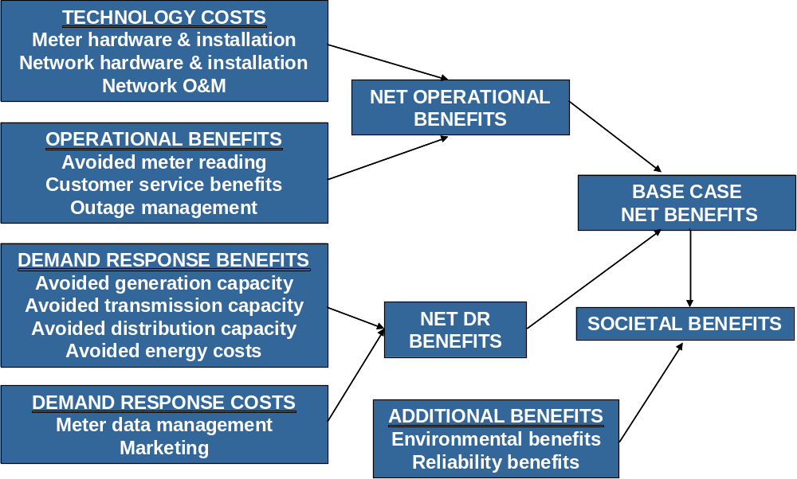
The AMI investment analysis involves estimating the net present value of costs over the life of the investment for a variety of technology options and choosing the option that meets the functional specification and other factors that influence investment choice (e.g., risk mitigation) at the least cost. The next step involves estimating the net present value of the operational savings, in the form of avoided meter reading costs, reduced outage costs and other factors that will result from AMI deployment. The difference between the operational benefits and costs is referred to as the operational net benefits. If this number is positive, it means that the operational savings will offset the cost of the investment even without any additional benefits that may be achieved through the implementation of time-based pricing.
The second key component of the analysis examines the net benefits associated with time-based pricing enabled by AMI. The primary benefits involve lower capacity costs (generation, transmission and distribution) resulting from reduced demand at times of system peak. Time-based pricing can also result in lower energy costs, due either to an overall reduction in energy use (if lower usage during peak periods is not completely offset by higher usage during off-peak periods) or to a shift from high cost to low cost periods. Partially offsetting these demand response benefits is the cost of marketing the rates or other demand response programs that generate the benefit streams. We have also included the costs associated with a meter data management system (MDMS) on this side of the ledger, since meter data management is essential to time-based pricing but some operational benefits associated with AMI can be achieved without a significant investment in MDMS functionality. The difference between the demand-response benefits and costs is referred to as the DR net benefits.
The difference between the operational net benefits and the demand response net benefits is an estimate of the overall gain to Vermont’s electricity consumers from a combination of AMI deployment and implementation of time-based pricing.
Using the above framework, net benefit estimates were developed for the five largest utilities in the state in terms of number of customers: CVPS, GMP, VEC, BED and WEC. VEC is already in the process of installing an AMI system. As such, estimates of the net demand response benefits were developed for VEC, but not the operational net benefits. The number of customers for each of the remaining 15 utilities ranges from a low of 319 to a high of 5,451. An examination of the data provided by these utilities indicates that, for 10 of the 15, it would be difficult to reduce operational costs by implementing AMI. In some cases, meter reading is only one of many responsibilities shared by meter readers so the employee position would not be eliminated if AMI is deployed. In other cases, electricity meter readers also read water meters. As a result, it would not be possible to eliminate the meter reading position unless new water meters that could be remotely read were also deployed. An analysis of the net benefits of implementing remote meter reading for water meters was beyond the scope of this study.
The five small utilities for which net benefit estimates were developed jointly were Hardwick, Lyndonville, Stowe, Morrisville and Ludlow. Combined, these utilities serve almost 21,000 customers. In total, the 10 utilities that were included in the analysis account for 96 percent of all of the electricity customers in Vermont and 93 percent of the load.

Results
Figure 1-2 summarizes the findings for each of the utilities and utility groups that were examined, as well as the overall findings for the 10 utilities combined. As seen, the operational net benefits in aggregate are negative for the 9 utilities for which costs and operational benefits were estimated (e.g., excluding VEC)—that is, the cost of the AMI system over its assumed 20-year life exceeds the estimated operational savings. However, this negative result is driven by the strongly negative business case for GMP, whose current meter reading costs are extremely low due to the business practice of reading meters every other month as well as the fact that the company uses low cost mobile AMR to read roughly one third of its meters. The operational net benefits equal roughly $4 million for the remaining 8 utilities, with BED being the only other case in which the AMI costs exceed the operational benefits. For CVPS, WEC and the combined small utility group, the benefits exceed the costs, meaning that implementation of AMI would reduce costs for these utilities even if time-based pricing was not implemented.
As emphasized throughout this report, the operational benefit estimates presented here are based on a small subset of benefit streams. It is likely that a more detailed, process-by-process analysis for each utility would be able to identify and quantify additional operational benefits. Consequently, we believe that the net operational benefit estimate of -$6.6 million is actually much closer to breakeven or could even be positive, in spite of the strongly negative GMP value.
In addition, the very recent passage of the Energy Independence and Security Act of 2007 provides for Federal grants of up to 20 percent of the cost of smart grid technologies, although the details regarding how grants would be awarded among competing projects given limited appropriations is yet to be worked out. If the AMI systems installed by Vermont’s utilities were to qualify for these grants, the operational benefits would turn from negative to positive, even with GMP’s negative business case included. Nevertheless, even with the 20 percent grant payments, it is unlikely that further analysis would completely eliminate the significantly negative operational gap at GMP as long as the Company continues to read meters bimonthly.
In short, we are confident in concluding that, even before considering demand response benefits, AMI is likely to be cost-effective for CVPS, BED (once additional benefits are identified), WEC and the small utility group. Based on GMP’s current business practice of bimonthly meter reading, even a more detailed analysis of operational savings and AMI investment costs is unlikely to show that AMI would be cost-effective based on operational savings alone.
Figure 1-1
Benefits and Costs Associated With Implementation of
AMI and Time Based Pricing in Vermont
(Present Value)
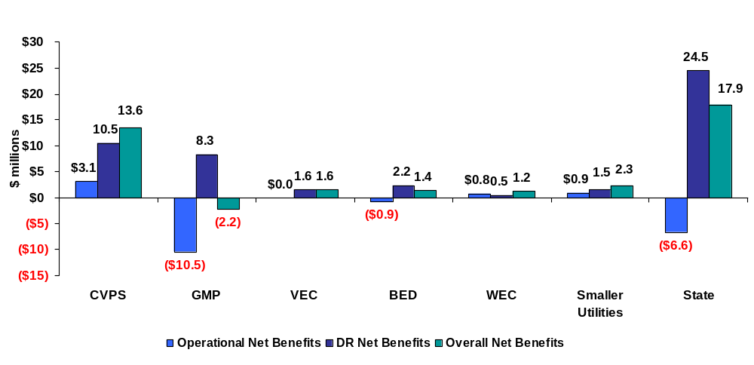

When the demand response benefits associated with implementation of time-based pricing are considered, the overall net benefits are significantly positive, amounting to roughly $18 million over the life of the investment. Some will argue that this estimate is high because of the underlying assumptions regarding awareness levels and participation rates for the time-based pricing option underlying this analysis (e.g., a peak-time rebate program that pays an incentive for customers to reduce energy use during peak periods on high-demand days). However, as pointed out in Section 5, these estimates may significantly understate the potential value of demand response in Vermont. The benefit estimate presented here is based on only about 55 percent of the total load in the state. A substantially higher estimate would result if demand response from the large industrial customers was included, if the application of enabling technologies that enhance demand response was considered, or if a pricing strategy that implements time-based pricing as the default tariff option was implemented for all customer segments. Some of the assumptions and analysis underlying the results are also quite conservative. For example, the demand reductions are based on average demand over the top 20 system load days in Vermont, whereas the capacity costs for ISO-NE market are based on the highest system load hour, which is roughly 20 percent higher than the average we have used here. That is, it is likely that the capacity benefits from time-based pricing could be significantly greater than estimated here.
It should be noted that, even with demand response benefits included, net benefits for GMP are negative. We believe this relatively small gap could be closed with more detailed analysis of operational savings and AMI costs and/or perhaps through a more inclusive, detailed analysis of demand response benefits. Nevertheless, it is clear that any decision regarding whether or not to move forward with AMI and time-based pricing at GMP is more risky in terms of the likelihood of it producing positive net benefits for the Company’s ratepayers than it is for any of the other utilities.

Recommendations
A significant amount of work and effort has gone into this analysis and we are confident in the general conclusion that Vermont should go further in investigating and pursuing implementation of AMI and time-based pricing. The following recommendations should be considered by Vermont’s policymakers as they continue to pursue this important policy decision.

AMI Technology Implementation
- The analysis of benefits and costs reveals that AMI technology will produce net benefits for most Vermont utilities on the basis of operational benefits alone. More detailed study of the benefits and costs by individual utilities is only likely to strengthen the case for these investments. Vermont utilities should act on this information. GMP, BED WEC and the smaller utilities (perhaps working together) should undertake the more detailed business case analysis required to move forward with an investment decision.
- CVPS should make investment plans to implement AMI at the Company. CVPS’s own analysis, as well as the independent analysis presented here, indicates that AMI is cost-effective at the Company based on operational savings alone. CVPS has decided to move forward with AMI on a schedule that contemplates meter installation starting in 2011. Given the significant operational benefits as well as the potential demand response benefits that are clearly achievable at CVPS, we suggest that the Board work with CVPS to see if a more rapid decision and deployment schedule might be feasible.
- Vermont should establish minimum requirements for advanced metering technologies to include, but not necessarily be limited to, two way communications and delivery of hourly data daily for all customers. Depending upon the outcome of recommendation 8, minimum standards associated with communication between the meter and in-home devices should also be considered.
- A working group of Vermont’s utilities should be formed to explore the feasibility and potential benefits of coordination in technology selection, meter purchasing and network utilization.
- Vermont’s utilities should monitor and, as appropriate, attempt to fulfill the requirements that will be established by DOE in 2008 regarding the appropriation of grants for the 20 percent coverage of investment costs in smart grid technologies authorized under the Energy Independence and Security Act.
- As part of the working group effort discussed in recommendation 4, consideration should be given to the implications of water meter reading on the business cases.
- The Commission should direct the utilities to establish a database that would map all of the meters in Vermont into a square-mile grid of the state and that would also contain additional information pertaining to terrain (e.g., a description of whether each square mile is relatively flat, hilly, mountainous, etc.). The database would also identify the utility serving each meter. This database would fall short of a full-scale, very expensive propagation study but would provide sufficient information for vendors to make proposals and for technical experts to explore the extent to which sharing network equipment across utility boundaries might be practical and cost-effective.

Ancillary Capabilities Enabled Through Advanced Meters
- Vermont should investigate the merits of encouraging utility meter investments to support ancillary capabilities enabled by investments in advanced meters including, but not necessarily limited to, Home Area Networks, in home information displays and selected control technologies. Recent evidence on the ability of in-home information displays to educate consumers about the relationship between costs and usage decisions suggests that this type of technology holds promise for improving both demand response and energy conservation decisions. This investigation should look at the advantages and disadvantages of various options, including open standards for communication between meters and other devices, Internet based accessibility to meter data, etc.

Date Management to Support Time-Based Pricing
- In concert with any decision to invest in advanced metering equipment, Vermont’s utilities should also be required to obtain meter data management and billing capabilities to support time-based pricing.
- VEC is currently installing advanced meters but does not yet have the capability to use the hourly data to support time-based pricing options. VEC should investigate the least cost option (e.g., purchase versus outsourcing) for obtaining a Meter Data Management System (“MDMS”) and billing capability to support time-based pricing, and develop a plan and schedule for implementing these capabilities.
- A working group of Vermont’s 15 smallest utilities (based on customer size) should be formed to explore cooperative options for least-cost provision of meter data management and billing for time-based pricing.

Rate Design
- Vermont should revisit its goals and current practices for electric rate design and determine whether alternative pricing strategies that take advantage of modern metering and information technology are warranted.
- From the standpoint of economic efficiency and maximizing the value of investments in advanced metering equipment, Vermont should consider, over time, moving toward some form of default, time-based pricing framework enabled by smart metering technology. Recognizing the inherent, real-world challenges of making such a move, Vermont should also consider alternatives and the interim steps necessary to implement such a pricing regime. This continuing investigation of pricing strategy should be done in parallel with implementation of the other recommendations and with furthering the deployment of AMI—AMI makes sense in most instances in Vermont regardless of whether or not default pricing is implemented.
- Once the relevant data management and billing capabilities are in place at VEC as recommended in item 10, VEC should create pricing plans that expand customer choice and may serve to expand the foundation of knowledge around dynamic pricing programs in Vermont. VEC should implement a pricing pilot that would examine customer interest in and response to various pricing options. To the extent feasible and practical, this pilot should focus on determining the likely participation rates among a variety of rate options and customer segments under different implementation schemes (e.g., opt-in, opt-out), marketing strategies, etc.

Regulatory Concerns
- The Public Service Board should consider what steps can be taken to mitigate regulatory risks associated with AMI investments. These risks include potential disallowances for stranded costs associated with the existing meter plant (e.g., disallowing costs of meters that are replaced under the economic used-and-useful rule that we understand exists in Vermont). These risks could also extend to second-guessing the technology investment decisions that a utility might make if new technology were to come along that was much more cost-effective, or if meter and/or network costs were to drop significantly soon after implementation. Importantly, Section 1307 of the new Energy Independence and Security Act amends PURPA and directs each state to consider authorizing electric utilities to recover the cost of AMI systems through the rate base and to continue recovering the remaining book-value costs of any equipment rendered obsolete by the deployment of smart grid systems.

Report Structure
The remainder of this report is organized as follows. Section 2 provides a brief summary of the procedural history that led to commissioning of this project. It also provides an overview of recent developments in AMI technology and time-based pricing initiatives in other jurisdictions. Section 3 contains a summary of AMI technology options. Section 4 provides a detailed discussion of the analysis framework, methodology and key input assumptions. Appendices A through H provide detailed documentation of the input assumptions and data that underlies the analysis. Section 5 presents the analytical results at the statewide level and Section 6 presents results for each of the individual utilities and utility groups for which benefits and costs were calculated. Section 7 provides a discussion of selected rate design issues and policy options. Section 8 summarizes the overall conclusions and presents recommendations for next steps.

STUDY OBJECTIVES AND OVERVIEW OF ADVANCED METERING AND TIME-BASED PRICING
The primary objective of this study is to evaluate the costs and benefits associated with implementing advanced metering infrastructure (AMI) and time-based pricing in Vermont. This study has been done in support of a Vermont Public Service Board (VPSB) investigation into the use of smart metering and time-based rates (Docket No. 7307).
This section begins with a brief history of the regulatory actions leading up to the decision to conduct the analysis summarized in this report. Following this background information is a brief summary of trends in AMI and time-based pricing.

Procedural History
Vermont has 20 vertically integrated electric distribution utilities that operate within a fully regulated environment—two relatively large investor-owned utilities, one smaller investor-owned utility, 15 municipal utilities and two cooperative utilities. There are only about 350,000 electricity customers in Vermont, with the two largest utilities, Central Vermont Public Service and Green Mountain Power, accounting for nearly 70 percent of that total. The five largest utilities in the state, the smallest of which has only 10,000 customers, account for almost 90 percent of all customers. The smallest five utilities average fewer than 700 customers each, although one of these, Vermont Marble, is the fifth largest utility in the state in terms of electricity sales. In addition to a large number of very small utilities, a large percent of Vermont’s electricity consumers live in sparsely populated, sometimes hilly terrain, all of which affect AMI technology choice, costs and operational benefits.
In 2005, the Federal Energy Policy Act (EPACT) called for state public utilities commissions to consider the adoption of a set of five standards. One of these standards concerned “smart meters” and time-based rates. Specifically, section 1252 of the Act requires every utility in the US to “offer each of its customer classes, and provide individual customers upon customer request, a time-based rate schedule” and requires each State regulatory authority to “conduct an investigation and issue a decision whether or not it is appropriate for electric utilities to provide and install time-based meters and communications devices for each of their customers which enable such customers to participate in time-based pricing rate schedules and other demand response programs.”
Written comments were solicited by the Board in response to EPACT, and a workshop was held, leading to the Board determination against adoption of EPACT’s offered standards, based on the unique characteristics of Vermont’s utilities. Following this determination, the DPS submitted comments suggesting more workshops and additional process. The procedural history of these workshops and comments of the DPS and utilities can be found through the Public Service Board’s website.
The workshops led the DPS to believe that the issue should be analyzed in greater depth. In April of 2007, the DPS submitted a petition to the Board requesting a formal investigation to evaluate the use of smart metering and increased time-based rates. In its petition before the Board, the Department stated:
- The use of “smart” metering equipment and the use of rates have the potential to provide numerous important benefits to Vermont electric consumers and utilities, including but not limited to sending more accurate price signals, load shifting, reduction in energy use, reduced meter reading costs, and improved customer service;
- Experience in other jurisdictions suggests that reductions in demand from pricing plans enabled through advanced meters generally correspond to peak periods when both utility costs and energy emissions are high;
- Potential benefits of “smart metering” also include more and better information about customer resource requirements for utility planners and the flow of that information to the final customer;
- Some Vermont utilities are deploying Automated Meter Reading (AMR) technologies. However, Advanced Meter Infrastructure holds more potential for overall value to ratepayers. Early deployment of AMR may undercut important ratepayer benefits from AMI technologies.
The DPS request for a formal investigation into the costs and benefits of AMI and time-based pricing was granted—the Board opened Docket 7307 on April 18, 2007. This report was commissioned in support of that proceeding.
In parallel to Board workshops and activities related to this investigation, the Vermont General Assembly has moved forward with legislation embracing both a formal Board investigation into advanced meter infrastructure and advanced time-based pricing. The legislative proposal also includes language proposing that the Board include consideration of inclining block electric rates in their investigation. In the Board’s opening order, the Board allowed flexibility to consider both issues together in the context of this investigation.

Recent Developments in AMI
In the last few years, interest in both demand response resources and advanced metering infrastructure (AMI) has rapidly grown nationally. It is no coincidence that interest in both has increased simultaneously, as price-driven demand response relies on advanced metering and the benefits of advanced metering are much greater if a utility implements a time-based pricing strategy along with AMI deployment. As one stakeholder in Ontario commented about that government’s decision to fully deploy AMI, “Smart meters combined with dumb prices simply don’t make sense.”
Many factors have combined to significantly raise utility and regulatory interest in demand response and AMI, including:
- The aforementioned passage of the Energy Policy Act of 2005;
- Near universal acceptance of the fact that demand response is essential to mitigating market power and price volatility in competitive wholesale markets, can reduce the need for new capacity and can improve reliability;
- Growing recognition of the fact that customers can and will respond to time-varying pricing and that, once they experience such prices, many customers prefer them over standard pricing options;
- Growing recognition of the magnitude and range of operational benefits that utilities can achieve when AMI is properly and effectively integrated into utility operations;
- Expanding technology options and decreasing costs associated with AMI deployment;
- Significant attention generated by the regulatory approval of Pacific Gas & Electric Company’s request to install roughly 9 million advanced meters (roughly 5 million electric and 4.1 million gas), regulatory approval of San Diego Gas & Electric’s (SDG&E’s) request to install roughly 2 million gas and electric meters, and decisions by the governments of Ontario, Canada and Victoria, Australia to require that all customers in those jurisdictions have advanced meters by near the end of this decade.
In spite of all of this momentum, there remains a lot of confusion and many misperceptions about the value of AMI and demand response. Indeed, there is not even a universally accepted definition of what an advanced meter is. In addition, many utilities fail to understand how transformative AMI technology can be for a broad range of utility operations and, therefore, fail to fully consider all of the benefits that AMI can generate when examining whether or not deployment is warranted. Many policymakers fail to understand that “the particulars matter” in the sense that costs and benefits vary greatly across jurisdictions and even across utilities within a particular jurisdiction, depending upon current operational practices and costs, customer density, wholesale market conditions, and many other factors. And both utilities and regulators are extremely reluctant to fully embrace more economically rational electricity pricing, even while basing their decisions to deploy AMI in part on the benefits that pricing reform can generate.

What is AMI?
Advanced metering infrastructure, or AMI, and automated meter reading, or AMR, are not the same thing, although the line between the two can be pretty grey, depending on the definition of each.
According to Wikipedia, the online encyclopedia, AMR “is the technology of automatically collecting data from water meters or energy metering devices and transferring that data to a central database for billing and/or analyzing.” A wide variety of AMR technologies can be used to read and transmit meter data. Wikipedia includes not only fixed network communication systems in its definition of AMR, but also mobile systems, including “drive-by” systems in which a meter reading device is installed in a vehicle that passes within a prescribed distance of each meter to obtain the meter read, “walk-by” systems and even “touch technology” through which a probe is inserted into a meter as a means of downloading meter reads. Most industry practitioners would limit the definition of AMR to either drive-by or fixed network systems.
Like AMR, the definition of AMI also varies depending upon who you ask. In its recent report on advanced metering and demand response, the Federal Energy Regulatory Commission (FERC) defined advanced metering as follows:
“Advanced metering is a metering system that records customer consumption [and possibly other parameters] hourly or more frequently and that provides for daily or more frequent transmittal of measurements over a communication network to a central collection point.”
Thus, the primary distinction between AMI and AMR according to this definition concerns the collection of interval data and the frequency with which the data are transmitted. Clearly, drive-by or walk-by AMR does not fit into this definition. While fixed network AMR systems typically involve frequent transmission of data to a collection point (often every few minutes), they typically are not designed to record hourly or sub-hourly usage information.
While FERC focuses exclusively on the frequency of usage measurement and data delivery in its definition of AMI, others have gone well beyond these features when defining AMI. For example, the Demand Response and Advanced Metering Coalition (DRAM) defines AMI as:
The communications hardware and software and associated system and data management software that creates a network between advanced meters and utility business systems which allows collection and distribution of information to customers and other parties such as competitive retail suppliers, in addition to the utility itself.
DRAM connects AMI with demand response directly by defining advanced metering or advanced metering system (as distinguished from advanced metering infrastructure) as follows:
A system that collects time-differentiated energy usage from advanced meters via a fixed network system, preferably two-way, on either an on-request or defined schedule basis. The system is capable of providing usage information to electricity customers, utilities and other parties on at least a daily basis and enables them to participate in and/or provide demand response products, services and programs. The system also supports additional features and functionality related to system operation and customer service, e.g. outage management, connect/disconnect, etc.
Finally, DRAM defines an advanced meter as:
An electric meter, new or appropriately retrofitted, which is 1) capable of measuring and recording usage data in time differentiated registers, including hourly or such interval as is specified by regulatory authorities, 2) allows electric consumers, suppliers and service providers to participate in all types of price-based demand response programs, and 3) which provides other data and functionality that address power quality and other electricity services issues.
Putting DRAM’s three definitions together, the organization significantly extends the functionality and specificity of advanced metering compared with FERC’s definition. Both the DRAM and FERC definitions agree that, at a minimum, AMI must be capable of delivering at least hourly data on a daily basis. However, DRAM introduces additional functionality, including two-way communication, outage detection, remote connect/disconnect, power quality monitoring, and provision of information to consumers and other stakeholders such as retailers.
The California Public Utilities Commission (CPUC) also went well beyond the narrow FERC definition in setting the minimum functionality of AMI in a rulemaking proceeding on advanced metering, demand response and dynamic pricing. Indeed, the minimum functionality directed by the CPUC was even broader than the functionality included in DRAM’s definitions. Specifically, the CPUC ordered California’s three primary investor owned utilities to examine AMI systems that:
- Will support implementation of a wide variety of rate options, including two and three-period time-of-use (TOU) rates, critical peak pricing (CPP) and hourly pricing (for large customers only);
- Collection of usage data that supports customer understanding of hourly usage patterns and how these usage patterns relate to energy costs;
- Customer access to personal energy usage data with sufficient flexibility to ensure that changes in customers preference of access frequency do not result in additional AMI system hardware costs;
- Compatible with applications that utilize collected data to provide customer education and energy management information, customized billing, and support improved complaint resolution;
- Compatible with utility system applications that promote and enhance system operating efficiency and improve service reliability, such as remote meter reading, outage management, reduction of theft and diversion, improved forecasting, workforce management, etc.
- Capable of interfacing with load control communication technology.
Two things are obvious from the above discussion. First, as previously indicated, there is no current consensus regarding the definition or functionality of AMI. All parties agree that a distinguishing characteristic is the frequent (typically daily) delivery of time-based data (hourly or sub-hourly) to a centralized collection point. Beyond that, there is significant variation regarding functionality that practitioners feel should be included in an AMI system.
The other primary conclusion is that technology is currently available that can provide a wide range of functionality, from the collection of hourly data daily to the delivery of the data back to consumers and to improvement in a wide range of customer services, including tailored bill scheduling, outage detection, remote connect/disconnect, and many more. Indeed, one of the primary challenges that a utility faces when considering whether or not AMI is a sound investment is determining the optimal functionality of the system through a thorough examination of the incremental costs and benefits associated with each functional capability. An even greater challenge, if a decision is made to deploy AMI, is modifying a wide range of business operations in order to take advantage of the system functionality and ensure that the potential benefits are realized.

Where Has AMI Been Deployed?
In the last couple of years, there has been so much attention focused on AMI and demand response that many people perceive that AMI is already wide spread. It is not. This misperception is partly a function of the confusion, discussed above, about what constitutes AMI. It may also partly be a function of misleading information provided in the aforementioned and widely sited FERC report on AMI and demand response.
Table 2-1 is reproduced from the FERC report. While it is true that most if not all of these AMR/AMI systems collect data frequently, often every few minutes, and transfer it to a concentrator, many of the systems would require significant upgrades in order to generate billing-quality interval data on a daily basis. In addition, many of the systems have only one-way rather than two-way communication capabilities, which limit functionality. To our knowledge, the only system that currently exists that collects and delivers billing quality hourly data for all customers on a daily basis is the PPL system. The PG&E system is designed to do this for electricity meters but it will not be fully deployed until 2011 or 2012.
Table 2-1
Announced Large AMI Deployments in the US
Utility | Commodity | AMI type | Number | Year Started
Kansas City Power & Light (MO) | Electric | Fixed RF | 450,000 | 1994
Ameren (MO) | Electric & Gas | Fixed RF | 1,400,000 | 1995
Duquesne Light (PA) | Electric | Fixed RF | 550,000 | 1995
Xcel Energy (MN) | Electric & Gas | Fixed RF | 1,900,000 | 1996
Indianapolis Power & Light (IN) | Electric | Fixed RF | 415,000 | 1997
Puget Sound Energy (WA) | Electric & Gas | Fixed RF | 1,325,000 | 1997
Virginia Power | Electric | Fixed RF | 450,000 | 1997
Exelon (PA) | Electric & Gas | Fixed RF | 2,100,000 | 1999
United Illuminating (CT) | Electric | Fixed RF | 320,000 | 1999
Wisconsin Public Service (WI) | Electric | PLC | 650,000 | 1999
Wisconsin Public Service (WI) | Gas | Fixed RF | 200,000 | 2000
JEA (FL) | Electric | Fixed RF | 450,000 | 2001
PPL (PA) | Electric | PLC | 1,300,000 | 2002
WE Energies (WI) | Electric & Gas | Fixed RF | 1,000,000 | 2002
Bangor Hydro | Electric | PLC | 125,000 | 2004
Ameren (IL) | Electric & Gas | Fixed RF | 1,000,000 | 2006
Colorado Springs | Electric | Fixed RF | 400,000 | 2005
Laclede | Gas | Fixed RF | 650,000 | 2005
TXU | Electric | BPL | 2,000,000 | 2005
PG&E (CA) | Electric | PLC | 5,100,000 | 2006
PG&E (CA) | Gas | Fixed RF | 4,100,000 | 2006
Hundreds of Small Utilities | Electric & Gas | Various | 5,000,000 | 2004
Total |  |  | 30,885,000

Although the number of AMI meters currently deployed is quite small, the number of meters that have either been approved for deployment or are actively being considered for approval by internal management or regulators is extremely large. In addition to PG&E, the utilities that fall into this category include:
- San Diego Gas & Electric has received approval to deploy roughly 1.4 million electric meters and 900,000 gas meters;
- Southern California Edison has an application pending before the California Public Utilities Commission (CPUC) to deploy advanced meters to roughly 5 million electricity customers;
- All of the New York utilities have analyzed the benefits and costs of AMI and two distribution companies of Energy East (Rochester Gas & Electric and New York State Electric & Gas) are seeking approval to move forward with AMI for roughly 1 million electricity consumers. Consolidated Edison and Central Hudson recently received permission to conduct pilots in anticipation of full scale implementation;
- Another Energy East Company, Central Maine Power, has requested regulatory approval to deploy AMI to roughly 550,000 electricity customers;
- Southern Company is planning to deploy advanced meters to more than 4.3 million electricity consumers, with the initial application focused on AMR but with the option to upgrade to full AMI functionality;
- TXU has already installed AMI meters to roughly 1.5 million out of 3 million customers, with potions of the system providing BPL functionality;
- Salt River Project, in Arizona, is deploying AMI to it’s entire customer population of more than 900,000 customers;
- Electric utilities in Ontario, Canada have been mandated by the provincial government to deploy AMI meters to all 4.5 million electricity customers by no later than 2010. Hydro One has already begun its deployment of 1.5 million meters.
In short, while there are relatively few AMI meters currently in place in North America, within five years, the number of advanced meters will be in the tens of millions. Internationally, ENEL is in the process of deploying 27 million AMR meters in Italy (using PLC technology) that can be upgraded to AMI and is planning to extend this technology to 30 million customers in Spain following its recent acquisition of Endessa. EdF in France is planning to deploy AMI to over 30 million meters beginning in 2010 and utilities throughout Australia will start deploying AMI meters in late 2008. Clearly, AMI metering is rapidly penetrating utilities in North America and in many regions world wide.

Technology Developments
Advanced metering is a very dynamic, highly competitive industry in which significant changes have occurred in the last couple of years in terms of product cost reductions and improvements in functionality. Each year, technology improvements are allowing faster communication and provision of basic AMI functionality at lower costs. Furthermore, cost reductions have allowed utilities to begin to purchase more functionality and, as a result, capture more benefits. In terms of enhanced functionality, perhaps the two most significant, recent developments are remote connect/disconnect and the ability to connect AMI systems with in-home devices that help enable energy efficiency and demand response.
With regard to remote connect/disconnect, this functionality has been available as a retrofit option for many years, but it was expensive and, depending on the vendor, it could change the size or footprint of the meter. In large part in response to the desire for a cost-effective solution to this functional requirement by Southern California Edison, combined with the Company’s willingness to work closely with the vendor community to define the desired functionality and the fact that Edison is a very large utility (with roughly 5 million meters), vendors are now offering meters that have this capability built into the basic meter for an incremental cost that is much more attractive than was previously the case. Currently, most utilities see this functionality as a means to avoid high-cost field visits to connect and disconnect customers when they move or as a way of better managing collections through pre-payment metering or through selective disconnections for non-payment. If customer churn is high or non-payment is a large problem, remote connect/disconnect can be a cost-effective option, at least for a subset of a utility’s customer base where these problems exist. However, this functionality could also be used to support new service offerings, such as demand-limited service. That is, the same functionality can be used to limit customer maximum demand during system peak times in return for incentive payments or lower overall prices. The same basic functionality is also needed to support prepayment metering, a practice that is not widespread in the US but in which there is growing interest in some jurisdictions.
Arguably, the most significant development in AMI technology in the last two years involves the concept of connecting AMI systems to in-home and in-business devices that can be used to automate demand response or to provide real-time or near-real-time information on energy use. These in-home information devices might be a specialized display unit, called an In-Home Display (IHDs), or a home or business owner’s personal computer. Control technologies might include simple switches for cycling end-use devices or more sophisticated devices such as programmable communicating thermostats (PCTs) that allow users to automatically adjust thermostat settings in response to price signals or other forms of incentive. Automating demand response using switches or other control options is not new in the utility industry—direct load control has been around for decades and some utilities have very large programs (mostly for controlling central air conditioning in hot climates). What is new, however, is recent interest in and market demand for connecting AMI systems with beyond-the-meter technologies. Utilities are exploring a variety of protocols and options for establishing a home area network interconnected with AMI meters. While there is a growing interest in using “open standards” for linking meters with in-home devices, there is little agreement about what those standards should be given the confusing array of potential options, including BlueTooth, ZigBee, 6L0PAN, SP100, HomePlug, and Z-wave, among others.
In spite of these challenges, the interest in connecting AMI to beyond-the-meter devices is high for a couple of reasons. One key driver stems from the findings of recent pricing experiments (discussed below) showing that enabling technology, such as PCTs, can boost demand response by 50 percent or more compared with residential customers who face time-varying rates but do not have technology that helps automate demand response. Evidence also suggests that demand response among small commercial customers is almost non-existent without enabling technology.
Another factor driving development of in-home devices and open standards is the growing interest in providing consumers with more detailed and useful information regarding energy costs (including, in some cases, indications of environmental impacts), energy usage behavior, and guidance regarding how to reduce their energy use and costs. A recent pilot by Hydro One in Ontario, Canada suggests that the provision of real-time energy usage information to consumers could reduce annual energy use by a few percent to as much as 16 percent depending on the end uses owned by a household.

Trends in Time-Based Pricing
The concept of prices that vary by time of day is not new in the electricity industry. Time-of-use (TOU) pricing dates back at least to the 1970s and became relatively widespread among large commercial and industrial customers following passage of the Public Utility Regulatory Policies Act (PURPA) in 1978. In some states, TOU pricing has been mandatory for large customers for decades. Following passage of PURPA, the US Department of Energy sponsored a number of TOU pricing experiments conducted at utilities throughout the country that demonstrated unequivocally that residential electricity consumers will modify their usage patterns in response to time-varying prices.
While time-based pricing is not new in the electricity industry, what is new is the proliferation of pricing options that are being considered and tried, at least on a pilot basis, and the focus on dynamic rate options rather than the traditional, static, time-based pricing that was explored decades ago in the DOE pricing experiments. Time varying pricing is a broad term that includes all pricing options in which the price of electricity varies across time periods (e.g., hours of the day, rate periods, seasons, etc.). There are both static and dynamic versions of time-varying pricing.
With static time-varying price options, both prices and the time periods in which each price is in effect are fixed. Traditional TOU tariffs are the primary example of a static, time-varying rate. With TOU tariffs, the price in each rate period (e.g., peak period, off-peak period, shoulder period) and the hours associated with those rate periods (e.g., noon to 6 p.m.) do not change except perhaps seasonally and across day types (e.g., weekdays and weekends), which are also fixed and known.
Dynamic rate options are different in that there is some uncertainty in the magnitude of prices, the time periods in which known prices are in effect, or both. A critical peak price is a dynamic price option in which there is no uncertainty concerning what prices are, but there is uncertainty concerning when certain prices will be in effect (e.g., peak-period prices on critical days). For example, with a CPP tariff, customers know that on critical peak days, the price is, for example, $0.60/kWh, but they don’t know when a critical day will occur, typically until the day prior to the event day. Real time pricing is another dynamic rate option but in this case, both the level of prices as well as the timing of the prices is uncertain.
AMI will support a wide variety of time-base pricing options, ranging from static TOU rates to real time pricing. The following five pricing options are increasingly being considered by utilities and/or regulators considered time-based pricing strategies:
- TOU: the same time-varying prices on all weekdays for a season or year—this is not really a dynamic rate;
- Pure Critical Peak Pricing (CPP): time varying pricing on high demand days only;
- Pure Peak Time Rebate (PTR): a pay-for-performance offering that pays customers a certain amount for each kWh not used during peak periods on high demand days;
- CPP/TOU: time varying prices on both high demand and other weekdays, with the highest prices occurring on high demand days;
- Real Time Pricing (RTP): prices that change hourly in response to market conditions.
A common concern that arises with respect to time-based prices is that they are more volatile than traditional utility prices. Although time-based prices vary more than the traditional flat rate, they are not necessarily volatile. As described above, except for RTP, there is no uncertainty in the prices themselves with any of the time-varying rate options, just in their timing. RTP prices can have volatility associated with them if they are linked to wholesale markets, but the degree of volatility is very much a function of the nature of the market, the amount of excess capacity, and other factors.
Indeed, concern about price volatility is a reason to implement AMI and time-based pricing, not avoid it. For example, analysis done on the California market in 2000 indicated that a 2.5 percent reduction in peak demand would have reduced the market clearing price at the time of system peak by 24 percent and would have reduced the average price across the entire summer by 11.6 percent, resulting in total cost savings of roughly $700 million. More recently, a report done for MADRI by the Brattle Group estimated that a 3 percent reduction in load in the PJM market would generate between $51 and $182 million in benefits to non-curtailed consumers due to lower market clearing prices. As these studies indicate, by giving customers an opportunity to reduce demand when wholesale market prices are high, market clearing prices will be lower. Put another way, price volatility in wholesale markets will be diminished relative to what would occur in a one-sided market where demand is perfectly inelastic and suppliers can bid higher prices with little fear that customers will exercise their competitive market option to reduce demand in order to avoid paying those higher prices.

Residential Customers
Figure 2-1 summarizes the findings from a number of recent pricing experiments (all of which were completed in the last five years) that demonstrate that customers are willing and able to respond to time varying pricing options. The experiments summarized in Figure 2-1 include:
- California’s Statewide Pricing Pilot (CA SPP): the 13.1 percent reduction in peak-period energy use on critical days represents the statewide average reduction for a sample of customers that were on a CPP/TOU rate during the summers of 2003 and 2004;
- AmerenUE: a pricing experiment done in St. Louis, MO by AmerenUE, which tested a CPP/TOU rate;
- Anaheim Peak Time Rebate: Customers in this experiment, conducted by Anaheim Public Utilities (APU), participated in a peak time rebate program in which they were paid 30 cents/kWh for each kWh reduced during the peak period on high demand days;
- PSE&G: this New Jersey utility tested a number of different tariff options including the CPP tariff that is depicted in the figure;
- Ottawa Hydro: this was the first experiment that tested both a CPP tariff and a peak time rebate on different samples of customers from the same general population.
Figure 2-1
Percent Reduction in Peak Period Energy Use
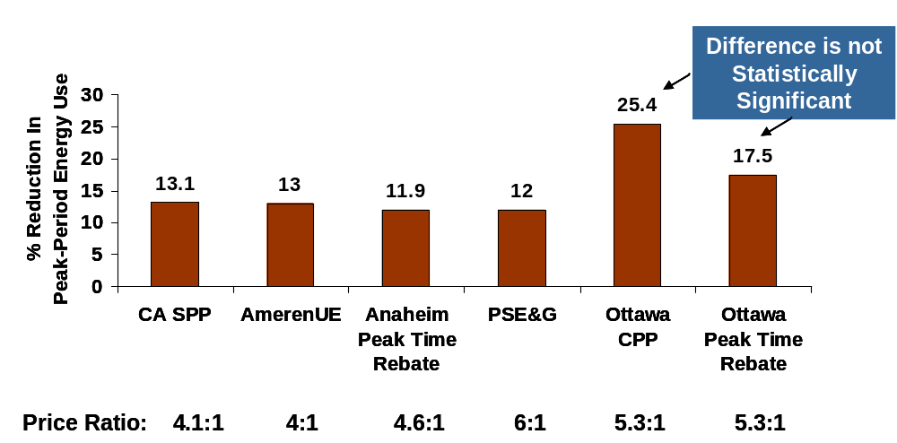
As indicated from these numerous pricing experiments, the reduction in peak period energy use is similar across a variety of dynamic rate options. This research indicates that the average residential customer will reduce energy use on critical days by an amount ranging from 11 to 25 percent in response to prices or incentives that are between four and six times higher than the average price they would have paid under a standard tariff. Importantly, the similarities in the peak-period reduction in the APU pilot and the SPP, as well as the Ottawa pilot comparisons, suggest that customers respond similarly to price increases (e.g., a CPP tariff) as they do to incentives paid for peak-period reductions (e.g., a peak time rebate program).
In addition to the irrefutable evidence summarized above indicating that a sufficient number of residential customers can and will respond to dynamic price signals, there is widespread evidence indicating that customers who volunteer for such rates are highly satisfied with their choice and most would not switch back to a standard tariff. For example, nearly half of all participants in California’s SPP gave a satisfaction rating of 9 or 10 on a 10-point satisfaction scale, and almost 90 percent reported that they felt the time-varying rates were fair. Furthermore, roughly 65 percent of participants remained on the critical peak pricing tariff one year after the end of the SPP even though the participation incentive provided as part of the experiment was discontinued and they had to pay a monthly meter charge of between $3 and $5 depending on the utility serving them. In PSE&G’s pilot, 75 to 80 percent of customers said they were satisfied with the program and 80 percent said they would recommend the program to a friend or relative. In the Ottawa Hydro pilot, 85 percent of customers enrolled in the CPP tariff and 80 percent enrolled in the peak time rebate option said they would recommend the pricing plan to their friends. Overall, roughly 80 percent of customers who were on one of the time-varying pricing plans indicated that they preferred a time-varying rate option to the standard, two-tier rate that they were on prior to being in the experiment.
Even though there is obviously strong evidence that customers like dynamic pricing once they experience it, getting customers to try it is challenging. One might summarize the challenge as, “If you ask customers if they want to go on a time-varying rate, most will say no. If you can find a way to get them on the rate and then ask them if they want to leave, most will say no.”
Detractors of time-varying pricing typically point to the fact that many utilities have offered traditional TOU tariffs for years but sign-up rates have been extremely low, often fractions of a percent of the eligible population. While true, there are exceptions to this general rule, including the fact that Salt River Project has roughly 20 percent of its residential customer base on a voluntary TOU rate and Arizona Public Service has approximately 40 percent of its residential customers on voluntary TOU rates. The low participation in many utility rate offerings is almost exclusively a result of little or no marketing of the tariffs, not a reflection of what could be achieved with focused marketing and customer communications. For example, in its AMI application, PG&E provided evidence that it could achieve acceptance rates for a CPP tariff equal to roughly 35 percent of its target population (residential air conditioning households) through aggressive marketing and first-year bill protection measures.
In spite of these examples, one cannot deny that the marketing challenge is real. Market research indicates that perhaps the primary barrier to customer acceptance of time varying rates, and especially dynamic rates, is the fact that customers are risk averse. Specifically, many customers focus more on the downside risk of higher bills if they were to go on a time-varying rate but did not change their usage pattern than they do on the upside potential of lower bills if they were able to reduce usage during high-priced periods. One approach to addressing this problem is to eliminate the down-side risk associated with “carrot and stick” CPP tariffs by offering a “carrot-only” peak period rebate program such as the one tested in the APU pilot mentioned previously. In its AMI application before the CPUC, SDG&E proposed such a strategy and offered testimony indicating that as many as 70 percent of customers could be made aware of the PTR option and, on average, would reduce peak-period energy use by about 12 percent. In its recent AMI application, Southern California Edison (SCE) also based their demand response benefits on a peak time rebate program, assuming a likely participation rate of 50 percent for residential customers.
To sum up, getting electricity customers to try time-varying rates is a challenge, but one that can be met through creative marketing and rate design. Once they experience these rates, a large number of customers prefer them.

Non-residential Customers
There have been relatively few pricing experiments focused on determining the extent to which small and medium C&I customers respond to time-varying prices. Those that have been done typically show that price responsiveness is less for C&I customers than it is for residential customers. That is, for the same percentage change in price, the percent reduction in peak period energy use will be significantly less for most C&I customer segments than it is for residential customers. Nevertheless, given that these customers have average energy use that is significantly greater than it is for residential customers, the average, absolute reduction in peak demand can be larger, especially for medium C&I customers.
California’s SPP investigated demand response associated with CPP tariffs for C&I customers. A CPP tariff was offered to a sample of C&I customers in Southern California Edison’s service territory with demands below 200 kW. The sample was segmented into two size strata, customers with demands below 20 kW (referred to here as the LT20 segment) and customers with demands between 20 and 200 kW (referred to as the GT20 segment).
With the CPP rate, on most weekdays, a peak-period price was in effect between noon and 6 pm. On critical peak days, a significantly higher peak-period price was in effect for up to five hours, all of which fell within the noon to 6 pm time period. While the tariff allowed the critical peak period to be any length up to 5 hours, during the experiment, the critical peak period was either 2 or 5 hours long. Prices changed over the two summers during which the treatment was tested (2004 and 2005). The average standard price for LT20 customers across the two summers was roughly $0.17/kWh and the average critical peak price was almost $1.00/kWh. For GT20 customers, the standard average price was $0.16/kWh and the critical peak price was roughly $0.60/kWh.
Participants in the SPP were given the option of having a programmable controllable thermostat (PCT) installed in their premises to automatically adjust air conditioning thermostat settings during the peak period on critical days. Even though this enabling technology was offered free of charge, not all customers accepted it. Indeed, only about one third of the LT20 customer segment and less than two-thirds of the GT20 segment took advantage of the offer. The fact that not all customers accepted the technology made it possible for SPP researchers to explore the incremental impact of the enabling technology on demand response.
Figures 2-2 and 2-3 show the relationship between the percent change in peak period energy use and critical peak prices based on the energy demand models estimated from the SPP. Key findings to note include:
- Small C&I customers are completely unresponsive to critical peak prices (even very high peak prices) in the absence of enabling technology;
- Even with enabling technology, the percent reduction in peak-period energy use on critical days for a given price is less for small C&I customers than it is for residential customers;
- Medium C&I customers display a modest degree of price responsiveness in the absence of enabling technology (roughly 5 percent at a critical peak price of $0.59/kWh);
- Price responsiveness roughly doubles for medium C&I customers when enabling technology is present.
Figure 2-2
Percent Reduction in Peak-Period Energy Use on Critical Days
For Small C&I Customers (<20kW) in California’s Statewide Pricing Pilot
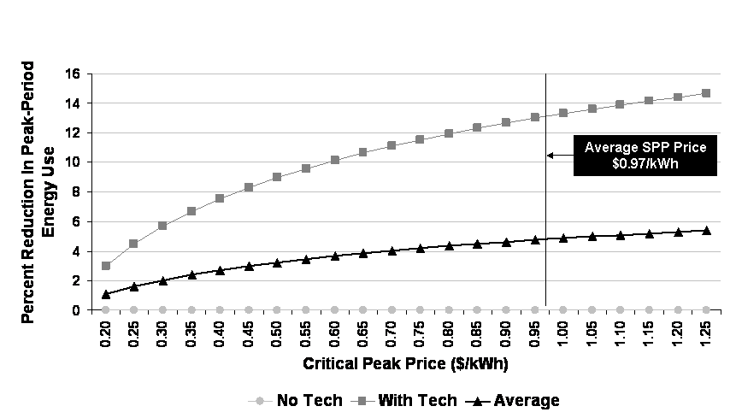

Figure 2-3
Percent Reduction in Peak-Period Energy Use on Critical Days
For Small C&I Customers (<20kW) in California’s Statewide Pricing Pilot

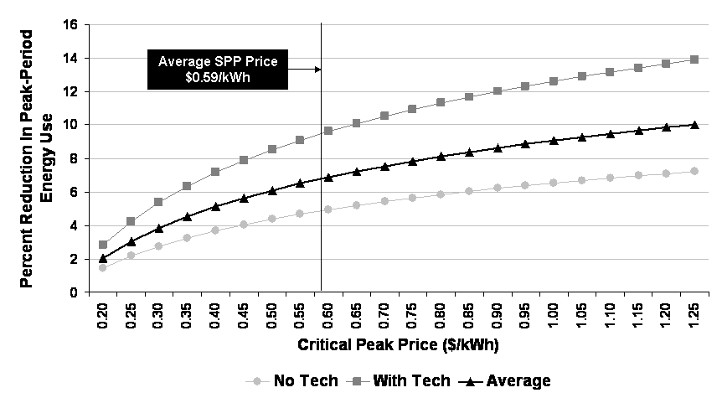

TECHNOLOGY OPTIONS
An AMI system consists of two major subsystems. The first consists of various components, including meters with communication modules, a communication network for transmitting information to a centralized collection point, and the “head-end” system that manages the network, supervises the communication and acquires the data. The second is the meter data management (MDM) system. The MDMS acquires the data from the meter reading system or systems (which could include AMI meters, AMR meters, manually read meters or other systems) and processes the data to meet user needs or forwards the data to other in-house systems, such as the Customer Information System (CIS), billing, outage management, field operations, etc.
This report section contains a general discussion of AMI technology options and some of the factors that influence technology choice. The basic approach to technology selection used in this study is summarized in Section 4 and the detailed cost assumptions underlying the analysis are described in Appendix B

Meter Options
A common misperception associated with AMI is that deploying an AMI system means replacing all existing electromechanical meters with electronic meters. This is not always the case. An AMI system can be implemented by retrofitting electromechanical meters with a module that counts the revolutions of the spinning disk and communicates that information to a collection device that then converts it to usage data. Indeed, the majority of fixed-network AMR/AMI deployments to date have used this approach for most meters on their systems. Moving forward, however, more and more installations are focusing on replacing existing meters with solids state meters. Solid state meters typically have more functionality than can be achieved through retrofitting an electromechanical meter. For example, solid state meters can typically measure lower minimum loads than can electromechanical meters and can also monitor power quality conditions.
Although there are differences in the prices charged by AMI system suppliers for meters, the magnitude of the difference has diminished in the last few years for meters with the same functionality. As a result, meter cost is no longer a significant differentiating factor in AMI system selection.

Data Collection and Communication Options
There are four primary options that have been (or may be) used for collecting the data generated at the meter end-point and communicating it to a centralized MDM system:
- Power line communication (PLC)
- Fixed radio frequency (RF) networks
- Broadband over power line
- Public networks (e.g., landline, cellular, or paging).
As summarized below, each of these options has advantages and disadvantages that vary with respect to the characteristics of a utility’s customer base (e.g., customer density), the configuration of the distribution system (e.g., the number of customers per transformer), geography (e.g., flat versus hilly terrain) and other factors. For utilities that only serve metropolitan areas, a single option may be sufficient for the entire customer base.
For utilities that have a mix of urban and rural customers, a mix of technology options may be optimal.

Power Line Carrier
PLC systems send data through power lines by injecting information into either the current, voltage or a new signal. To accomplish this, PLC systems typically require that equipment, called concentrators, be installed at each substation on a distribution system to collect the meter readings provided by the endpoint, and then the information is transmitted from the substation to a centralized location using either existing utility communications networks or public networks. Each concentrator can support upwards of 30,000 to 40,000 meters per substation, depending on the specific AMI technology, if only monthly kWh meter reads are required. However, if hourly data are needed, the number of meters per substation concentrator is significantly less, in the range of 4,000 to 8,000, depending on the concentrator technology. A substation with near the maximum number of meters per concentrator may only be able to deliver hourly interval data for all meters once every 8 hours. If sub-hourly data are needed, the time it will take to retrieve the data for all metes is even greater. On the other hand, if data are needed on short notice for a single customer (e.g., while the customer is on the phone with a service representative), the data can be retrieved in a few seconds.
Figure 3-1 depicts a typical PLC system configuration.
Figure 3-1
Power Line Carrier Network Configuration
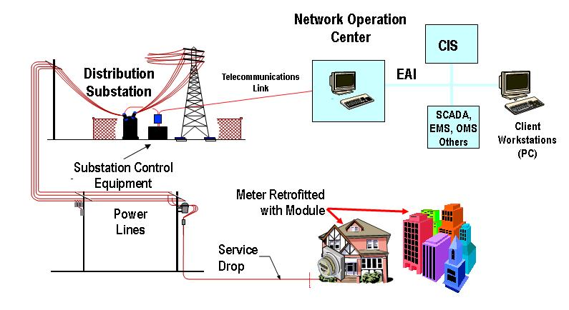
PLC systems are unaffected by terrain. For utilities with a mix of rural and urban areas, PLC provides an option for using a single approach for all customers. PPL currently uses PLC to read all of the company’s electricity meters, for example. The major vendors for power line communications include Cannon Technologies, DCSI and Cellnet-Hunt Technologies.

Radio Frequency Systems
Currently, the primary alternative to PLC systems is fixed network, radio frequency (RF) systems. There are two primary RF configurations that are used for AMI, star and mesh.
With star RF systems, meters communicate using radio signals over a private network directly to a data collector or a repeater. Repeaters may forward information from numerous endpoints to the more sophisticated collectors that store meter readings from meters or repeaters within range. The data collectors then upload the meter readings to the AMI host system at preset times using a variety of communication methods, ranging from public networks to microwave to Ethernet connections. The communications between the data collector and the network controller are usually two-way and allow the network controller to query for a recent meter reading and the status of one or a group of meters. The vast majority of fixed network AMR systems currently in place in the US use this basic RF technology. Star network suppliers include Cellnet+Hunt (UtilNetTM), Hexagram, Sensus and Tantalus.
Figure 3-2 depicts a typical star RF system. With a star system, meters communicate directly with a concentrator that has an antenna mounted typically from 20 to 800 feet in elevation. There is a wide range in the number of meters that are supported for each concentrator, from a few hundred to tens of thousand. The distance between meters and the concentrator can range from several thousand feed to tens of thousands of feet, depending on system characteristics. For example, some star networks use high powered radios in the meters to increase communication ranges up to 10 miles in flat areas. However, in hilly and mountainous terrain, such as in many places in Vermont, the effective range of these long range systems may be similar to those of lower power, short range systems.
Figure 3-2
Radio Frequency Star Network Configuration
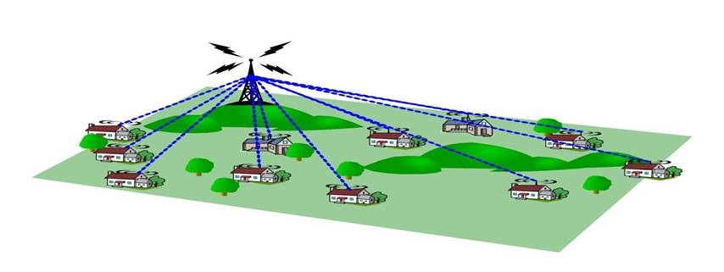
Figure 3-3 shows the impact of concentrator range and terrain on a star system. As seen, the cost associated with a star system will be affected by the fact that some meters are too far from the concentrator to be included in the system (without adding a second concentrator) while other meters may be within range but blocked by hills.
Figure 3-3
The Impact of Terrain and Density on Star Networks
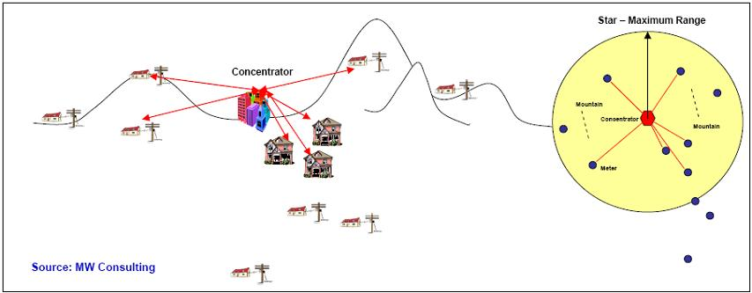
Other RF networks, called mesh networks, have been developed in recent years in which the meters themselves form part of the network. With mesh network systems, meters can communicate with “neighbor” meters and some meters act as data collectors. These systems may offer better coverage and more robust communications than star RF systems. They are more tolerant of terrain variation as the communication hops are relatively short range. One desirable feature of these advanced systems is that they can “self heal.” That is, if the endpoints have more than one communication path to the main hub of the system, and the best path is no longer available, endpoints can change their communication path. This allows the system to maintain a high degree of reliability as new buildings are constructed or when trees or other shrubbery grow that might block communications with a more traditional RF system. Major vendors of mesh RF systems include Cellnet-Hunt (StatSignalTM) , Elster, Itron, Silver Spring Networks and Trilliant.
Figure 3-4 shows the typical configuration for a mesh network system and Figure 3-5 shows how mesh networks can navigate the hilly terrain that is often found in Vermont.
Figure 3-4
Radio Frequency Mesh Network
Configuration
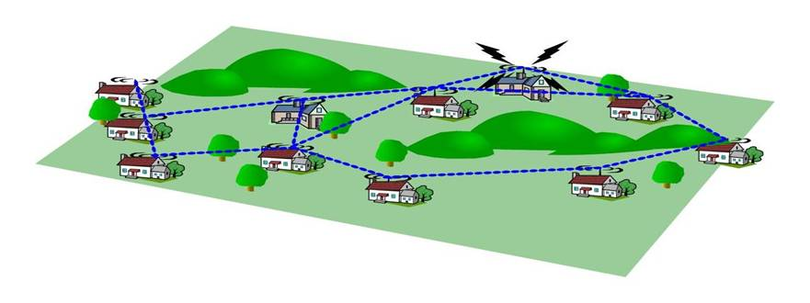
Figure 3-5
The Impact of Terrain and Density on Star Networks
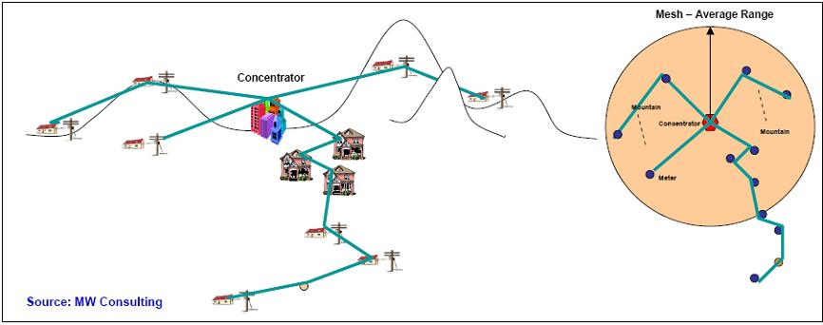

Broadband Over Powerline
An emerging AMI technology is broadband over power line (BPL). BPL works by modulating high-frequency radio waves with the digital signals from the Internet. These high frequency radio waves are fed into the utility grid at specific points, often at substations. They travel along medium voltage circuits and pass through or around utility transformers to subscribers’ homes and businesses. Due to the tendency of transformers to filter out the high-frequency BPL signal, steps must be taken to address this problem, which might include making modifications to push the signal through the transformer, bypassing the transformer or sending the signal to the home or business using a Wi-Fi device located near the distribution transformer. In Europe, where there are typically 100 or more customers served by a transformer, these steps may not be cost prohibitive. In the US, where one transformer typically services six to ten customers, the cost of addressing this problem can be quite high. This is even more true in Vermont, where as many as half of the transformers for some utilities have only one meter attached. Consequently, we did not do a detailed analysis of BPL in this study, as it was clear that this technology would not be cost effective in Vermont. Major vendors of BPL include Ambient, Amperion, Current Technologies, Main.net, and PowerComm Systems.

Public Networks
The final AMI option is to use public networks such as paging, satellite, internet and/or cellular or landline telephone systems to provide communications between meters and utilities. Obviously, the primary advantage of using public networks is avoiding the upfront cost and time required to build a dedicated network. As long as there is coverage at a location, installation costs are limited to installing the new endpoint and setting up the service. In low density applications, this approach can be cost effective. In fact, utilities that have deployed RF systems quite often use public networks for the small percent of customers that are difficult or too costly to reach using RF technology.
Key limitations of public network applications are that even these systems can have coverage issues, they can cost more per meter than other AMI systems, communication protocols can change (this is especially true in the cellular segment) and operational costs can be high. Public network systems have been used for large customers for years and for some small rollouts of AMI. Recently, Hydro One in Ontario, Canada announced that it had selected Rogers Wireless Inc./Smart Synch to provide 25,000 “smart meters” as part of a pilot program. The Smart Synch system relies on a selection of various public networks for communications.
A California utility with 40,000 meters has announced plans to be the first deploy a WiFi based AMI network. The utility cited several benefits of using public networks like WiFi but did not address the issues of security risk from hackers accessing the AMI system or the possibility that the underlying WiFi network might be changed out over the next 20 years as new WiFI technologies emerge or other issues. When AMI systems only read meters and used one-way communication, security was less important than today with the potential inclusion of disconnect switches, programmable communicating thermostats and even interfaces to the DA and SCADA systems. This mixing of uses raises many security and privacy considerations.
Another utility is said to be embarking on a project to deploy a completely cellular based AMI system for all of its customers. To date the economics and third party risks of such systems have limited their use to large C&I customers. Insufficient public domain information exists on this project at this time to comment in greater detail on the potential breakthroughs of long term viability of mass deployments using cellular technologies.

Meter Data Management System
As is true with AMI systems, there is no common definition or widespread agreement regarding the typical functionality of a meter data management system. At a minimum, an MDMS collects, cleans and stores data obtained from an AMI system. For an AMI system that produces hourly data, the amount of data that must be stored annually is roughly 730 times greater than for a utility that stores monthly kWh usage data. If half-hourly data are produced, the amount of data is almost 1,500 times greater than for monthly meter reads. The validation, editing and estimation (VEE) procedures required to convert raw interval data into billing quality data are also much more complex than for monthly meter reads. If time-based pricing is being implemented in conjunction with an AMI system, the MDMS may also convert the interval data into the requisite billing determinants needed to produce customer bills, such as usage by rate period.
In order to capture the full potential benefits of an AMI system, an MDMS must be integrated with many other utility business applications, including the customer information system, outage management system, mobile workforce management, geographic information system, transformer load management and others. If remote connect/disconnect functionality is included in the AMI specification, the MDMS must be configured to manage that application. If multiple AMI technologies are used to produce the least cost network, the MDMS must be able communicate with each meter and communication system type. In short, an MDMS can be a relatively simple, data storage and quality assurance tool or a fully integrated, key component a utility’s business enterprise system.
If a utility is implementing an AMI system primarily to reduce meter reading costs (e.g., using an AMI system strictly as AMR), it may not be necessary to simultaneously install an MDMS system. Vendors typically offer very simplistic MDM capabilities as part of the standard AMI offering, which would be sufficient to generate monthly bills. For example, for a number of years, PPL did not have a fully functioning MDMS system—the PPL system obtained hourly data on all customers but the data was simply discarded once the monthly usage data needed for billing was determined. However, PPL eventually determined that substantial benefits were being lost due to the absence of a more robust MDMS system and installed Nexus Energy Software’s MDMS system.
The major issue to be resolved in the next few years is the scope of an MDMS. While MDMS vendors have aggressively added functionality to their offerings, much of this added functionality is already available from suppliers of other systems such as CIS, OMS and related items. The suppliers of these other systems are now adding MDMS aspects to their core offerings. The future scope of MDM systems remains fluid at this time but the core requirement of interfacing to various AMI or other data systems and processing data into billing determinants will likely remain.

BENEFIT COST ANALYSIS METHODOLOGY AND INPUTS
This section contains a summary of the methodology, input values and assumptions that were used to estimate the benefits and costs associated with AMI and time-based pricing in Vermont. Detailed documentation of the key assumptions and input values is contained in Appendices A through H.

Conceptual Overview of AMI Benefit-Cost Analysis
Figure 4-1 provides a conceptual overview of the benefit-cost methodology that underlies the results presented in Sections 5 and 6.
Figure 4-1
Benefit-Cost Framework
The analysis involves two parallel paths, one focused on the AMI investment and the other on time-based pricing.
The AMI investment analysis involves estimating the net present value of costs over the life of the investment for a variety of technology options and choosing the option that meets the functional specification and other factors that influence investment choice (e.g., risk mitigation) at the least cost. The next step involves estimating the net present value of the operational savings, in the form of avoided meter reading costs, reduced outage costs and other factors that will result from AMI deployment. The difference between the operational benefits and costs is referred to as the operational net benefits. If this number is positive, it means that the operational savings will offset the cost of the investment even without any additional benefits that may be achieved through the implementation of time-based pricing. As seen in Section 6, this is true for several of the utilities in Vermont. This is not surprising given the rural nature of the population in many areas, which typically results in above average meter reading costs.
The second key component of the analysis examines the net benefits associated with time-based pricing enabled by AMI. The primary benefits involve lower capacity costs (generation, transmission and distribution) resulting from reduced demand at times of system peak. Time-based pricing can also result in lower energy costs, due either to an overall reduction in energy use (if lower usage during peak periods is not completely offset by higher usage during off-peak periods) or to a shift from high cost to low cost periods. Partially offsetting these demand response benefits is the cost of marketing the rates or other demand response programs that generate the benefit streams. We have also included the costs associated with a MDMS on this side of the ledger, since meter data management is essential to time-based pricing but some operational benefits associated with AMI can be achieved without a significant investment in MDMS functionality. A case could be made, however, that these costs should be counted as part of the operational business case. The difference between the demand-response benefits and costs is referred to as the DR net benefits.
The difference between the operational net benefits and the demand response net benefits is an estimate of the overall gain to Vermont’s electricity consumers from a combination of AMI deployment and implementation of time-based pricing.
Benefit estimates were also developed for two additional value streams that could result from implementation of AMI and time-based pricing. One value stream derives from the reduction in outage duration that can be obtained using AMI. The associated reduction in outage management costs is included as part of the operational benefit stream. However, shorter outage duration also provides benefits to consumers, as outages impose costs on consumers (e.g., in the form of lost production for businesses). Still another benefit stream associated with time-based pricing is the potential reduction in environmental pollution that would arise if energy use falls or if off-peak generation is more environmentally friendly than peak-period generation.
Using the above framework, net benefit estimates were developed for the five largest utilities in the state in terms of number of customers: CVPS, GMP, VEC, BED and WEC. VEC is already in the process of installing an AMI system. As such, estimates were only developed for the net demand response benefits for VEC, not the operational net benefits. The number of customers for each of the remaining 15 utilities ranges from a low of 319 to a high of 5,451. An examination of the data provided by these utilities indicates that, for 10 of the 15, it would be difficult to reduce operational costs by implementing AMI. In some cases, meter reading is only one of many responsibilities shared by meter readers so the employee position would not be eliminated if AMI is deployed. In other cases, electricity meter readers also read water meters. As a result, it would not be possible to eliminate the meter reading position unless new water meters that could be remotely read were also deployed. An analysis of the net benefits of implementing remote meter reading for water meters was beyond the scope of this study. However, installing advanced water meters would likely double the cost per customer for meter installation. As such, it is unlikely that the cost savings would be sufficient to produce a positive operational business case, although the electricity demand response benefits might still be large enough to offset the operational gap. Further exploration of this possibility may be warranted.
The five small utilities for which net benefit estimates were developed jointly were Hardwick, Lyndonville, Stowe, Morrisville and Ludlow. Combined, these utilities serve almost 21,000 customers. Stowe was included in this group even though the utility reads both water meters and electricity meters because the city employs two meter readers. As such, we assumed that one meter reader could be eliminated if AMI was implemented for electricity meters only. Net benefits were estimated for this group of five small utilities jointly, not individually.
In total, the 10 utilities that were included in the analysis account for 96 percent of all of the electricity customers in Vermont and 93 percent of the load. The percent of load covered by the analysis is smaller than the percent of customers because Vermont Marble is not included among the 10 utilities for which the analysis was completed. Vermont Marble has only 872 customers but these customers use roughly 217,000 MWhs, or roughly 3.8 percent of Vermont’s total annual energy use. AMI is not required to obtain potential demand response benefits from the small number of very large customers served by Vermont Marble, as the customer’s meters could be read cost-effectively using telephone lines.

Technology Selection and Cost Analysis
AMI is a long term capital investment that generates costs and delivers benefits over an extended time period. Figure 4-2 shows the five cost categories that are included in this analysis:
- The hardware and installation costs to replace all existing meters with advanced meters;
- The hardware and installation costs for the advanced meter communication network;
- The incremental cost for meter replacement and installation of new meters to support customer growth in future years, over and above what those costs would have been under current meter standards and policies;
- Annual network operating costs; and
- Network maintenance costs.
Key assumptions underlying the analysis are summarized below. A more detailed discussion of the assumptions and input values is contained in Appendix B.
Figure 4-2
AMI Cost Components
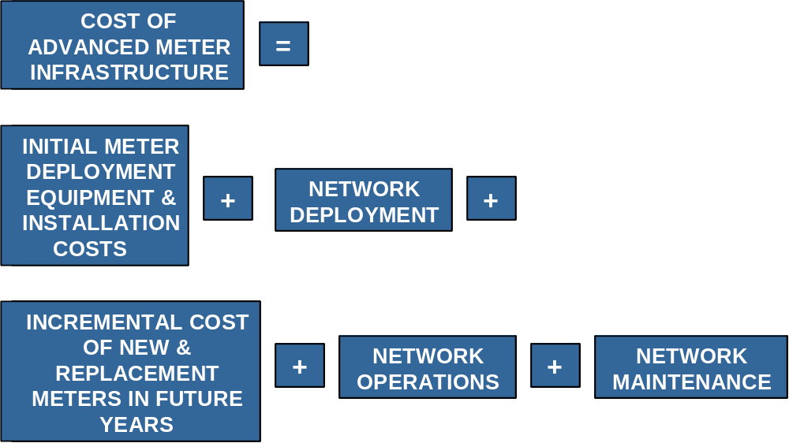

Initial Meter Hardware and Installation Costs
Although network costs can differ significantly with technology selection (e.g., star, mesh, PLC, etc.), today, there is little difference in the cost of meters that communicate with these different network options. The analysis assumed that the cost of meters and meter installation is the same regardless of network technology. Other key assumptions include:
- The average cost for a single phase meter is $85 and the average cost for all other meters is $300.
- The above prices can be achieved by all utilities, regardless of size. This may not be the case unless most of the smaller utilities in the state coordinate their meter purchases and/or coordinate with the larger utilities to achieve the scale needed to secure reasonably favorable pricing from vendors.
- Average installation costs equal $20 for single phase meters and $75 for other meters. These values assume that meter installation is outsourced and completed in an efficient manner over a relatively short time period. If meters are installed by utility personnel over an extended time period, costs could be higher.
- Meter installation would begin in May 2009 and be completed within two years for CVPS and GMP and within 1 year for each of the other utilities. Some have suggested that this schedule is optimistic, both in terms of start date and duration.
- Estimates of the number of meters that are replaced for each utility were based on data provided by the utilities. In some cases, the number of meters may be substantially greater than the number of customers. This is especially true for CVPS, which has a large off-peak water heating program for which water heaters are separately metered.
- The incremental cost for incorporating remote connect/disconnect functionality into AMI meters is assumed to equal $50. This functionality was only assessed for BED, where customer churn is high due to the large presence of college students in BED’s service territory.
The costs and benefits associated with adding Home Area Network (HAN) functionality to the metering system were not examined. Including a meter module that supports a home area network would add roughly $20 to the average meter cost in large volumes (several hundred thousand meters). However, in order to produce additional benefits from this functionality, it would be necessary to add “beyond-the-meter” technology in the form of in-home displays (IHDs), control devices for end-use equipment, and/or interface devices with personal computers. Determining the costs and benefits associated with this additional functionality under various assumptions about take-up rates and impacts is beyond the scope of this study. This is an area worthy of further examination, however, as it has the potential to produce both demand response and energy efficiency benefits.
The stranded cost associated with the existing meter stock has not been counted as a cost for the AMI investment analysis. These are sunk costs that should not affect the policy decision regarding whether investment in AMI is cost-effective. Having said that, strict adherence to a “used and useful” regulatory doctrine could result in disallowance of the un-depreciated value of the existing meter stock in future rate cases, a regulatory risk that is a potential barrier to a utility’s decision to move forward with AMI. It should also be noted that Section 1307 of the very recently passed Energy Independence and Security Act of 2007 amends PURPA and directs each state to consider authorizing electric utilities to recover the cost of AMI systems through the rate base and to continue recovering the remaining book-value costs of any equipment rendered obsolete by the deployment of smart grid systems.
Concern about possible disallowances could also influence technology choice. A common misperception associated with AMI is that deploying an AMI system means replacing all existing electromechanical meters with solid state meters. This is not the case. An AMI system can be developed by retrofitting electromechanical meters with a module that counts the revolutions of the spinning disk and communicates that information to a collection device that then converts it to usage data. Indeed, the majority of fixed-network AMR/AMI deployments to date have used this approach for most meters on their systems. One advantage of the retrofit approach is that, since the existing meters remain in place (but are modified by installing a counting and communication device “under the glass”), the current meter stock remains used and useful and, therefore, the stranded cost issue is no longer pertinent. On the other hand, this approach may be suboptimal in that electronic meters may generate more benefits than can be obtained with retrofit options. Regulatory assurance that stranded costs will not be disallowed would not only eliminate this potential barrier to implementation but would keep open for consideration the full range of technology options.

Network Equipment and Installation Costs
As outlined in Section 3, RF and power line are the two primary forms of dedicated communication networks that are used to support advanced meter deployment, with public communication networks sometimes used for remote meter reading for large customers or for hard-to-reach regions within a utility’s service territory. For a given system functionality, a key driver of technology choice is meter density, measured in terms of meters per square mile for RF systems, meters per substation for PLC systems and meters per transformer for BPL. Another key driver is terrain, since hilly and mountainous terrain can be quite limiting for RF systems. Both density (and lack thereof) and terrain are potentially limiting factors in Vermont. Determining the best technology choice for each utility in Vermont would require a detailed propagation study, which would map the location of each meter relative to other meters and potential locations for network concentrators. Conducting a detailed propagation study was beyond the scope of this project. However, as described in Appendix B, we were able to consider the impact of density to some degree based on higher level data that was readily available.
As indicated in Section 3, broadband over power line technology is a “non-starter” in Vermont due to the very low ratio of meters to transformers. Similarly, long range star radio technology is almost certainly not cost-effective in Vermont due to the relatively rural nature of the population combined with the mountainous terrain, which significantly diminishes the effective range of these systems. Appendix B contains a “back of the envelope” calculation of the costs of long-range star technology illustrating that it is dominated by other technologies in Vermont.
Of the remaining three technology options, a short-range star network was considered in BED’s service territory only, which is compact and flat enough to allow for reasonable assumptions to be made in the absence of a propagation study. The relative cost of mesh and PLC were examined in all other service areas. With more detailed mapping of meter density and terrain, it is possible that some combination of star, mesh and/or PLC networks would be the least cost option for one or more utilities.
Key assumptions and input data used in developing network cost estimates include:
- All networks must be capable of delivering hourly data daily for all customers;
- Two-way communication;
- Information on the number of meters per substation obtained from each utility was used to estimate the number of concentrators and the cost per concentrator for PLC systems;
- The installed cost for a PLC concentrator with the capacity to deliver interval data daily for up to 8,000 customers was estimated to equal $35,000 and the installed cost for a concentrator that can deliver data for up to 4,000 customers is estimated to equal $25,000;
- Estimates of the number of concentrators required for a mesh network system were based on one of two limiting factors, geographic coverage (maximum reach of 25 miles per concentrator) or maximum capacity per concentrator (3,000 meters for interval data). Geographic coverage was the limiting factor in all cases except in BED’s 16 square-mile service territory, where the number of meters was the limiting factor. The number of mesh concentrators required ranged from a low of 7 for BED to a high of 125 for CVPS;
- The installed cost for a mesh concentrator was assumed to equal $1,000;
- Estimates of the number of repeaters required to bridge gaps between clusters of meters that are too far apart to communicate with each other in a mesh network was based in part on estimates of the percent of a utility’s customers that are located in the more densely populated village centers within each town. The percent of customers in the more densely populated town centers was estimated to be 100 percent for BED, 49 percent for WEC, 43 percent for GMP, 26 percent for CVPS and 16 percent for the small utility group;
- It was assumed that one repeater would be required for every 15 meters outside the town centers for CVPS, GMP, BED and the small utility group, and one repeater was needed for every 5 meters for WEC, where customer density is 5 to 7 times lower than for the other utilities. These estimates may be conservative but it is difficult to know in the absence of a much more detailed propagation study. The assumed cost for each repeater is $300. The number of repeaters estimated to be needed to ensure coverage outside town centers ranges from 0 for BED (where all customers are assumed to be in the densely populated town center area) to more than 7,700 for CVPS;
- The estimated installed cost for a short-range star network concentrator is $2,000;
- Network costs are phased in based on the meter deployment schedule lagged two months.

Incremental Meter Costs in Future Years
Following initial meter deployment, costs will be incurred in future years to replace defective meters and to support customer growth. Meter hardware costs for these meters will be higher than during the deployment period because they will be purchased in small quantities. This is true of both AMI meters and standard meters. The relevant value for analysis purposes is the incremental cost of an AMI meter over and above what the cost of a standard meter would have been in the same year. Key assumptions for this portion of the cost analysis include:
- The cost for both single and polyphase AMI meters beyond the initial deployment period is 150 percent of the cost during the deployment phase;
- The cost of standard replacement meters (both electromechanical and electronic) in small lots is assumed to equal roughly $35 for a single phase meter and $150 for a polyphase meter. Thus, the incremental cost of an AMI replacement/new meter compared with a standard meter is $92.50 for single phase meters [($85)(1.5) - $35] and $300 for a polyphase meter [($300)(1.5) - $150];
- Installation costs for new and replacement meters beyond the initial deployment period do not factor into the analysis, based on the assumption that the installation costs are the same regardless of whether an AMI or a standard meter are installed in future years and that the replacement rate is the same for both meter types.;
- The annual replacement rate is equal to 1 percent for both AMI and standard meters;
- The effective useful life of a meter is 20 years.
Another factor that must be incorporated into the cost analysis is that AMI meters typically come with a warranty. During the warranty period, no incremental meter costs would be incurred under the AMI scenario for replacement meters, whereas costs would be incurred for meter replacement during the same period for standard meters. For this analysis, a 2 year warranty period for new AMI meters was assumed.
All of the meter cost estimates described above were adjusted for inflation using a general inflation rate equal to 2.5%.
It is important to note that, while the analysis includes the costs associated with all future meter installations, the benefit stream associated with these meters ends 20 years after the initial meters are installed (in 2031 for CVPS and GMP and in 2030 for the other utilities). Thus, the full cost of a new meter that is installed to support customer growth in, say, 2021, is included on the cost side of the analysis but only 10 years of benefits are counted on the benefit side of the ledger. As such, the present value of costs is probably overestimated relative to the present value of benefits. Given the slow customer growth rate in Vermont, this bias is probably small, however, relative to what it would be if customer growth were higher.

Network Operation Costs
The primary network operation costs derive from the communication link between the data concentrators and the centralized meter data repository. We have assumed a cost of $100 per concentrator per month. Given the large number of mesh concentrators relative to PLC concentrators, communication costs are much higher for mesh systems than for PLC systems.

Network Maintenance
Network maintenance costs are based on a replacement rate of 5 percent per year for concentrators and 1 percent per year for repeaters and an installed cost equal to 150 percent of the deployment-period costs for these items.

Financial Calculations
The most relevant cost estimate against which benefits are compared is the present value of revenue requirements (PVRR). When business cases are developed for an individual utility, the PVRR is typically calculated using discounted cash flow (DCF) analysis and the utility’s revenue requirements model. This detailed analysis was beyond the scope of this study.
Among the most important factors to consider when calculating the PVRR are the weighted average cost of capital and the potential requirement to pay corporate taxes on capital costs. We have assumed that taxes are only paid by investor owned utilities, not municipalities. Tax payments are a function of the assumed depreciation schedule as well as the debt-equity ratio. For purposes of this report, we relied on a model provided by CVPS to calculate a tax adjustment factor that was used to mark up capital investments for purposes of the PVRR calculation. With a debt-equity ratio approximately equal to 55/45 and a 20-year tax depreciation schedule for capital investments, CVPS and GMP require an additional 32.9% in revenue over and above the estimated purchase prices of capital equipment (e.g., meters, concentrators, repeaters, etc.) in order to cover both the equipment costs and corporate taxes. For the base case, we assumed a 20 year depreciation schedule for CVPS and GMP.
The discount rate used to calculate present value is the weighted average cost of capital (WACC) provided by each of the utilities in response to the data request. The values for each utility are contained in Appendix G.

Operational Benefits
There is a wide variety of operational benefits that potentially can be obtained with the implementation of AMI. Utility-specific business cases often quantify dozens of operational benefit streams through lengthy, detailed analysis of existing business operations. Many business cases include benefits such as reduction in energy theft and improved meter accuracy that are primarily income transfers rather than true economic benefits to society. Important benefit streams include:
- Avoided meter reading costs: This cost category should cover both regular and off-cycle read costs. It should also include not only direct labor costs, but also the cost of employee benefits and overheads for meter readers and supervisors; the reduction in post-employment benefits, such as pension contributions and ongoing health costs after retirement; vehicles and materials, including hand-held reading devices (plus replacement of same); and any reduction in insurance or claims associated with safety and premise damages from meter reading activity.
- Reduced billing costs: AMI significantly reduces or completely eliminates meter reading errors and estimated bills, thus reducing exception processing and rebilling costs. AMI can lead to cash flow improvements by eliminating delayed associated with summary billing for multi-location accounts. For some utilities, costs associated with manual billing processes for TOU accounts can also be reduced or eliminated.
- Reduced call center costs: The elimination of estimated bills and inaccurate meter reads can also reduce call center costs. The number of calls can be reduced in at least four areas: high bill inquiries due to inaccurate meter reads; bill inquiries associated with estimated bills; delayed bills due to unavailability of meter reads; and complaints about meter readers.
- Reduced outage management costs: AMI systems with two-way communications can be used to “ping” a meter when a customer calls regarding an outage to determine whether or not the outage is on the customer’s side of the meter, thus avoiding the dispatch of field crews if it is. Outage detection can also help reduce outage duration and restoration costs during wide scale outages by detecting whether or not power has been successfully restored everywhere while crews are still in the field, thus avoiding crew re-dispatch.
- T&D Planning: Having detailed load data on all end-use customers can be quite valuable in optimally sizing transformers and determining the potential benefits of other T&D capital investments.
- Remote connect/disconnect: Incorporating remote connect/disconnect functionality in AMI meters will significantly reduce the need to dispatch field crews to disconnect and reconnect the power when customers move or as a means of managing collections.
- Reduced read-to-bank time: Some utilities have used AMI/AMR systems to reduce the average time it takes from reading a meter to issuing a bill from three to five days down to one to two days.
The analysis presented here was based primarily on information provided by the utilities through the data request that was initiated at the outset of the project (see Appendix H). In many cases, the details needed to develop estimates for certain benefit streams is not collected by a utility and, therefore, could not be provided. For example, most utilities in Vermont do not gather information on the number of calls by call type, making it very difficult to estimate reductions in call center costs associated with fewer estimated bills or complaints about meter readers. Hardly anyone was able to provide information on the cost of billing exceptions or manual billing operations.
Where appropriate, cost estimates were based on publicly available information or on information provided by other utilities in Vermont, with judgmental adjustments made for potential differences in operations in some cases. However, much of the publicly available data from other business cases comes from much larger utilities and may not be applicable to Vermont’s utilities. When in doubt, we have been conservative in our assumptions, often not counting savings that might be achievable and quantifiable through more detailed, utility-specific business case analysis. As such, we believe that the operational savings estimated here probably undercount what is obtainable in many instances, perhaps significantly so in some cases. The detailed input data and assumptions associated with the operational savings estimates are documented in Appendix C. Among the key inputs and assumptions underlying the operational benefit estimates are:
- Average meter reading costs vary significantly across utilities, from a low of $0.38 per read for BED to a high of $1.46 per read for CVPS. GMP’s average cost per read is in the middle, at $0.95 per read, but the meter reading budget per customer is much lower for GMP than for the other utilities because the company only reads meters every other month.
- Savings associated with reductions in customer calls are assumed to equal 10 percent of the proportion of the call center budget associated with non-storm related calls for CVPS, GMP and WEC. It was assumed that BED would not be able to obtain any savings from reduced call volume based on discussions indicating that the utility has a very high meter read completion rate and, therefore, a low number of customer calls stemming from inaccurate reads or estimated bills. Savings for the small utility group were also assumed to be 0 based on the understanding that they do not have formal call centers and customer calls are answered by individuals who have many other job responsibilities and, therefore, labor costs could not be eliminated even if call volume was to fall.
- Costs associated with “no light” calls that could be eliminated using AMI were based on data from CVPS on the number of outage call field trips that are the result of a problem on the customer’s side of the meter and data from GMP and CVPS on the cost of an outage call field trip. Estimates were developed for the four largest utilities in proportion to the number of customers and judgment regarding which of the two trip cost estimates ($150 per trip for GMP and $275 per trip for CVPS) is most relevant to BED and WEC based on population density (e.g., the lower estimate was used for BED and the higher estimate for WEC). The resulting estimates of “no light” costs in the base year equaled $96,000 for CVPS, $31,000 for GMP, $6,500 for BED and $7,200 for WEC.
- Estimates of the reduction in storm restoration costs were based on the experience of PPL, which estimates that it has managed to reduce its storm restoration budget by 10 percent since installing AMI. Storm and non-storm related budget data was provided by GMP and WEC, and total field operation budget was provided by CVPS. The storm budget for CVPS was estimated based on the ratio of storm and non-storm related budgets from GMP and WEC. BED did not provide field operations data and discussions with BED indicated that their cost savings would be minimal due to the fact that much of their distribution wires are underground plus the fact that BED has less foliage per line-mile than other utilities. As such, the operational savings for BED do not include any cost reductions for storm related outages.
- Savings estimates associated with remote connect/disconnect capability were developed for BED only, where customer churn generates thousands of field crew trips each year in the Department’s service territory. The estimates were based on data provided by BED concerning employee costs associated with this activity at the BED.

Demand Response Benefit Analysis
Demand response benefits emanate from the change in energy use by time of day induced by time-based pricing. The change in energy use by time period is valued at the marginal cost of capacity and energy by rate period over the forecast horizon. The stylistic equations below summarize at a very high level the basic approach to DR benefit estimation:
(1) MW Impact = (Average use per customer during peak period on the current rate) x
(% Drop in peak period use per customer given a change in price) x
(Number of customers in the target population) x
(Customer participation rate)
(2) Total Benefits = [(MW Impact) x (Avoided Capacity Cost)] +
[(MWh Impact by Rate Period) x (Avoided Energy Cost by Rate Period)]
A variety of input data are required to estimate DR benefits, including:
- Estimates of the number of customers by market segment by year;
- Average energy use by rate period and customer segment prior to the DR program going into effect;
- Explicit or implicit (in the case of a PTR program) prices before and after the DR program goes into effect, by rate period;
- Estimates of the price elasticity of demand, cross-price elasticity of demand, or elasticity of substitution by rate period, tariff type and customer segment;
- Assumptions about the number of customers by segment that will select a DR option (or be aware of the option in the case of peak time rebates);
- The marginal cost of generation, transmission and distribution capacity by year;
- The marginal cost of energy by rate period and year;
- Line loss estimates, reserve margins, discount rates, inflation rates and other miscellaneous inputs.
Appendix D provides detailed documentation of the methodology, data and input assumptions underlying the demand response benefit analysis. A brief summary is provided below.

Number of Customers
Information on the number of residential, commercial and industrial customers was provided by DPS based on the annual reports of each utility. Information on the number of customers by tariff was provided by the utilities in response to the data request. Essentially all residential customers for the 10 utilities covered by this analysis were included, even those that are currently on time-based rates. Energy use for customers that are on off-peak water heating rates was not included in the analysis.
As discussed in Section 2, evidence from California’s Statewide Pricing Pilot indicates that small commercial customers do not respond to time-based prices unless enabling technology is present to aid response. As such, estimates of the number of small commercial customers who were unlikely to provide demand response benefits were developed. A discussion of the process for developing these estimates is contained in Appendix D. In addition, customers with demand greater than 200 kW were excluded on the grounds that many of these customers already have interval meters. Even if they don’t have interval meters, the small number of large customers in Vermont could be cost-effectively served through non-AMI based meter reading systems. As a result, any demand response benefits for this customer segment should not be counted when assessing whether or not AMI should be deployed.
The number of customers included and excluded for each utility is shown in Table D-1 in Appendix D. In total, for the 10 utilities that were included in the analysis, roughly 30 percent of commercial and industrial customers were included in the analysis with the remainder excluded either because they were too small or too large.
Forecasts of customer growth were based on estimates of state population change (2000-2030) developed by the U.S. Census Bureau. For Vermont, population was projected to grow from 608,827 in 2000 to 711,867. This amounts to an average annual growth rate of 0.52 percent. The annual growth rate was applied to residential and commercial customers for all utilities except BED, which provided its own customer specific forecasts. For BED, residential and commercial customers were projected to grow at an average annual rate of 0.39 and 0.19 percent, respectively.

Average Energy Use by Rate Period
In order to forecast the change in energy use and demand, it is necessary to start with estimates of energy use by time period in each year in the absence of demand response. Specifically, for the analysis presented here, the most important driver of demand response benefits is average energy use per hour during the peak period on high demand days.
Estimates of average annual energy use per customer for each utility were derived from response to the data request and data obtained from Efficiency Vermont. The hourly load shape data that was available in time to use for this analysis was provided by BED, who recently conducted a detailed load research study. The share of annual energy use in each hour based on the BED load shapes was applied to annual energy use for each utility by customer segment to develop estimates of energy use by rate period. For the PTR impact analysis, estimates of energy use between noon and 6 pm on the top 20 system load days was used to represent average demand for a typical day on which a PTR event is likely to be called. This average is likely to understate demand at the time of system peak. Indeed, as indicated in Appendix D, Section D.2, demand at the hour of system peak is likely to be between 15 and 25 percent higher than this average value. Put another way, if the system peak hour was used to value demand response benefits, the benefit would be 15 to 25 percent higher than the estimates provided here.
Due to the significant investment in energy efficiency in Vermont, average annual energy use is forecasted to decline over the next 20 years and peak demand growth is expected to grow very modestly in spite of an anticipated increase in air conditioning saturation. Statewide forecasts of the change in energy use per customer were applied to each utility except BED, which had it’s own forecast of energy use. The annual decline in average annual energy use per customer is estimated to equal -0.21% and the annual growth in peak demand is estimated to equal 0.03% per customer. The same growth/decline values were used for the residential and commercial sectors because the DPS forecast did not distinguish the two sectors.

Prices by Rate Period
Demand response is driven by the change in prices by rate period before and after a customer goes onto a time varying rate or participates in a PTR program. Before going on such a rate, prices for most customers are the same in each rate period and are equal to the current average price. After going onto a time-varying rate or participating in a PTR program, the implicit or explicit price in each time period varies and differs from the current price. It is this difference that drives the change in energy use. If prices are higher, as they are during critical peak periods for a critical peak tariff, or a customer is paid an incentive to reduce demand, as is the case with a PTR program, customers will reduce energy use either by curtailing energy use or shifting it to another time period. If prices are lower, customers may increase energy use in that time period.
The demand models used to estimate impacts are based on the average price by time period. Initial, average prices were estimated for each customer segment based on the tariffs in effect for each utility and average energy use data. Where demand charges apply, these charges were factored into the average price. Fixed monthly charges, on the other hand, were excluded. A detailed explanation of the assumptions that were made for each utility and tariff segment is contained in Appendix D.
If a critical peak price or traditional time of use price is being evaluated, it is typical that a revenue neutral set of prices would be developed that would produce the same bill for the average customer if they did not shift load. This approach was used to develop the prices and price impacts that are discussed in Section 7. For the base case analysis underlying the results in Sections 5 and 6, a peak time rebate is used.
Under the PTR program, the incentive payment for each customer segment underlying the analysis equals $0.75/kWh. Conceptually, this is based on the idea that utilities should be willing to pay up to the avoided cost of capacity to reduce usage during times when capacity costs are incurred. The $0.75/kWh value is significantly less than the full avoided capacity cost, as explained in Appendix E. If the rebate reflected the full avoided capacity cost, DR benefits would be higher.

Price Responsiveness
The change in energy use during peak periods on PTR days is based on estimates of the elasticity of substitution and daily price elasticities from California’s Statewide Pricing Pilot (SPP), adjusted for differences in Vermont’s population characteristics and climate. The elasticity of substitution can be used to estimate the change in the ratio of peak to off-peak energy use as a function of the ratio of peak to off-peak prices. The daily price elasticity can be used to estimate the change in daily energy use as a function of the change in average daily prices. In combination, the two values can be used to predict the change in energy use for each rate period and overall.
The SPP models allow the elasticity values for residential customers to be adjusted based on differences in climate and central air conditioning saturations. An important driver of demand response is air conditioning saturation—climate has a much smaller incremental influence once variation in air conditioning saturation is accounted for. In Vermont, households with air conditioning typically have room air conditioners instead of central air conditioning. In total, 4% of the homes in Vermont have central air conditioning and an additional 15.5% have multiple room air conditioners. Moreover, the penetration and saturation of room air conditioners has been growing over the last decade and is expected to continue growing over the forecast horizon. Because of the differences in the type of air conditioning equipment, the 3.2% of homes with three or more room air conditioners were treated as equivalent to a central air conditioner in order to created tailored elasticity estimates for Vermont. Estimates of cooling degree hours were based on hourly temperature data for 2003 to 2007 for the Vermont zone obtained from ISO-NE.
The SPP analysis also estimated price elasticities for C&I customers. These estimates do not vary with climate or customer characteristics other than size. Elasticity values were estimated for two customer segments in the SPP, one for customers with peak demands below 20 kW and one for customers with peak demands between 20 and 200 kW. Elasticity values estimated from the SPP pilot also varied for customers with and without Programmable Communicating Thermostats (PCTs). For the small customer segment, there was no statistically significant price response unless PCTs were present. Larger customers were price responsive with and without PCTs present, but the elasticity estimates were larger given the presence of a PCT.
As discussed above, we excluded the smallest customers from this analysis based on the above finding that they were not price responsive unless PCTs were present. We used the non-PCT enabled elasticity of substitution estimate for the 20 to 200 kW customer segment from the SPP to represent both the small and medium customer segments in this analysis.

Participation/Awareness Rates
The demand response strategy underlying this analysis is based on a voluntary Peak Time Rebate (PTR) incentive program, which pays customers a $0.75/kWh rebate for reductions in energy use during the six-hour peak period (from noon to 6 pm) on 12 high-demand/high-cost days during the three summer months of June, July and August.
A PTR incentive is similar to a critical peak price (CPP) except that it is a “carrot-only” option compared with the “carrot-and-stick” incentives associated with CPP tariffs. With a CPP tariff, customers with “peakier” load shapes may see bill increases if they do not reduce usage on critical days and market research indicates that consumers often focus more on this downside risk than the upside potential when considering whether or not to go on a CPP tariff. With a PTR program, if customers do not change their energy use during peak periods, their bills remain the same—if they reduce energy use, their bills fall. As such, it is not necessary to enroll customers in a PTR program, but simply to inform them that an opportunity to reduce their bills is available. Market research indicates that the average demand reduction per customer is similar for PTR and CPP options, but that more customers are likely to take advantage of a PTR rebate than to volunteer for a CPP tariff. As such, total demand response is likely to be greater for a PTR incentive than for a CPP tariff.
The estimated demand response benefits in this analysis are based on achieving an awareness level for the PTR program of 50% among residential consumers and 25% among commercial and industrial (C&I) customers. This does not mean that 50% of all residential customers or 25% of commercial customers will necessarily modify their behavior in response to the incentive. Rather, it means that this percent of customers are aware of the opportunity to reduce their bills if they change their behavior, are made aware when each critical event day occurs, and that enough customers respond to the incentive to produce the average impact predicted by the demand models. The 50% value for residential customers is the same awareness level that the California Public Utilities Commission (CPUC) accepted as reasonably achievable when it approved San Diego Gas and Electric Company’s (SDG&E) recent AMI application. SDG&E testified that it thought that a 70% awareness rate could be achieved at reasonable cost. In New York, NYSEG and RG&E have actually measured awareness rates of 80% in surveys regarding customer choice in New York. Thus, a 50% awareness rate seems reasonably achievable.

Marginal Capacity Costs
Reductions in energy use can lead to reductions in the need for new generation, transmission and distribution capacity. A detailed description of the assumptions and input values associated with avoided capacity costs is contained in Appendix E. A brief description is provided below.
In the New England market, demand response can participate as a supply side resource in the Forward Capacity Market (FCM) and collect capacity payments. Alternatively, demand response can be employed by utilities to reduce the share of capacity payments that is allocated to them. In the analysis reported here, the avoided capacity was valued using the second approach.
With the ISO-NE FCM, the amount of capacity resources that will be procured is determined by the adopted installed capacity requirements and the capacity price is determined in an auction. The resulting costs are then allocated among the load serving entities (i.e., the utilities) based on each utility’s contribution to the prior year’s system peak. Load reduction can effectively lower a utility’s contribution to system peak and, as a result, reduce its overall allocation of capacity costs. However, there is a one-year lag between when the load is reduced and when the benefits accrue. This lag has been factored into the benefit analysis.
The ISO-NE has designed the FCM around the capacity value of $7.50 per month or $90 per kW-year, which is also referred to as the cost of new entry (CONE). In the analysis presented here, the FCM transition prices were employed for the years 2008, 2009 and 2010. After 2010, capacity values were assumed to ramp up over three years to the long run equilibrium value (e.g., CONE), and held at the equilibrium value in real terms through the rest of the analysis period. Finally, the cost of capacity is projected to escalate at 4.0% per year.
Like supply resources, transmission and distribution infrastructure investments are based on forecasted peak loads within and outside specific areas. However, local peaks are typically used for planning such investments and they are not always coincident with the system peak or with the critical system hours targeted by a time-varying rate. Overall, the need for transmission capacity is generally (though not exclusively) coincident with the system peak demand, while the need for distribution capacity is tied more to local peaks and is less likely to be coincident with system demand.
Because DR delivers targeted load reductions for a small share of hours throughout the year, ideally, T&D capacity value would be adjusted based on a detailed analysis that estimates the likelihood that DR would indeed offset transmission and/or distribution investments (a performance factor) given the hours DR is expected to operate and the relevant peaks used for sizing different T&D components. To value avoided transmission and distribution costs for the analysis presented here, the Vermont levelized cost employed for screening energy efficiency programs was customized for DR by:
- Calculating the share of value assigned to transmission and distribution, respectively, based on the historic and forecasted T&D expenditures. Doing this reflects the fact that the share of money invested in transmission versus distribution varies according to the specific characteristics of utilities.
- Applying separate performance factors for transmission and distribution that reflect the likelihood that DR would indeed offset specific investments. The performance factors need to be tailored depending on the hours targeted by the time-varying rate. For example a TOU rate might cover a larger number of hours or have a longer peak period time block and, as a result, may offset more distribution investment than a critical peak price that operates over fewer hours. The base performance factors selected are placeholders based on experience and judgment, but are not a substitute for a detailed study of the coincidence of particular time varying rates with the time periods relevant for transmission and distribution planning (i.e., the relevant local peaks).
The effective T&D avoided capacity value ranged from $21.95 to $42.72 depending on the utility. These values are in line with those used in a recent Edison Electric Institute white paper titled “Quantifying the Benefits of DR in Mass Markets”, which employed capacity values of $15/kW- year for transmission and $12/kW-year for distribution.

Marginal Energy Costs
Avoided energy cost estimates are based on the change in energy use by time period valued at the average wholesale cost of energy during those time periods. The energy cost values were based on 2005-2006 wholesale market data from the Vermont zone for ISO-NE and the Vermont residential and commercial load shapes.
For electricity, it is necessary to take into account the hourly variation in prices and weight it by the amount of energy used/purchased in each specific hour. To better account for avoided wholesale energy costs, the hourly NE-ISO price data was merged with the hourly load shapes for the residential and commercial sector. For each of the rate periods, the total wholesale market cost for purchased energy in the day ahead market was divided by energy use during those periods, producing a load weighted price by rate period.
The average market prices by rate period were then combined with estimates of usage by rate period before and after demand response. Expenditures required to purchase electricity with and without the demand response were calculated. Finally the value was grossed up for line losses. The decrease in expenditures required to purchase electricity for customers constitutes the wholesale market savings associated with the demand response.

Miscellaneous Inputs
See Appendix G for documentation of estimates of line losses, discount rates, inflation rates and other miscellaneous inputs.

Demand Response Cost Analysis
In order to generate the demand response benefits estimated here, two additional cost categories must be addressed. One is the cost of marketing the rates and creating the awareness levels that underlie the analysis. The other concerns the cost of installing and operating a meter data management system (MDMS) which is essential to implementing a large scale, time-based pricing initiative.
The primary marketing costs associated with a PTR incentive program are the costs of generating awareness about the PTR opportunity and how it works and the cost of notifying consumers about specific PTR events. In this analysis, we have based the estimate of marketing and communication costs on testimony provided in SDG&E’s AMI application, which included a similar PTR program as a cornerstone of the Company’s DR strategy. The SDG&E marketing/communication strategy was based largely on a general awareness campaign followed by a notification strategy for critical events that relied heavily on low or no-cost media such as news announcements, which are commonly used to highlight “spare the air days” for smoggy days in California or “spare the power days” when electricity demand is high. The analysis assumes that the marketing activities required to promote awareness will cost roughly $2.00 per customer per year in 2009 and 2010 and roughly $1.00 per customer per year for all subsequent years.
Utilities have two main options for obtaining MDMS functionality: 1) purchase the necessary hardware and software licenses and run the system in-house, or 2) outsource the meter data management. The first option requires more up-front investment, but also is associated with lower long term operation cost for larger utilities such as CVPS and GMP. On the other hand, outsourcing the MDMS requires a smaller up front investment and is also a more viable option for smaller utilities, with outsourcing being available for utilities as small as 20,000 meters. This lower bound clearly raises question as to whether and how smaller utilities such as Washington Electric, Lyndonville, Ludlow, Hardwick, etc. could support the meter data management system required to enable time-based pricing. Technically, if the utilities have compatible billing systems, some synergies are possible.
Table B-8 in Appendix B lists the meter data management options and costs employed in the analysis. For CVPS and GMP, in-house data management was selected, with CVPS requiring $600,000 in initial software, hardware, and set-up costs and GMP requiring $500,000 in initial software, hardware, and set-up costs. The outsourcing option was employed as the base case in the BED, WEC, and smaller utilities analysis. In the case of WEC and the smaller utilities, an outsourcing option was assumed to be possible in the future, although currently, meter data management outsourcing is only available for utilities with about 20,000 or more customers.

Reliability Benefits
Reliability benefits due to faster outage restoration are widely cited as a benefit of AMI. The concept is intuitive. AMI can help pinpoint the source of outages more quickly, thus requiring utility crews to spend less time testing lines and searching for the outage source and leading to faster outage restoration. In addition, an AMI system can help reduce outage duration during wide scale outages by detecting whether or not power has been successfully restored everywhere while crews are still in the field, thus avoiding crew re-dispatch and longer outages.
The reliability benefits associated with reduced outage durations can be valued based on lower customer outage costs. Outage costs have been extensively studied and quantified over the last few decades and are a function of outage frequency, duration and other characteristics (e.g., onset time, season, etc.) and customer characteristics (customer type, size, industry, etc.). As a result, the reliability benefits of AMI can be quantified by estimating the difference between outage costs with and without AMI. The calculation requires two major components: the impact of AMI on average outage duration and estimates of average yearly outage costs with and without AMI. The detailed approach and input values underlying reliability estimates is described in Appendix F.

Environmental Benefits
In evaluating demand side programs, the Vermont Department of Public Service employs an environmental adder of 0.87cents (2007 dollars). The adder was applied to the net reduction in energy use due to DR.

STATEWIDE BENEFIT-COST ANALYSIS
This section contains a brief summary of the benefits and costs of AMI implementation and time-based pricing for Vermont. As discussed in Section 4, the analysis was completed for the five largest utilities in Vermont individually as well as jointly for a group of five smaller utilities for which operational savings may be achievable if AMI is implemented. In total, these 10 utilities account for roughly 96 percent of Vermont’s electricity consumers and 93 percent of the States’ total electricity use. When we refer to Vermont in this section, we mean this subset of the State’s customers.
The discussion of statewide results is complicated by two factors. First is the fact that VEC is already in the process of implementing AMI. As such, we did not estimate the cost of AMI implementation at VEC, nor any operational benefits. The analysis only examined the DR costs and benefits. Thus, any comparison of overall costs and benefits for the 10 utilities includes the benefits for VEC but not the costs. This comparison is legitimate if one wants to know the incremental costs and benefits of AMI and time-based pricing implementation, over and above current plans and sunk costs. On the other hand, if one wants to know the net benefits of implementing AMI in Vermont as a means to achieve time-based pricing, including the VEC benefits without any AMI costs will bias that answer. In order to address this complication, we present results both with and without VEC included.
The second complication is that the statewide results mask significant differences across the individual utilities, both in terms of size as well as the nature of the results. Any number reported for the 10 utilities is dominated by CVPS and GMP, which account for roughly 85 percent of AMI costs and 80 percent of demand response benefits. In addition, as is discussed at length in Section 6, the operational business case for CVPS is strongly positive, and even more so when DR benefits are considered, while the operational net benefits for GMP are significantly negative and are marginally negative even when DR benefits are included. Thus, the benefits and costs for the 10 utilities are dominated by one strongly positive and one strongly negative example. Put another way, any conclusions or policy recommendations should probably be based on the underlying, utility-specific analysis rather than the overall net benefits reported in this section. Utility-specific results are reported in Section 6.

Summary of Key Assumptions
Before presenting the results, a brief summary of some key assumptions underlying the analysis is provided:
- The costs are based on the least cost option for each utility, which was determined to be either PLC or Mesh. Mesh was the least cost option in all cases except for WEC. However, the costs were close between Mesh and PLC in most instances and the cost for a Star network was also very similar for BED.
- The analysis is based on a 20 year meter life, with installation starting in May of 2009 for all utilities and lasting two years for GMP and CVPS and one year for the other utilities. This start date may be optimistic. A later start date would not materially change the conclusions based on the current assumptions about costs. If costs were to change dramatically prior to a later start date, or functionality were to increase at the same costs, the overall conclusions could differ (and would most likely improve, based on historical trends).
- For CVPS and GMP, a 20 year depreciation period is assumed for the meters for tax purposes. Accounting for tax depreciation does not factor into the analysis for the other utilities, as they are municipalities.
- The operational benefit analysis is dominated by avoided meter reading costs. In some cases, it is the only benefit that has been included in the analysis. Based on other business cases that are in the public domain, it is likely that a more thorough, company-specific business case analysis would identify additional operational savings. As such, we believe this analysis is a conservative estimate of the operational savings that are likely to be achieved through AMI implementation.
- The demand response benefits are based on implementation of a peak time rebate program with an incentive payment of 75 cents/kWh and participation/awareness levels of 50 percent for residential customers and 25 percent for the subset of C&I customers included in the analysis. For several reasons explained below, the estimates presented here do not represent the full demand response potential that could be achieved through implementation of AMI and widespread use of time-based pricing.
- The present value calculations are based on the weighted average cost of capital for each utility.
- After ramping up from current values, the avoided cost of generation is assumed to equal the estimated cost of new entry (CONE) for capacity in the ISO-NE Forward Capacity Market, currently set at roughly $90/kW-yr, and adjusted for inflation.
- Marginal T&D capacity costs vary across utilities, but range from roughly $22 to $43/kWh-yr.
- Avoided energy costs are based on ISO-NE wholesale market prices, adjusted for inflation.

Statewide Benefits and Costs
Figure 5-1 summarizes the costs and benefits associated with implementation of AMI and time-based pricing in Vermont for 9 of the 10 utilities included in the analysis. Figure 5-2 shows the same information with VEC included.

Figure 5-1
Statewide Benefits and Costs Excluding VEC
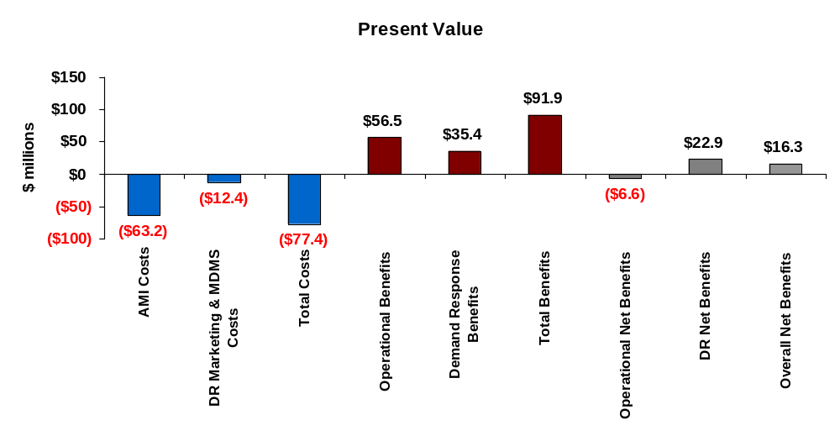

Figure 5-2
Statewide Benefits and Costs Including VEC
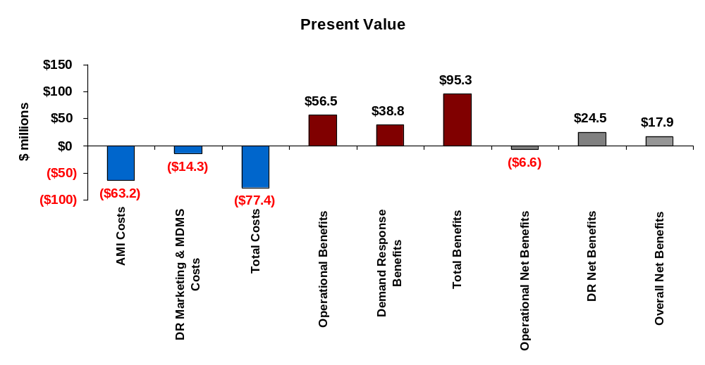
As seen in Figure 5-1, the total present value of costs for implementing AMI for the 9 utilities is $63.2 million. The operational savings estimated for this group of utilities is roughly $56.5 million. That is, the operational benefits do not quite offset the investment and operating costs over the life of the system for this group of utilities. However, if GMP were excluded, the net operational benefits would be a positive $3.7 million rather than negative $6.6 million. As discussed in Section 6, AMI costs exceed the operational benefits for GMP by $10.5 million.
When demand response benefits are included in the analysis, overall net benefits total more than $16.3 million with GMP included and $18.6 million with GMP excluded. With VEC included in the analysis, overall net benefits equal almost $18 million with GMP included and $20.2 million with GMP excluded.
Figure 5-3 shows the breakdown of the present value of AMI system costs by cost category over the life of the investment. More than 78 percent of the total costs derive from meter hardware and installation. Roughly 8 percent of total costs are due to the hardware equipment and installation and another 8 percent of costs are associated with equipment maintenance. WAN communication costs account for nearly 5 percent of the total. As discussed in Section 6, remote connect/disconnect functionality was analyzed for BED only and a partial deployment of this functionality proved cost effective. The costs associated with this functionality account for less than 1 percent of the overall total.
Figure 5-3
AMI Costs (Excluding VEC)
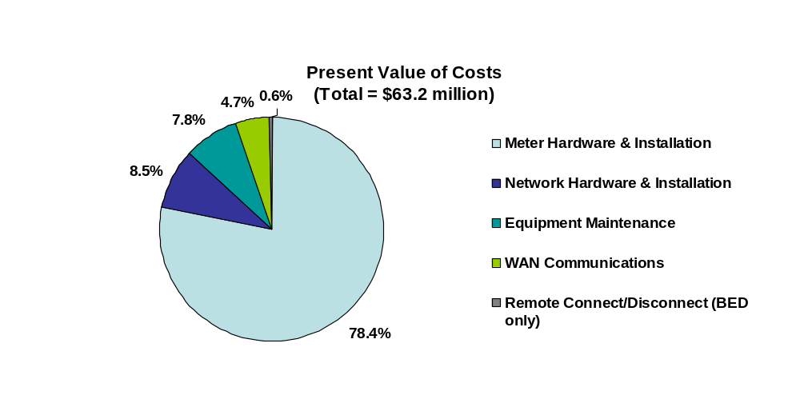

The initial cost of meter and network deployment for the 9 utilities equals roughly $37.3 million, which represents an average cost per meter of $115. Of this total, $33.5 million is for meter hardware and installation and $3.8 million is for network hardware and installation.

Figure 5-4 shows the breakdown of the $56.6 million in operational benefits by benefit category. By far, the majority of benefits, nearly 88 percent, derive from avoided meter reading costs. As seen in Section 6, the percent of operational benefits by category varies quite a bit across utilities. The estimate of 88 percent overall for avoided meter reading benefits is quite high compared with other publicly available business case information and reflects the aforementioned challenge of quantifying all of the potential operational benefits in a high-level study such as this. Figure 5-5 shows the percent of total operational benefits attributable to avoided meter reading costs from other studies. As seen, additional benefits often account for half or more of the total benefit stream. This suggests that the operational benefits estimated in this analysis are most likely low, perhaps significantly so, compared with what might be achievable through more detailed, utility-specific business process analysis.

Figure 5-4
Operational Benefits (excluding VEC)
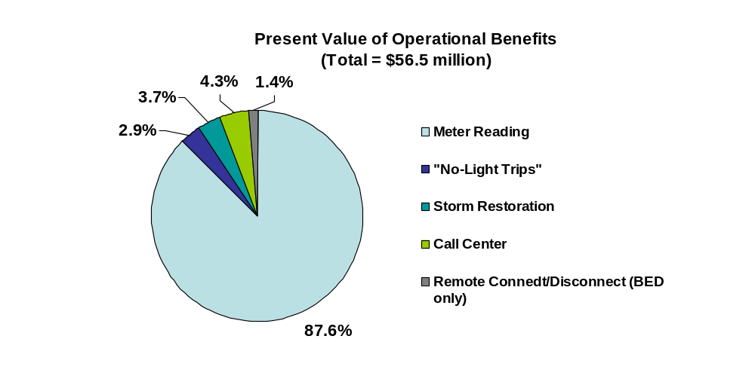
Figure 5-5
Percent of Operational Benefits Attributable to Avoided Meter Reading
From Publicly Available Business Case Analysis
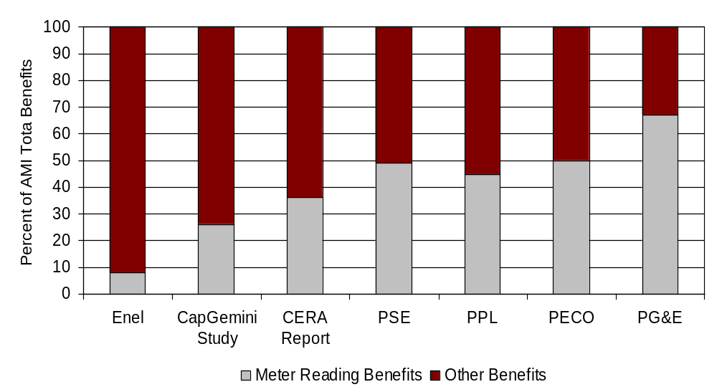

Figure 5-6 shows the demand response costs and benefits associated with implementation of the PTR program included in the base case. These estimates include VEC. Total DR benefits equal almost $39 million and total costs equal roughly $14 million. Net benefits equal nearly $25 million. With respect to benefits, almost 69 percent of the total is attributable to avoided generation costs, with just 6 percent of the total attributable to avoided energy costs. The remaining 25 percent is associated with avoided T&D capacity costs.
Figure 5-6
Demand Response Costs and Benefits
(Including VEC)
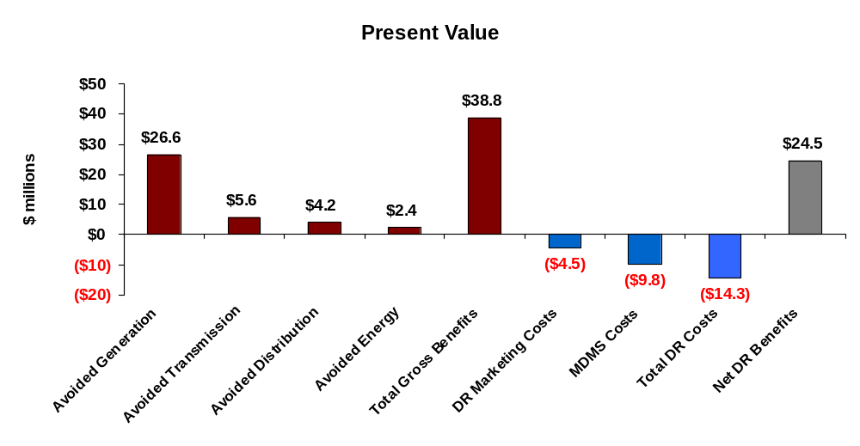
Some reviewers of the preliminary analysis have questioned several aspects of the DR benefit analysis. For example, some wonder whether the T&D capacity benefits are achievable based on a pricing strategy that primarily targets overall system peak load, since distribution capacity in particular is driven by localized peaks that may or may not coincide with the system peak demand on summer days. Some have also questioned whether the marketing cost assumptions are too low given that they are based on an approach that primarily relies on low or no-cost mass media notification options and other relatively low cost options for raising general awareness. Finally, some have questioned whether the awareness levels underlying the analysis are achievable, at least if they are based on the marketing costs and approach assumed. The values in Figure 5-6 can be used to assess the impact of changing some of these assumptions.

For example, if distribution benefits were equal to 0, net DR benefits would still equal roughly $20 million. Alternatively, if DR marketing costs were tripled, to $13.5 million, DR benefits would still exceed costs but only by about $1 million. If marketing costs were held constant at the original level, but it was expected that this level of marketing expenditures would only achieve an awareness level of roughly 15 percent for residential customers and 7.5 percent for C&I customers (that is, 1/3 of the base case level), DR costs would exceed benefits by roughly $1.5 million. As these examples illustrate, the net DR benefit estimate is relatively robust across a wide range of values for individual input assumptions. Of course, the net benefits would obviously be negative if low values were chosen for all of these variables simultaneously.

Figure 5-7 shows the MW reduction forecasted for the peak-time rebate program over time. Several things must be kept in mind when examining this rather modest reduction in Vermont’s overall system peak demand, which equals roughly 1,032 MW.
First, these forecasts are based on the average demand across the 6 hour peak period from noon to 6 pm on the top 20 system load days, using customer load profiles that were obtained from BED. As discussed in Appendix D, Section D.2, based on 2006 data, this average demand is 15 to 25 percent below what the average was on the highest system load day. Thus, the estimate of 20 MW in the first year after full deployment could equal almost 25 MW on the system peak day.
Second, as discussed in Section 4 and in more detail in Appendix D (Table D-1), the customers included in this analysis only represent about 55 percent of Vermont’s annual system energy use. Substantially more demand response might be obtainable from the large C&I customers that were excluded from the analysis and a modest amount might be obtained from the residential customers served by the 10 utilities that were not included in the analysis.
Third, additional demand response potential exists among the small C&I customers that were excluded based on the empirical evidence that these customers do not respond significantly to price signals in the absence of enabling technology. If further investigation were to indicate that enabling technology was cost-effective, there could be substantially more demand response not only from this customer segment, but from residential customers and medium C&I customers as well.
Finally, as discussed in Section 7, additional demand response could be obtained through a policy of implementing default, time-based pricing for all customer segments. If such a policy was pursued, market research suggests that participation levels of 80 percent for residential customers and 60 percent for commercial customers might be achieved. Under this policy option, demand response benefits and peak reductions would be substantially higher than those estimated here.
In summary, the estimates of MW reductions, and the demand response benefit estimates determined here, should not be perceived as representative of the total demand response potential that could be achieved through implementation of AMI and widespread use of time-based pricing in Vermont. Default time-based pricing, aggressive implementation of enabling technology, and including all customer segments in the analysis would substantially increase the demand response benefit estimates compared with those presented here. Furthermore, as discussed previously, by using average demand over the top 20 system load days as the starting value for demand response, rather than the single our of system peak or some smaller subset of hours, the avoided generation capacity estimates underlying the demand response benefit calculations may be quite conservative.
Figure 5-7
Reduction in Peak Demand from PTR Program
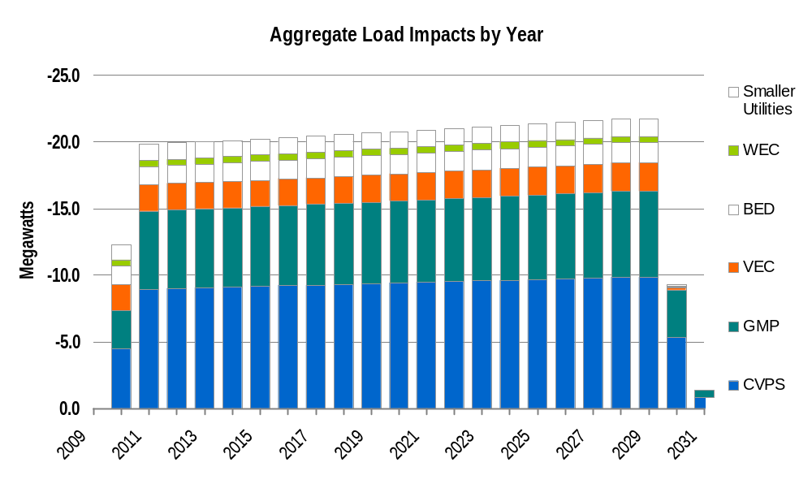

Environmental and Reliability Benefits
In addition to operational and demand response benefits, there are two additional benefit streams that can be considered when determining the potential value of AMI implementation and time-based pricing—environmental benefits and reliability benefits associated with time-based pricing. The environmental benefits would result from any overall reduction in annual energy use or, depending on the generation mix, from any shift in energy use from peak to off-peak periods. The reliability benefits in this instance are based on the reduction in outage duration that can be achieved using AMI. The assumptions underlying these estimates are summarized in Section 4 and explained in more detail in Appendices E and F.
Including environmental and reliability estimates in the analysis of the ten utilities substantially raises the overall net benefits from $17.9 to $39.5 million, and increases the benefit cost ratio from 1.23 to 1.51. If VEC is excluded, adding reliability and environmental benefits raises net benefits from $16.3 to $35.7 million and increases the benefit cost ratio from 1.22 to 1.47. Including all ten utilities, the estimated environmental benefits equal just $166,000 because of the modest impact of a PTR program on energy savings. In contrast, the reliability benefits associated with reduced outage duration equal $21.4 million for all 10 utilities, $18.8 million if VEC is excluded, and $14.4 million if VEC and GMP are excluded.

UTILITY SPECIFIC BENEFIT-COST ANALYSIS
This section presents the results of the benefit cost analysis for each of the five largest utilities in Vermont as well as for the aggregate for a group of five smaller utilities for which operational savings may be achievable if AMI were implemented. In total, these 10 utilities account for roughly 96 percent of Vermont’s electricity consumers and about 93 percent of the State’s total electricity use.

Central Vermont Public Service
CVPS is Vermont’s largest utility, serving roughly 44 percent of the State’s customers and about 40 percent of total annual energy use. CVPS serves 153,024 customers, of which 131,483 are residential customers. The demand response benefit estimates summarized below are based on only 5,800 of CVPS’s 15,742 non-residential customers, as the roughly 10,000 excluded customers were either too small to provide DR benefits in the absence of enabling technology, or too large to be included as discussed in Section 4.
The CVPS service territory covers almost 4,200 square miles and has an average customer density of roughly 37 customers per square mile. CVPS has the highest average number of meters per customer in Vermont as a result of the Company’s relatively large number of residential off-peak water heating customers, which have two meters, one for the water heater and one for the rest of the household. CVPS serves more than 180,000 meters, of which roughly 95 percent are single phase meters.
The PVRR resulting from an AMI investment was estimated for two technology options, mesh and PLC. The estimated PVRR over the life of the AMI investment totals $35.4 million for a mesh system and $37.2 million for a PLC network. The difference between the two estimates is not large and is probably within the error bound of the estimates, given the uncertainty in the required number of concentrators, repeaters and other system components. A detailed propagation study and firm cost estimates from vendors could easily produce a result indicating that PLC or some combination of mesh, star and PLC networks would be the optimal configuration.
For the mesh system, the cost for the initial deployment of meters and network components equals approximately $20.2 million, which represents an average cost per meter of roughly $112. Of this total, $18.1 million is for meter hardware and installation and $2.8 million is for the network hardware and installation.
The present value of the operational savings from an AMI deployment at CVPS equals $38.5 million. More than 90 percent of this total, or $36.8 million, stems from avoided meter reading costs. The estimate of avoided meter reading costs is comprised of roughly $29.5 million in labor costs (including benefits and overheads) and $7.3 million in vehicle and other costs. The $29.5 million is net of the estimated severance costs of $1.2 million that would be paid to meter readers and supervisors that would no longer be needed. CVPS has among the highest meter reading costs in Vermont. With an annual budget exceeding $3 million, the average cost per meter read for CVPS is roughly $1.50. Over the life of the AMI investment, the present value of avoided meter reading costs per customer equals approximately $232. Other operational benefit estimates include approximately $830,000 in call center savings, $1.05 million associated with avoided “no light” field calls and $1.15 million in storm restoration savings. The average present value of total operational benefits per customer equals roughly $252. Figure 6-1 summarizes the operational savings estimates for CVPS.
Figure 6-1
Operational Benefits for CVPS
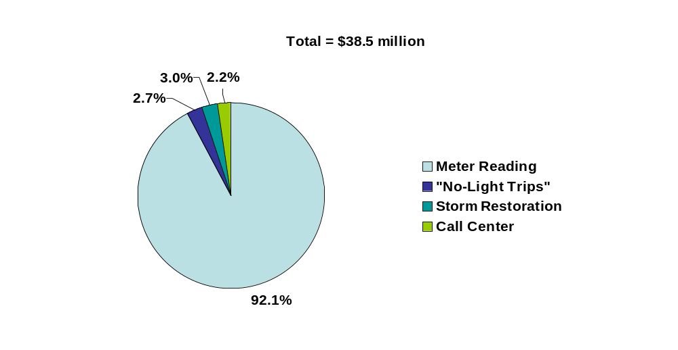
The operational benefits exceed the investment and operational costs of the AMI system by roughly $3.1 million over the life of the investment. This represents an operational benefit/cost ratio of 1.09.
The present value of demand response benefits based on a peak time rebate program is estimated to equal $15.8 million. As discussed in Section 4, the peak time rebate adder is assumed to equal 75 ¢/kWh and the customer awareness rate is assumed to equal 50 percent for residential customers and 25 percent for non-residential customers. The magnitude of benefits is directly proportional to the awareness rate. That is, if the awareness rate for both residential and non-residential customers equaled half the assumed rate, the present value of benefits would be roughly $7.9 million.
Figure 6-2 shows the breakdown of DR benefits between avoided generation, transmission and distribution capacity and energy costs. As seen, roughly 70 percent of the benefits derive from avoided generation capacity. Approximately 76 percent of the total DR benefits are provided by residential customers. The average demand reduction on critical days for residential customers is estimated to equal roughly 0.1 kW, which represents a 10.2 percent drop in energy use during the peak period. The average reduction for small commercial customers is 0.8 kW, or 7.2 percent, and for larger commercial customers, average peak-demand reductions equal 4.3 kW, or 7.9 percent. The demand reduction is based on average load between the hours of noon and 6 pm on the top 20 system load days. The reduction at the hour of the annual system peak would be greater by roughly 15 to 20%. As such, the generation capacity benefits may be understated.
Figure 6-2
Demand Response Benefits for CVPS
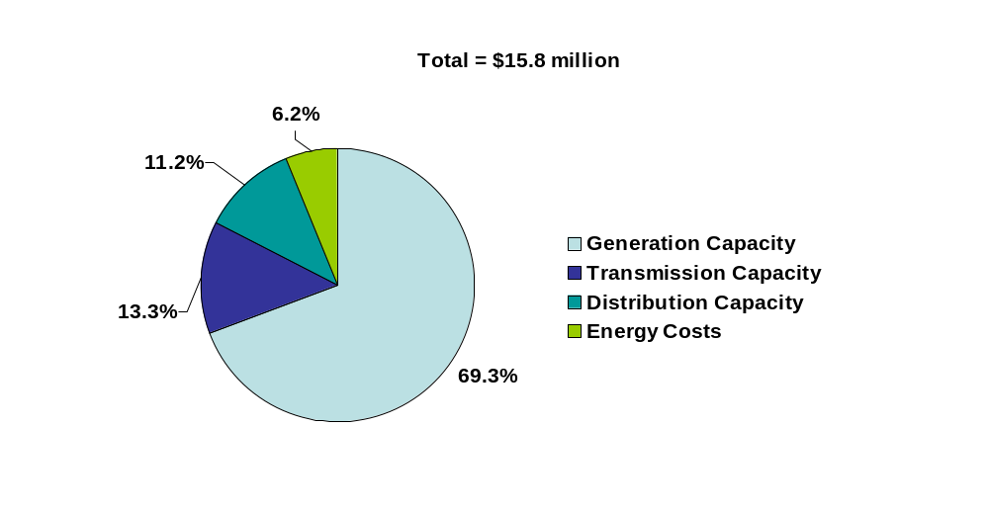

The MDMS and marketing costs needed to generate the demand response benefits are estimated to total $5.4 million. Of this total, $3.5 million is associated with the MDMS and the remaining $1.9 million stems from marketing and notification activities. The net demand response benefits total $10.5 million.
Figure 6-3 summarizes the benefits and costs for CVPS. The operational net benefits equal $3.1 million and the demand response net benefits equal $10.5 million. The overall net benefits total $13.6 million. The benefit-cost ratio equals 1.33.
Figure 6-3
Summary of Benefits and Costs for CVPS

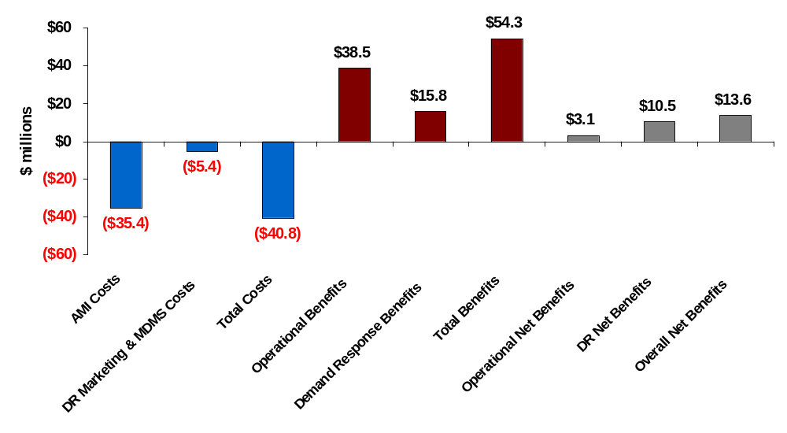

As discussed in Section 4, there are two additional benefit streams that can be considered when determining the potential value of time-based pricing—environmental benefits and reliability benefits. The estimated environmental benefits based on an environmental adder of roughly 0.9 ¢/kWh and the modest change in annual energy use associated with a PTR program equal just $72,000. The reliability benefits associated with reduced outage duration equal $12.0 million. With these additional benefits included, net benefits for CVPS exceed $25 million and the benefit-cost ratio equals 1.63.

Green Mountain Power
GMP is the second largest utility in Vermont, serving roughly 26 percent of Vermont’s electricity customers and 34 percent of annual energy use. GMP serves roughly 92,400 customers, of which 78,367 are residential customers. The demand response benefits estimated here are based on residential customers and roughly 4,800 of GMP’s 14,000 non-residential customers.
GMP’s service territory covers about 1,600 square miles and has an average customer density of 58 customers per square mile, which is more than 50 percent greater than CVPS’s customer density. Unlike CVPS, there is less than a 2 percent difference between the number of customers and the number of meters in GMP’s service territory. GMP has roughly 94,203 meters, of which 87,707 are single phase meters.
The PVRR associated with an AMI system for GMP is estimated to equal $19.5 million for a mesh network and $21.0 million for PLC. As with CVPS, the difference in the two technologies is not large. For the mesh system, the cost of the initial AMI investment equals $11.1 million, or about $118 per meter. Meter equipment and installation account for roughly $10.1 million of this total.
The present value of operational savings stemming from deployment of AMI, at $9.0 million, is less than half the cost of the investment over the life of the AMI system. This large shortfall stems from the very low meter reading costs at GMP which, in turn, results primarily from the fact that GMP only reads meters every other month. In addition, more than a third of GMP’s meters are read using mobile AMR technology, which keeps meter reading costs much lower than they would be otherwise. Even if monthly meter reading costs were to double, however, the avoided costs would still be less than the operational savings. The present value of meter reading costs over the life of an AMI investment at GMP, based on current meter reading practices, equals only about $6.57 million. Thus, a doubling of the avoided meter reading costs would result in an operational benefit stream equal to $15.57 million, which still falls short of the $19.46 million cost of the AMI system. This result highlights the fact that, in addition to having low costs because of their bi-monthly meter reading practice, GMP also has much lower average cost per meter read than does CVPS for example, due to lower labor costs as well as the existence of the AMR meters. GMP’s average cost per meter read is roughly $0.93, which is about 40 percent less than the average cost for CVPS. The lower average cost per meter read combined with the bimonthly meter reading practice means that no AMI system is likely to be cost-effective relative to the achievable operational benefits at GMP.
GMP has higher call volume and higher call center costs than CVPS, more than twice the cost on a per customer basis. This could at least partially be the result of greater call volume associated with the large number of estimated bills, as GMP bills monthly while only reading meters every other month. The estimated savings from a reduction in the number of calls due to implementation of AMI equals $1.2 million. Other operational savings estimates include $370,000 from avoided “no light” calls and a $870,000 reduction in storm restoration costs. Figure 6-4 shows the breakdown of operational benefits across the various benefit streams.
Figure 6-4
Operational Benefits for GMP
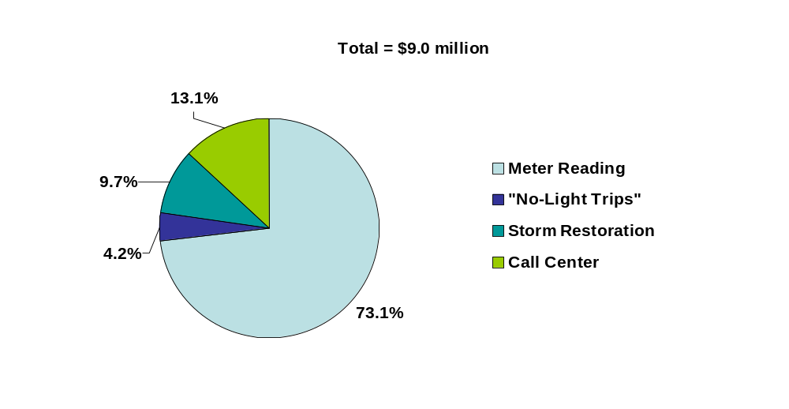
The operational benefits fall short of the AMI system costs by roughly $10.5 million and the operational benefit-cost ratio is only 0.46. With a Federal grant covering up to 20 percent of the initial investment cost of an AMI system, the operational gap would fall by several million dollars but it would still be negative. If GMP’s meter reading costs were twice as high as their current level, consistent with a business practice of monthly meter reading, the operational business case might be approximately breakeven.
The present value of demand response benefits based on a peak time rebate program is estimated to equal $12.2 million. Figure 6-5 shows the breakdown of DR benefits between avoided generation, transmission and distribution capacity and energy costs. As seen, roughly two thirds of the benefits derive from avoided generation capacity. Approximately 73 percent of the total DR benefits are provided by residential customers. The average demand reduction on critical days for residential customers is estimated to equal 0.10 kW, which represents a 9.9 percent drop in energy use during the peak period. The average reduction for small commercial customers is 0.64 kW, or 7.9 percent, and for larger commercial customers, the average peak-demand reduction equals 2.4 kW, or 8.0 percent.
Figure 6-5
Demand Response Benefits for GMP
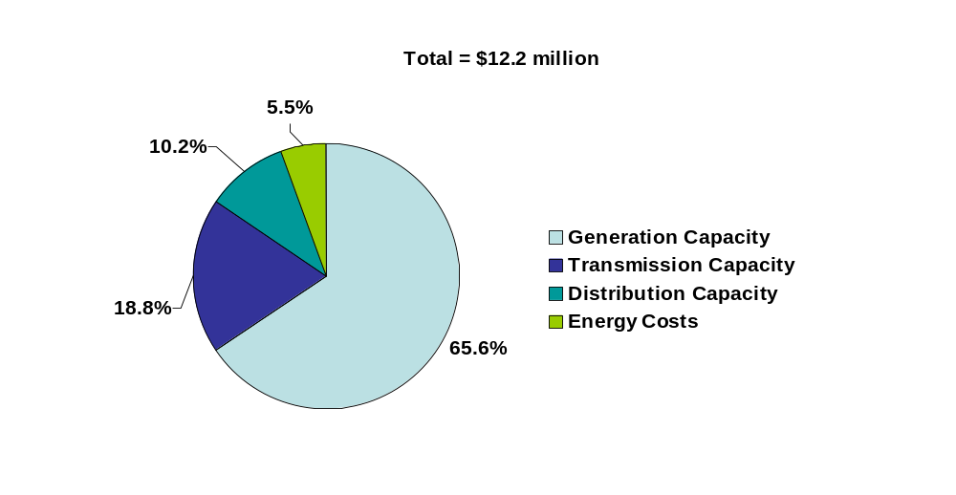
The MDMS and marketing costs required to generate the demand response benefits at GMP are estimated to equal $3.84 million. Of this total, $2.57 million is associated with the MDMS and the remaining $1.27 million stems from marketing and notification activities. The net demand response benefits total $8.28 million.
Figure 6-6 summarizes the benefits and costs for GMP. The operational net benefits are a negative $10.5 million and the demand response net benefits equal $8.3 million. The overall net benefits, including demand response, equal -$2.18 million and the benefit-cost ratio equals 0.91. With environmental and reliability benefits included, the total benefits would equal $25.6 million, producing a net benefit equal to $2.3 million and a benefit-cost ratio of 1.10.

Figure 6-6
Summary of Benefits and Costs for GMP

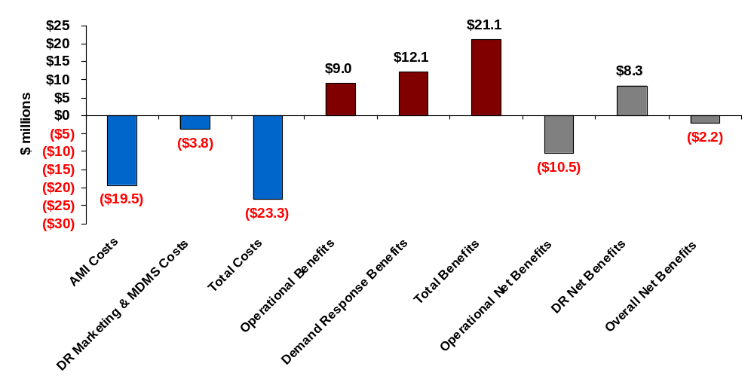

Vermont Electric Cooperative
VEC is the third largest utility in Vermont, serving roughly 11 percent of the State’s customers and 8 percent of annual energy use. VEC has approximately 39,000 customers, of which 33,000 are residential. Of the remaining 6,000 customers, 834 were included in the demand response analysis summarized below.
VEC is already in the process of installing advanced meters. As such, the analysis only examined the net demand response benefits associated with time-based pricing. VEC’s current deployment plan does not include installation of an MDMS to support time-based pricing, so the cost of an MDMS was included in the analysis, as were the marketing costs required to make customers aware of the PTR offering underlying the demand response analysis.
The present value of demand response benefits based on a peak time rebate program is estimated to equal $3.4 million. Figure 6-7 shows the breakdown of DR benefits between avoided generation, transmission and distribution capacity and energy costs. As seen, roughly two thirds of the benefits derive from avoided generation capacity. Over 80 percent of the total DR benefits are provided by residential customers. The average demand reduction on critical days for residential customers is estimated to equal roughly 0.09 kW, which represents a 9.4 percent drop in energy use during the peak period. The average reduction for small commercial customers is 1.2 kW, or 8.2 percent, and for larger commercial customers, the peak-demand reduction equals 2.3 kW, or 8 percent.

Figure 6-7
Present Value of Demand Response Benefits for VEC
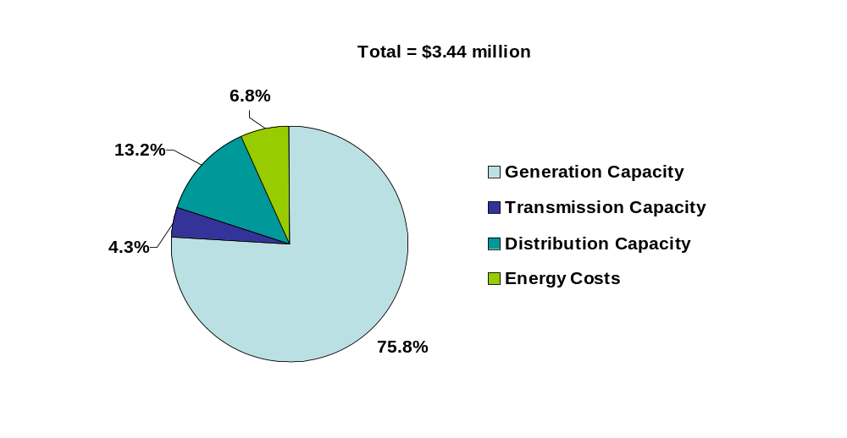

The MDMS and marketing costs needed to generate the demand response benefits for VEC are estimated to total $1.9 million. Of this total, $1.4 million is associated with the MDMS and the remaining $0.5 million stems from marketing and notification activities. The net demand response benefits for VEC total $1.6 million.
If environmental and reliability benefits are included, overall net benefits equal $4.2 million. The estimated environmental benefits based on an environmental adder of roughly 0.9 ¢/kWh and the modest change in annual energy use associated with a PTR program equals just $15,900. In contrast, the reliability benefits associated with reduced outage duration equals $2.6 million.

Burlington Electric Department
BED serves 19,855 electricity consumers that collectively use 359 GWhs annually. Both the number of customers and the annual energy use equal approximately 6 percent of Vermont’s total. BED is by far the most compact service territory in Vermont, covering less than 16 square miles. BED’s customer density is more than 1,200 customers per square mile, which is 20 times greater than GMP’s customer density, the next highest among the five largest utilities in Vermont. The high customer density combined with the compact service area results in much lower AMI network costs and brings additional technology options into consideration. On the other hand, BED also has among the lowest average meter reading costs in the State, meaning that the meter reading savings associated with AMI are relatively small.
The PVRR associated with an AMI investment for BED is estimated to equal $2.79 million for mesh and $3.24 million for PLC. The cost for a star network system was also estimated. At $2.83 million, the star network costs were nearly identical to the cost for a mesh system. The initial network cost for both mesh and star systems is extremely low, equal to roughly $7,000 for the 7 mesh concentrators needed to cover the territory and approximately $16,000 for the 8 star network concentrators assumed to be needed to provide full coverage for a star system. Initial network costs for a PLC system were substantially higher, equal to roughly $195,000. The initial cost for meters for all three technology options equals roughly $2.2 million. Considering the initial network costs and expected maintenance cost, the mesh network was selected as the base case.
Because of the large concentration of college students in the BED service territory, customer churn is high and contributes to above average costs for connection/disconnection services. As such, BED asked that the net benefits associated with remote connect/disconnect functionality be estimated. Costs were estimated under two scenarios. One scenario was based on installation of disconnection switches on all multi-family households, assuming that the vast majority of churn occurs in this segment. Approximately 40 percent of BED’s residential customers live in multi-family housing. The other scenario assumed that switches are placed on 100 percent of BED’s meters. The average, incremental cost for adding a switch to an AMI meter in both scenarios was assumed to equal $50. The partial deployment scenario adds roughly $440,000 to the present value of costs, bringing the total cost for this scenario to $3.16 million. The incremental cost for the full-deployment scenario is roughly $1.10 million, bringing the total AMI cost with remote connect/disconnect for all customers to $3.82 million.
If BED did not include remote connect/disconnect capabilities with any of their meters, the present value of operational benefits for BED equals $1.56 million. This estimate is based almost exclusively on avoided meter reading costs which, as discussed above, are among the lowest in the state. Discussions with BED indicated that they have a very high meter read completion rate and, therefore, a low number of customer calls stemming from inaccurate reads or estimated bills. A large share of their call volume stems from customer churn (e.g., service termination, disconnection and reconnection requests, etc.). Consequently, we did not estimate any call center cost savings associated with AMI deployment. It is likely that some savings could be achieved but the amount of cost savings would not be sufficient to make this scenario a positive business case based solely on operational benefits, as the gap is large and the operational benefit-cost ratio is only 0.57 without any remote connect/disconnect enabled meters.
The operational savings estimate also does not include any savings resulting from a reduction in storm restoration costs. BED does not track costs for this category of work and, therefore, could not provide an estimate of storm related expenditures. Furthermore, it was not appropriate to develop an estimate based on other utilities in Vermont, as BED has a lot of underground wire and also has many fewer trees that can cause outages relative to other utilities in the state. These facts are evident from the CAIDI and SAIFI metrics for BED, which are significantly lower than for any of the other large utilities. As such, we assumed that storm restoration cost savings were zero for BED. Again, this assumption may be too conservative but any reasonable estimate of potential savings would be small and not sufficient to offset the operational gap, even in combination with some modest estimate of call center savings.
Aside from avoided meter reading costs, the only operational savings for BED stem from a reduction in “no light” trips. BED does not track the proportion of outage calls that are due to outages on the customer’s side of the meter so an estimate was developed based on a combination of data from CVPS and GMP, as documented in Appendix C. The present value of cost savings for this business operation is $99,000.
The estimated savings associated with adding remote connect/disconnect functionality equals approximately $1 million for the 100 percent deployment scenario and $750,000 for the 40 percent deployment scenario. As indicated above, the incremental cost for the full deployment scenario is $1.10 million, indicating that this scenario is not cost effective. However, the incremental cost for the partial deployment scenario is significantly less than the estimated savings, thus improving the business case. The present value of operational benefits of $2.30 million for the partial deployment scenario still falls short of the costs of $3.16 million by roughly $860,000, but the operational benefit-cost ratio increases from 0.57 to 0.73. As indicated below, with demand response benefits included, the overall business case is strongly positive.
Figure 6-8 summarizes the operational benefits for BED for the preferred scenario, which involves mesh technology and the partial deployment of remote connect/disconnect functionality. As seen, roughly 63 percent of the operational savings come from avoided meter reading costs and 33 percent come from avoided costs for connections and disconnections. The remaining 4 percent of operational savings come from avoided “no-lights” trips.
Figure 6-8
Operational Benefits for BED
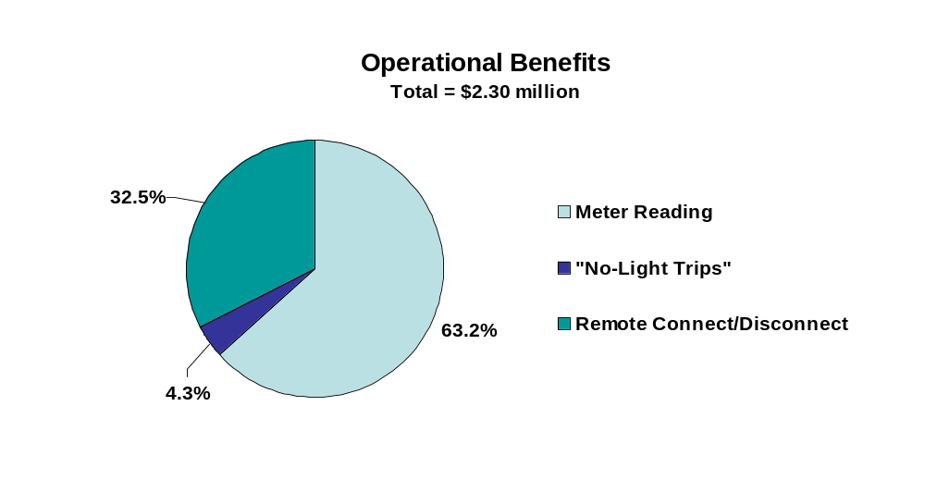
The present value of demand response benefits for BED is estimated to equal $3.47 million. Figure 6-9 shows the breakdown of DR benefits between avoided generation, transmission and distribution capacity and energy costs. As seen, roughly two thirds of the benefits derive from avoided generation capacity. The share of DR benefits provided by residential customers is only 50 percent for BED, which is significantly less than for the other service territories. This is the result of the relatively small average energy use by residential customers in BED’s service territory (which, in turn, is a function of the high penetration of smaller, multi-family housing) and the larger share of commercial customers/load as a share of total customers/load relative to other Vermont utilities. The average load of BED’s residential customers on peak demand days is only 0.79 kW and the average load reduction resulting from the PTR program is only 0.079 kW, both of which are smaller than for the other utilities. The average reduction for commercial customers in BED’s service territory is 3.29 kW, or roughly 8.2 percent.

Figure 6-9
Demand Response Benefits for BED
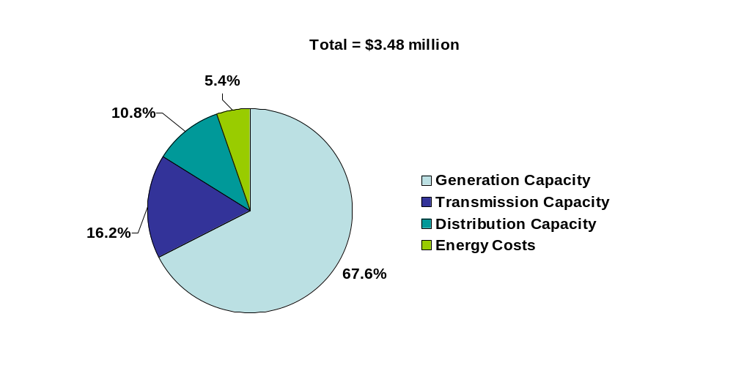

The MDMS and marketing costs needed to generate the demand response benefits for BED equal $1.24 million. Of this total, roughly $925,000 is associated with the MDMS and the remaining $310,000 stems from marketing and notification activities. The net demand response benefits for BED total $2.23 million.
Figure 6-10 summarizes the benefits and costs for BED. The operational net benefits equal -$0.85 million and the demand response net benefits equal $2.23 million. The overall net benefits total $1.38 million. The benefit-cost ratio equals 1.31. With environmental and reliability benefits added in, the overall net benefits equal $1.83 million and the benefit cost ratio equals 1.42.

Figure 6-10
Summary of Benefits and Costs for BED
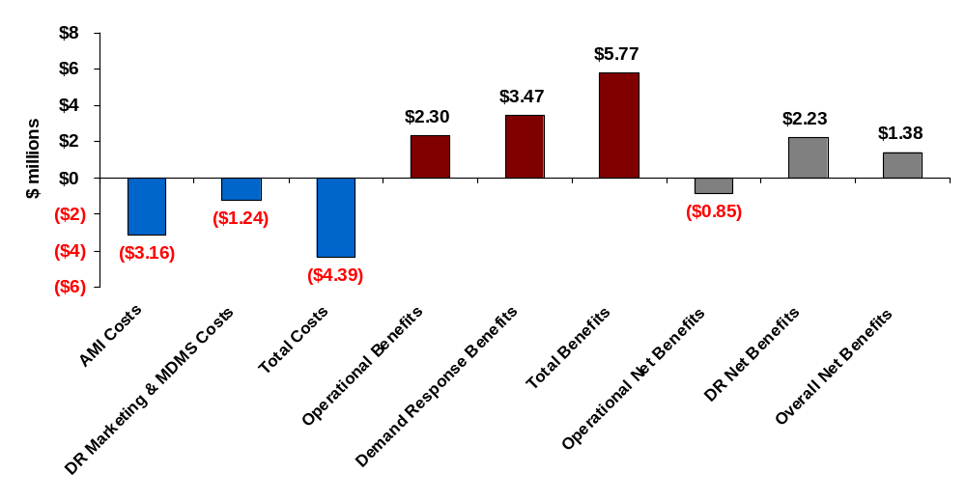

Washington Electric Cooperative
WEC serves electricity to 10,183 customers, almost all of which (9,917) are residential customers. Although the number of customers served is small, WEC’s service territory is quite large, spanning 1,197 square miles. As such, customer density is extremely low, at only 8.5 customers per square mile.
AMI costs were estimated for two technology options, mesh and PLC. The present value of costs over the life of the AMI investment was estimated to equal $2.30 million for a mesh network and $1.85 for a PLC network. As indicated in Appendix B, the large number of concentrators (36) and repeaters (almost 1,000) needed to cover the sparsely populated service territory for WEC drove the mesh network costs above the PLC costs, which required only 8 of the more expensive PLC concentrators. The deployment costs for the PLC network were estimated to equal roughly $200,000 while the initial cost for meters was estimated to equal roughly $1.0 million.
Given its sparsely populated service territory, WEC’s meter reading costs are above average. Indeed, at $1.95 million, the present value of avoided meter reading costs alone exceed the cost of the AMI system. With estimated call savings of $440,000, savings from avoided “no light” calls equal to $110,000 and storm related cost reductions equaling $100,000, the operational savings of $2.60 million significantly exceed the AMI system costs over the life of the investment. The net operational benefits equal roughly $750,000 and the operational benefit-cost ratio is 1.41. Figure 6-11 summarizes the operational benefits for WEC.
Figure 6-11
Operational Benefits for WEC
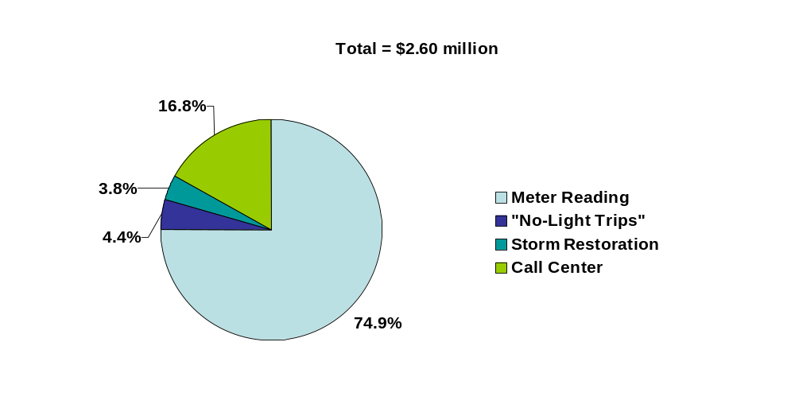

The present value of demand response benefits for WEC is estimated to equal $1.19 million. Figure 6-12 shows the share of benefits stemming from the various demand response value streams. As with the other utilities, approximately 70 percent of the total DR benefits stem from avoided generation capacity. Roughly 98 percent of the DR benefits are provided by residential customers. The average demand by WEC’s residential customers on high demand days is approximately 0.88 kW and the average demand reduction is 0.08 kW, or 9.5 percent.

Figure 6-12
Demand Response Benefits at WEC
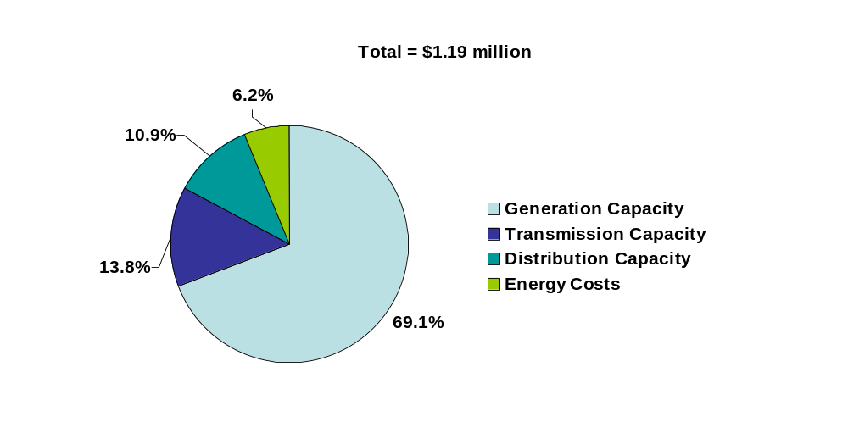

The MDMS and marketing costs needed to generate the demand response benefits for WEC are estimated to total $720,000. Of this total, roughly $534,000 is associated with the MDMS and the remainder stems from marketing and notification activities. The net demand response benefits total $468,000.
Figure 6-13 summarizes the benefits and costs for WEC. The operational net benefits equal $755,000 and the demand response net benefits equal $468,000. The overall net benefits total $1.22 million. The benefit-cost ratio equals 1.48. If environmental and reliability benefits are included, the net benefit estimate equals $1.58 million and the benefit cost ratio equals 1.61.
Figure 6-13
Summary of Benefits and Costs for WEC

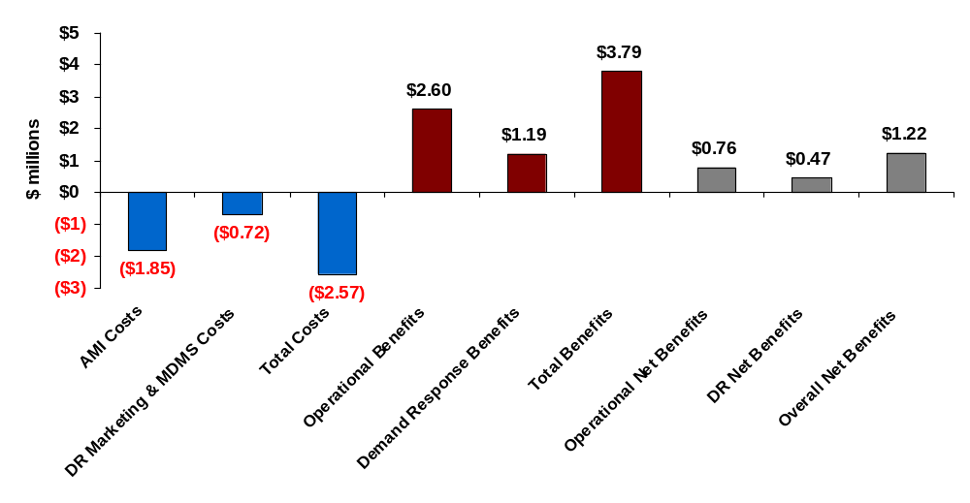

Small Utility Group
As discussed in Section 4, estimates of benefits and costs were developed for a “prototypical” small utility represented by five utilities—Hardwick, Lyndonville, Stowe, Morrisville and Ludlow. Combined, these utilities serve 20,673 customers and deliver roughly 263 GWHs of electricity annually. The total number of meters served by the five utilities equals slightly more than 21,100, of which all but 512 are single phase meters. This group of small utilities collectively covers 468 square miles, indicating a customer density of 44 customers per square mile, which is between CVPS’s density of 37 and GMP’s density of 58 customers per square mile.
AMI costs were estimated for two technology options, mesh and PLC. The present value of cost over the life of the AMI investment was estimated to equal $3.26 million for the mesh option and $4.29 million for PLC. The deployment cost for the mesh network was estimated to equal roughly $300,000 while the initial cost for meters was estimated to equal $2.2 million.
The operational savings estimate for the small utilities is based solely on avoided meter reading costs. Data on call center operations, outage-related field visits and storm budgets was not provided by any of the utilities and extrapolation of these costs based on much larger utilities was not deemed appropriate. Importantly, the operational business case for AMI appears to be cost effective based on avoided meter reading costs alone. The present value of operational savings from meter reading is estimated to equal $4.11 million (net of severance costs), which exceeds the AMI cost estimate by $850,000. It is likely that some savings would also arise from other business processes, making an even stronger case for AMI for this group of utilities.
Current meter reading costs for the five small utilities are summarized in Appendix C. The weighted average cost per meter read for the five utilities is $1.10, with a range in costs going from a low of $0.80 per meter read for Ludlow to a high of $1.42 for Morrisville. Assuming the AMI costs are scalable from the group to the individual utilities, the avoided meter reading costs for Ludlow would still produce close to a breakeven operational business case (and a positive case when demand response benefits are considered). The avoided costs for Stowe are based on elimination of one of the two meter readers at Stowe, since Stowe reads both electricity and water meters.
The present value of demand response benefits for the small utility group is estimated to equal $2.75 million. Figure 6-14 shows the share of benefits stemming from the various demand response value streams. Approximately 79 percent of the benefits are based on peak demand reductions by residential customers, for whom the average load reduction is 0.09 kW, or about 10.1 percent. The average reduction for medium commercial customers is 0.36 kW, or about 7.6 percent, and for larger commercial customers, the load reduction equals 1.3 kW, or about 7.8 percent.
Figure 6-14
Demand Response Benefits for Five Small Utilities
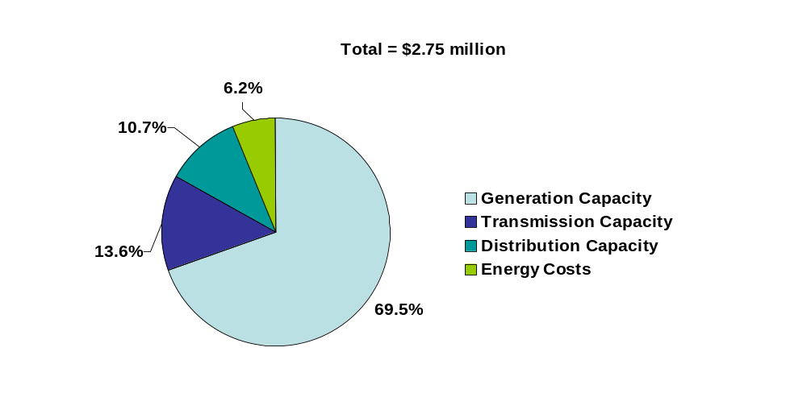

The MDMS and marketing costs required to generate the demand response benefits for the small utilities are estimated to total $1.26 million. Of this total, roughly $934,000 is associated with the MDMS and the remainder stems from marketing and notification activities. The MDMS cost estimate assumes that it would be possible for this group to outsource MDMS functions as a group, which may or may not be feasible at the assumed cost. Even if the costs for the MDMS were double the estimated amount, the net demand response benefits would still be positive and the costs could increase nearly four fold before the overall costs would exceed the benefits. Based on the current set of assumptions, the net demand response benefits total $1.47 million.
Figure 6-15 summarizes the benefits and costs for the small utility group. The operational net benefits equal $850,000 and the demand response net benefits equal $1.47 million. The overall net benefits total $2.33 million. The benefit-cost ratio equals 1.51. If environmental and reliability benefits are included, the net benefit estimate increases to $3.94 million and the benefit cost ratio increases to 1.87.
Figure 6-15
Summary of Benefits and Costs for Five Small Utilities
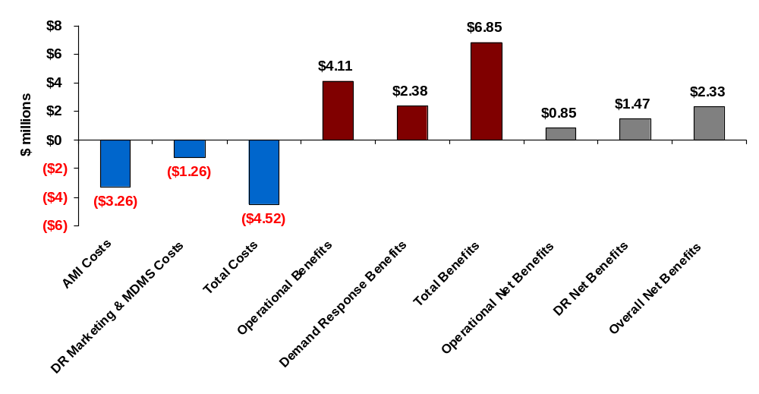

RATE DESIGN ISSUES AND POLICY OPTIONS
The implementation of AMI provides utilities and regulators with the opportunity to offer customers a wide variety of rate options that can reduce customer’s bills and improve economic efficiency. As seen in previous sections, for some utilities, such as CVPS, AMI is cost-effective even in the absence of any demand-response benefits that might result from implementation of time-based pricing. For other utilities, the implementation of time-based pricing may be needed to justify the investment in AMI. Regardless of the situation, any utility that deploys AMI should carefully consider a comprehensive pricing strategy that takes advantage of the new options enabled by the AMI investment.
Determining the best pricing strategy requires understanding the implications and tradeoffs among the numerous options that exist. To date, pricing decisions have often been based on conjecture and/or misunderstandings regarding the options and tradeoffs associated with time-based pricing. The primary objective of this section is to illuminate the options and tradeoffs so that sensible strategies can be developed.

Pricing Objectives
No discussion of pricing objectives would be complete without mention of Bonbright’s Principles (see Table 7-1), nor the obvious tradeoffs among them (e.g., simplicity versus accurate reflection of costs across rate classes). The primary objective of time-based pricing is to more accurately reflect the time-varying cost of supply and, by doing so, improve economic efficiency relative to the current, average-cost based pricing that sets the price too low during high cost periods and too high during low cost periods. Developing rates that accurately reflect the marginal cost of supply is not difficult. What can be very difficult, however, is designing economically efficient rates that customers understand well, that overcome the political challenges associated with transitioning away from the longstanding cross-subsidies inherent in current rates to more equitable and efficient cost allocation, and that can be implemented cost effectively.
Table 7-1
Bonbright’s Rate Design Principles
1 | The related “practical” attributes of simplicity, understandability, public acceptability, and feasibility of application
2 | Freedom from controversies as to proper interpretation
3 | Effectiveness in yielding total revenue requirements under the fair-return standard
4 | Revenue stability from year to year
5 | Stability of the rates themselves, with minimum of unexpected changes seriously adverse to existing customers
6 | Fairness of the specific rates in the appointment of total costs of service among the different customers
7 | Avoidance of “undue discrimination” in rate relationships
8 | Efficiency of the rate classes and rate blocks in discouraging wasteful use of service while promoting al justified types and amounts of use:  (a) in the control of the total amounts of service supplied by the company  (b) in the control of the relative uses of alternative types of service (on-peak versus off-peak electricity, Pullman travel versus coach travel, single-party telephone service versus service from a multi-party line, etc.)

Prices Must Be Understandable To Be Effective
A simplistic approach to a pricing strategy focused on improving economic efficiency might conclude that mandatory time-based rates that have demand-charges for transmission and distribution and real-time prices for generation would be optimal. However, this simplistic notion ignores the reality that, in the absence of enabling technology such as real-time feedback devices and automated response technology, customers will not know nor be able to respond to real time prices because they are not known until after the fact. Given this, day-ahead hourly pricing may be more effective than real-time pricing and critical peak pricing with day-ahead notification might be even more effective in producing demand response, even if it doesn’t precisely match what supply costs are after the fact. A practical guide to effective pricing strategy is “don’t let the perfect become the enemy of the good.” Prices that perfectly reflect cost causation may not be very effective in improving economic efficiency because the associated prices are very difficult to know a priori or, even if known, they may be too difficult to understand to meaningfully influence customer decision making.
An obvious but often ignored principle of effective pricing strategy is that prices must be understandable to be effective. This fact applies not just to time-based pricing, but to quantity-based pricing as well. For example, increasing block pricing may more accurately reflect the increasing marginal cost of supply and, in theory, could encourage energy efficiency. In reality, however, with block pricing, it is extremely difficult for customers to know what block they are consuming in at any given point in time and, therefore, what the marginal price is that they are paying. Given this fact, combined with the inherent difficulty of understanding how their consumption decisions translate into kWh usage and bill impacts, one must wonder if increasing block pricing has any impact at all on consumption patterns. Indeed, we are unaware of any empirical studies that have examined the effectiveness of increasing block pricing on energy use or efficiency decisions. That is, the theory that increasing block pricing drives energy efficiency may be just that, a theory. It may still be a good pricing policy in terms of accurately reflecting cost causation, but it may not affect customer behavior.
In contrast, time-based pricing may be more easily understood by customers than block pricing. While customers still will not know how their actions directly translate into bill impacts, it’s quite easy to communicate to customers that electricity is two, three or more times expensive during certain hours of the day than during other hours and to have that information influence usage decisions. A simple refrigerator magnet, for example, can quite effectively communicate these relative prices and the times when they are in effect. Indeed, survey data from a recent time-based pricing pilot conducted in Ontario, Canada indicated that 49 percent of customers overall, and 57 percent of customers on a PTR rate option, said that the most useful resource for “helping you understand the time-of-use prices” was a refrigerator magnet. In other words, it may be easier to effectively communicate the relative cost of electricity by time of day than by usage stratum.
The ability for customers to understand and respond to the relative prices associated with time-based pricing is quite clear from California’s SPP. In that experiment, time-based prices were layered on top of a five-tiered, increasing block tariff. Given this extremely complex tariff, it was virtually impossible to know what the marginal price was at any moment in time. Nevertheless, participants shifted load in response to time-varying price information that was provided to them in the form of information pamphlets and refrigerator magnets and were able to describe with reasonable accuracy in follow-up surveys the general characteristics of the time-based tariffs they faced.
Importantly, the SPP also showed that increasing block tariffs are not an effective substitute for time-based pricing when it comes to reducing peak demand. Prior to the experiment, some policy makers felt that time-based pricing would have little incremental impact on air conditioning energy use in light of the fact that many air conditioning customers already faced extremely high prices in the tail block of the five-tiered rate (where the marginal price was roughly 25 cents/ kWh). In spite of this, significant reductions were achieved from the CPP prices that were tested in the SPP and the percent reduction was much higher for air conditioned households than for non-air conditioned households.
The objectives of simplicity and understandability also suggest that two-period tariffs may be more effective than three or four-period tariffs. It would also suggest that TOU and CPP tariffs may be more effective in changing customer behavior than real-time or day-ahead pricing. However, there is at least one example suggesting that this may not be the case. A pricing program implemented by the Chicago Community Energy Cooperative in conjunction with Commonwealth Edison showed that residential customers can and will respond to day-ahead, hourly price signals and that the demand reductions generated by this type of pricing are similar to CPP pricing when prices are comparable. However, there is still more to learn about this result. This particular program notified customers when prices were expected to hit certain thresholds. As such, it is unclear whether the combination of day-ahead pricing with notification is effectively equivalent to a CPP pricing strategy. Put another way, it may be that customers are completely ignoring the day-to-day, hourly-to-hour fluctuations in price but do respond when they get a notification that prices are expected to be high on the occasional high-demand/high price day. If so, it could be that a pure-CPP price might be equally effective and less costly to bill and implement.

Dynamic Versus Static Rate Options
The simplicity objective might also suggest that static, time-varying rates would be preferable to dynamic rates. However, other more important objectives come into play that argue in favor of dynamic rates over static rates, at least if the primary goal is to reduce peak demand on days when costs are high or reliability is threatened.
While static TOU rates are more reflective of time-varying costs than are standard rates, they are still based on average costs over many hours across which costs may vary significantly. Consequently, a revenue neutral, cost-reflective TOU rate might produce a ratio for peak-to-off-peak prices equal to something between 1.5 to 1 and 2.5 to 1 whereas a cost-reflective CPP price might produce a price ratio between 5 to 1 and 10 to 1. Demand reductions in response to the latter price signal will be much greater than demand reductions in response to the former, and the resulting avoided costs will be much greater. Furthermore, the CPP price is more reflective of the underlying economics of supply, as averaging costs across the 400 to 600 hours that are typical for the summer peak period for a TOU rate still significantly under prices supply during the 60 to 75 hours when costs are really high. The rifle shot price signal associated with a CPP tariff is much more effective at reducing generation capacity than is the dart gun signal associated with many TOU tariffs. Up to a point, the larger the peak period price, the greater will be the reduction in peak-period energy use.
Some of the tradeoffs associated with different time-varying rate options can be observed based on the information in Table 7-2, which shows a number of revenue neutral pricing options using the current CVPS residential average price as a starting point. Revenue neutral in this instance means that, if the average customer does not change his or her usage pattern in response to the rates, their bill (and utility revenue) will remain the same as it was under the current tariff.
Table 7-2
Revenue Neutral Rate Options For CVPS
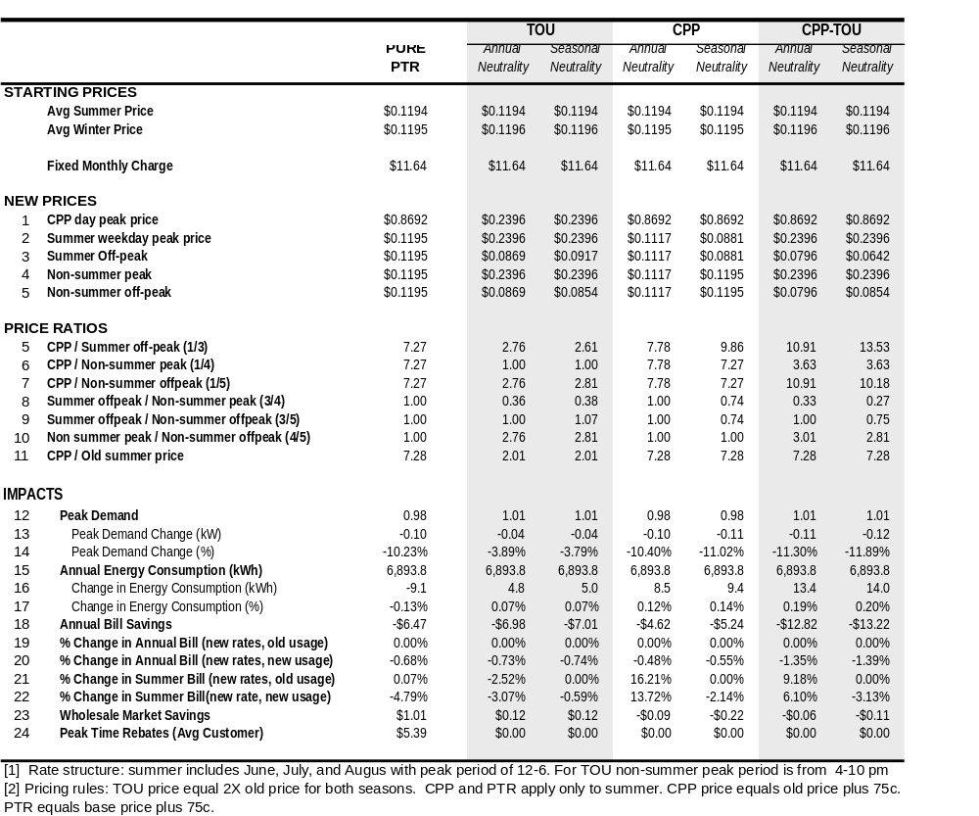
Table 7-2 shows seven different rate options, summarized below:
- Pure PTR: This is the rate or incentive program option that underlies the analysis in prior sections. It pays an incentive of 75 cents/kWh to reduce energy use between noon and 6 pm on 12 high-demand days during the summer. As indicated in the table, the implicit price signal during the critical peak period is the incentive plus the current average price, the sum of which is roughly 87 cents/kWh. During the remaining 8,688 hours in the year, the customer pays 11.9 cents/kWh.
- TOU (Annually Neutral): Under this tariff, higher prices are in effect from noon to 6 pm on every weekday during the three-month summer period (June, July and August) and from 4 to 10 pm on every weekday for the remaining nine months. Lower prices are in effect on all remaining hours. The peak and off-peak prices are the same all year long.
- TOU (Seasonally Neutral): With this tariff option, the structure is the same as for option 2, but the revenue neutrality is applied on a seasonal basis. That is, the average summer bill would be the same given the same summer usage pattern as with the current rate and the average non-summer bill would be the same given the same non-summer usage pattern. The fact that the off-peak price in the summer is higher than the off-peak price in the non-summer period results from the fact that average use in the summer peak-period is actually lower than average use in the winter peak period for residential customers. As such, more revenue is collected during the peak period in the non-summer period than in the summer period. Consequently, to keep prices seasonally revenue neutral, the off-peak price must be lower in the non-summer period than in the summer period.
- CPP (Annually Neutral): With this tariff option, prices are high during the peak period only on the assumed 12 critical days in the summer months, and are lower and constant across all remaining hours. This option is conceptually similar to option 1.
- CPP (Seasonally Neutral): With this tariff, except for the 72 critical peak hours during the summer period, prices during all remaining summer hours are low enough to offset the additional revenue collected on critical peak days. Prices during the remaining 9 months of the year are the same as the current tariff. With this rate option, off-peak prices are much lower during the summer than for the annually revenue neutral rate option.
- CPP/TOU (Annually Neutral): With this tariff, prices are higher during the peak period on all weekdays during the year, and lower at all other times. In addition, prices are at the highest level on the 12 CPP days that are assumed to occur during the summer period. The timing of the peak periods is the same as for options 2 and 3. As seen, the off-peak prices are lower than for the annually neutral TOU option (option 2) because of the additional revenue collected during the CPP periods during the summer.
- CPP/TOU (Seasonally Neutral): This option is conceptually similar to option 3 except that the CPP price is layered on top of the TOU price during the summer period. With both the CPP and TOU rates in effect during the summer, the off-peak price must be lower than in the winter to remain seasonally revenue neutral.
Table 7-2 also shows the percent change in energy use during the peak period on high demand days and the change in annual energy use under each tariff. The following points are worth noting:
- As noted above, the percent reduction in energy use during the peak period is substantially less for TOU rates than for any of the dynamic rate options. This is a direct result of the higher prices for the dynamic rate options compared with the static TOU rate. Any attempt to achieve similar demand reductions using a high TOU peak price would necessarily result in unrealistically low off-peak prices.
- There are only slight differences in the percent reduction in peak-period energy use on critical peak days across the various dynamic rate options. Even though the peak price on critical days is the same under all of these options, the percent reductions vary some because they are driven not by the level of the price during the peak period, but by the ratio of the peak-to-off-peak prices on critical days. Since off-peak prices vary across the various rate options, the impacts vary, although not by a lot.
- The change in annual energy use varies across the different options, but it is quite small (less than 1 percent) in all cases. Except for the PTR option, energy use actually increases for the other six options. The reason this occurs is because the off-peak prices fall rather significantly relative to the increase in peak-period prices, and there are many more hours priced at the lower rate than there are hours priced at the higher rate.
The above results will vary some with differences in underlying price elasticities, initial load shapes and with the tariff options and price levels chosen. There are an almost limitless number of revenue neutral (and non-revenue neutral) tariff options that could be examined, although many would not make good sense from either an economic or policy perspective. However, within the reasonable range of pricing options, it is almost certainly the case that cost-based dynamic rate options will produce larger demand reductions when they count the most than will static, TOU rates. It is also true that the overall impact on annual energy use will be small in almost all cases. Time-varying rates are primarily designed to reduce peak demand, not to reduce energy use overall.

Maximizing Customer Participation
The magnitude of demand response benefits is a function of the average demand response per participating customer and the number of customers who participate in the rate option. A pricing strategy that produces a large average response but has very few participants will be less effective than one that has a lower average response but many more participants. Numerous pricing pilots have shown that customers can and will respond to time-varying pricing. Getting customers to participate, however, is a significant challenge.
There is widespread evidence indicating that customers who volunteer for time-based rates are highly satisfied with their choice and most would not switch back to a standard tariff after experiencing time-based rates. For example, nearly half of all participants in California’s SPP gave a satisfaction rating of 9 or 10 on a 10-point satisfaction scale, and almost 90 percent reported that they felt the time-varying rates were fair. Furthermore, roughly 65 percent of participants remained on the critical peak pricing tariff one year after the end of the SPP even though the participation incentive provided as part of the experiment was discontinued and they had to begin paying a monthly meter charge of between $3 and $5 depending on the utility serving them. In PSE&G’s pilot, 75 to 80 percent of customers said they were satisfied with the program and 80 percent said they would recommend the program to a friend or relative. In the Ottawa Hydro pilot, 85 percent of customers who enrolled in the CPP tariff and 80 percent who enrolled in the peak time rebate option said they would recommend the pricing plan to their friends. Overall, roughly 80 percent of customers who were on one of the time-varying pricing plans indicated that they preferred a time-varying rate option to the standard, two-tier rate that they were on prior to being in the experiment.
Even though there is obviously strong evidence that customers like dynamic pricing once they experience it, getting customers to try it is challenging. One might summarize the challenge as, “If you ask customers if they want to go on a time-varying rate, most will say no. If you can find a way to get them on the rate and then ask them if they want to leave, most will say no.”
Detractors of time-varying pricing typically point to the fact that many utilities have offered traditional TOU tariffs for years but sign-up rates have been extremely low, often fractions of a percent of the eligible population. While true, there are exceptions to this general rule, including the fact that Salt River Project has roughly 20 percent of its residential customer base on a voluntary TOU rate and Arizona Public Service has approximately 40 percent of its residential customers on voluntary TOU rates. These examples suggest that the low participation in many utility rate offerings is almost exclusively a result of little or no marketing of the tariffs, not a reflection of what could be achieved with focused marketing and customer communications.
In spite of these examples, one cannot deny that the marketing challenge is real. Market research indicates that perhaps the primary barrier to customer acceptance of time varying rates, and especially dynamic rates, is the fact that customers are risk averse. Specifically, many customers focus more on the downside risk of higher bills if they were to go on a time-varying rate but did not change their usage pattern than they do on the upside potential of lower bills if they were able to reduce usage during high-priced periods. One approach to addressing this problem is to eliminate the down-side risk associated with “carrot and stick” CPP tariffs by offering a “carrot-only” peak period rebate program such as the one tested in the APU pilot mentioned in Section 2 and the PTR program underlying the analysis in Sections 5 and 6. In its AMI application before the CPUC, SDG&E proposed such a strategy and offered testimony indicating that as many as 70 percent of customers could be made aware of the PTR option and, on average, would reduce peak-period energy use by about 12 percent. In its recent AMI application, Southern California Edison (SCE) also based their demand response benefits on a peak time rebate program with an assumed participation rate of 50 percent.
Some have argued that the implicit price signal associated with a PTR incentive will not elicit the same response as will the “stick” incentive associated with an equivalent CPP price. The current evidence suggests otherwise, however. Testimony in support of SDG&E’s AMI application showed that models developed using the SPP, which are based on a CPP/TOU tariff, accurately predicted the reduction in peak-demand for the Anaheim Public Utilities PTR program, indicating that consumers respond very similarly to the two pricing options. Recent evidence from the Ottawa Hydro pilot, summarized in Figure 2-1 in Section 2, also suggests that there is no statistically significant difference in price responsiveness between a CPP and PTR pricing strategy.
Obviously, an alternative approach to maximizing participation is to impose mandatory, time-based rates. However, there seems to be little political will to do this. A more feasible, although still rarely used option for maximizing customer exposure to time-based pricing, is to place customers on some form of time-based rate as the default tariff, with the option to “opt out” to some other tariff, including a non-time varying option. A number of utilities have used this approach for selected C&I customers. For example, San Diego Gas & Electric has a TOU rate as the default tariff for all C&I customers with demands above 20 kW. Many other utilities have a default TOU rate for customers above higher thresholds, such as 500 kW or 1 MW. In a few states that have restructured the electricity industry, such as New York, hourly pricing is the default tariff for very large C&I customers. However, we are not aware of any utility that has implemented default, time-based pricing for residential customers.
Market research done in conjunction with California’s Statewide Pricing Pilot estimated that as many as 80 percent of residential customers would stay on a CPP/TOU rate if they were placed on such a rate on a default basis. The same study showed that roughly 20 percent would participate in the same rate option on an opt-in basis. Clearly, if Vermont is serious about managing peak demand and improving economic efficiency in electricity usage, default time-based pricing is something to carefully consider.
The market research regarding customer satisfaction with such rates once they have been tried suggests that the fear that many policymakers have about customer backlash against such a policy may be unfounded. It should also be remembered that default, time-based pricing is a voluntary rate, not a mandatory one. Under such a strategy, customers would most likely still have the option to choose a non-time varying rate option, albeit one that fully reflects the hedging costs that are required to support such a rate option.
In spite of the fact that default pricing is voluntary, a common worry among policymakers considering a move to default, time-based pricing is the potential negative impacts on low income consumers. Quite often, such concerns are based on assumptions or conjecture rather than analysis. Indeed, in states such as Vermont, where air conditioning is more of a luxury than a necessity, logic would suggest that low income customers would have a lower saturation of air conditioning than high income customers. As such, the load shapes of low income customers may be flatter than those of high income customers, in which case they are likely to be cross-subsidizing high income customers under average cost pricing. A move to default time-based pricing is likely to reduce low income user’s bills even without any load shifting.
Recent analysis of California’s SPP data also suggests that low income consumers are unlikely to be negatively affected by default time-based pricing. Among the relevant findings are the following:
- Across income levels, mean bill-change values are statistically indistinguishable. These results imply that (1) customers, on average, save money on CPP rates, (2) low-usage customers save proportionally more than do high-use customers, and (3) savings are statistically indistinguishable across income levels. (p. 2126)
- Average satisfaction ratings for customers on CPP rates, ranging from 7.7 to 8.3 out of a maximum of 10 points, are slightly higher for low-use customers than for high-use customers, but the difference is statistically insignificant. Satisfaction ratings across income levels are statistically indistinguishable. These results imply that customer satisfaction with CPP tariffs is high and does not vary significantly across income or usage levels. (p. 2126)
- Low-income customers did not pay more under CPP tariffs. (p. 2127)
Another common concern is that default time-varying pricing will be difficult for low income customers (and perhaps other customers) to manage because it will produce larger variation in bills across months and seasons than occurs under standard pricing. The degree of monthly variation in bills will vary with a number of factors, including whether the tariffs are seasonally or annually revenue neutral, the degree of variation on load shapes across months and others. Regardless of the degree of variation in monthly bills, the best way to address this concern is through balanced payment plans, not through a distortion of the price signals to customers. Contrary to the opinion of some, there is no inconsistency between implementing time-varying pricing and allowing customers to go on a balanced payment plan. As discussed earlier, evidence indicates that customers on time-based pricing options base their usage decisions primarily on information about relative prices across time periods communicated through simple methods such as refrigerator magnets combined with advanced notification of critical event days, not on some after-the-fact evaluation of their bills. Indeed, we are not aware of any empirical evidence suggesting that customers on balanced payment plans make any different usage decisions than do those on month-to-month billing plans.

Summary
The primary objective of time-based pricing is to more accurately reflect the time-varying costs of electricity supply in the price signals communicated to consumers and, through this, to improve the economic efficiency of resource use associated with electricity generation and delivery. AMI will support a wide variety of pricing options. Implementing “smart meters” while retaining “dumb prices” would not be sound public policy. A sound pricing strategy should consider the following:
- “Don’t let the perfect become the enemy of the good.” Tariffs that accurately reflect the complexity of electricity supply but that can’t be understood by consumers will not produce the desired change in usage behavior.
- There is a large body of empirical evidence indicating that consumers can not only understand time-varying tariffs, but will change their usage patterns in response to them.
- Increasing block pricing may be good in theory but, in practice, may not generate the desired effect of reducing overall energy use and inducing energy efficiency investments based on the higher marginal prices in tail blocks.
- Dynamic rates will produce larger reductions in peak-period energy use on high demand days than will static, TOU rates.
- Overall demand response is a function of the average response per customer and the number of customers responding. Maximizing customer participation is a challenge. Default, time-based pricing, which is still a voluntary rate, is the most certain way of maximizing demand response and improving economic efficiency.
- The “carrot-only” incentive associated with peak time rebates compared with the “carrot-and-stick” incentive associated with critical peak pricing and other options, is a means of overcoming the risk aversion of customers that is a barrier to opt-in participation in rate options.
- Many of the claims and fears of negative impacts of time-varying rates on low income customers are not based in fact. Empirical evidence suggests that low income customers are not adversely affected by time-varying rate options. Even if they were, it would be better to address this problem through transfer payments than by distorting price signals.

CONCLUSIONS AND RECOMMENDATIONS
This report presents a preliminary analysis of the benefits and costs associated with the implementation of advanced metering and time-based pricing in Vermont. The analysis pertains to 10 of the 20 utilities in Vermont that collectively serve 96 percent of Vermont’s electricity consumers.
Advanced metering and time-based pricing are being implemented in a variety of jurisdictions in the US as well as internationally. However, Vermont has many unique characteristics, including a large number of small utilities, hilly and mountainous terrain and low population density, all of which make the analysis of and economics of AMI implementation challenging. In addition, Vermont has low penetration of air conditioning and relatively low average electricity use among mass-market customers, which suggests that demand response benefits are likely to be less in Vermont than in many other jurisdictions. In light of these differences, the Vermont Department of Public Service commissioned this study to obtain an initial assessment regarding whether implementation of AMI and time-based pricing is likely to be beneficial to Vermont’s electricity consumers. The analysis presented in this report indicates that, in spite of the challenges outlined above, implementation of AMI and time-based pricing is likely to reduce the cost of electricity supply and delivery in Vermont relative to a business-as-usual, base case scenario.

Conclusions
Figure 8-1 summarizes the findings for each of the utilities and utility groups that were examined, as well as the overall findings for the 10 utilities combined. As seen, the operational net benefits in aggregate are negative for the 9 utilities for which costs and operational benefits were estimated (e.g., excluding VEC)—that is, the cost of the AMI system over its assumed 20-year life exceeds the estimated operational savings. However, this negative result is driven by the strongly negative business case for GMP, whose current meter reading costs are extremely low due to the business practice of reading meters every other month as well as the fact that the company uses mobile AMR to read roughly one third of its meters. The operational net benefits equal roughly $4 million for the remaining 8 utilities, with BED being the only other case in which the AMI costs exceed the operational benefits. For CVPS, WEC and the combined small utility group, the benefits exceed the costs, meaning that implementation of AMI would reduce costs for these utilities even if time-based pricing was not implemented.
As emphasized throughout this report, the operational benefit estimates presented here are based on a small subset of benefit streams. It is likely that a more detailed, process-by-process analysis for each utility would be able to identify and quantify additional operational benefits. Consequently, we believe that the net operational benefit estimate of -$6.6 million is actually much closer to breakeven or could even be positive, in spite of the strongly negative GMP value.
In addition, the very recent passage of the Energy Independence and Security Act of 2007 provides for Federal grants of up to 20 percent of the cost of smart grid technologies, although the details regarding how grants would be awarded among competing projects given limited appropriations is yet to be worked out. If the AMI systems installed by Vermont’s utilities were to qualify for these grants, the operational benefits would turn from negative to positive, even with GMP’s negative business case included. Nevertheless, even with the 20 percent grant payments, it is unlikely that further analysis would completely eliminate the significantly negative operational gap at GMP as long as the Company continues to read meters bimonthly.
In short, we are confident in concluding that, even before considering demand response benefits, AMI is likely to be cost-effective for CVPS, BED (once additional benefits are identified), WEC and the small utility group. Based on GMP’s current business practice of bimonthly meter reading, even a more detailed analysis of operational savings and AMI investment costs is unlikely to show that AMI would be cost-effective based on operational savings alone.
Figure 8-1
Benefits and Costs Associated With Implementation of
AMI and Time Based Pricing in Vermont
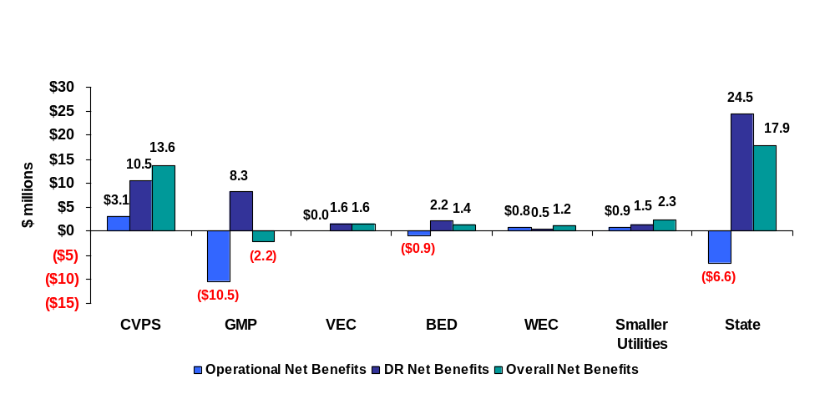

When the demand response benefits associated with implementation of time-based pricing are considered, the overall net benefits are significantly positive, amounting to roughly $18 million over the life of the investment. Some will argue that this estimate is high because of the underlying assumptions regarding awareness levels and participation rates for the peak-time rebate. However, as pointed out in Section 5, this may significantly understate the potential value of demand response in Vermont. The benefit estimate presented here is based on only about 55 percent of the total load in the state. A substantially higher estimate would result if demand response from the large industrial customers was included, if the application of enabling technologies that enhance demand response was considered, or if a pricing strategy that implements time-based pricing as the default tariff option was implemented for all customer segments.
It should be noted that, even with demand response benefits included, net benefits for GMP are negative. We believe this relatively small gap could be closed with more detailed analysis of operational savings and AMI costs and/or perhaps through a more inclusive, detailed analysis of demand response benefits. Nevertheless, there is no doubt that any decision regarding whether or not to move forward with AMI and time-based pricing at GMP is more risky in terms of the likelihood of it producing positive net benefits for the Company’s ratepayers.

Recommendations
A significant amount of work and effort has gone into this analysis and we are confident in the general conclusion that Vermont should go further in investigating and pursuing implementation of AMI and time-based pricing. The following recommendations should be considered by Vermont’s policymakers as they continue to pursue this important policy decision.

AMI Technology Implementation
- The analysis of benefits and costs reveals that AMI technology will produce net benefits for most Vermont utilities on the basis of operational benefits alone. More detailed study of the benefits and costs by individual utilities is only likely to strengthen the case for these investments. Vermont utilities should act on this information. GMP, BED and WEC should undertake the more detailed business case analysis required to move forward with an investment decision. We believe that more detailed analysis is likely to improve the operational business cases for each utility, perhaps substantially so, and there is sufficient promise for at least BED and WEC that we see little reason for delaying this next step. We believe this is also true for the five utilities that were included in the small utility group analyzed here, but it may be more sensible to have this group work together as suggested in Recommended 4 below above rather than working independently.
- CVPS should make investment plans to implement AMI at the Company. CVPS’s own analysis, as well as the independent analysis presented here, indicates that AMI is cost-effective at the Company based on operational savings alone. CVPS has decided to move forward with AMI on a schedule that contemplates meter installation starting in 2011. AMI is a significant undertaking for any utility and, perhaps even more so for a relatively small utility like CVPS. We also understand that any large investment such as AMI must compete for management and staff time and capital dollars with other major initiatives at any company. Nevertheless, given the significant operational benefits as well as the potential demand response benefits that are clearly achievable at CVPS, we suggest that the Board work with CVPS to see if a more rapid decision and deployment schedule might be feasible.
- Vermont should establish minimum requirements for advanced metering technologies to include, but not necessarily be limited to, two way communications and delivery of hourly data daily for all customers. Depending upon the outcome of recommendation 8, minimum standards associated with communication between the meter and in-home devices should also be considered.
- A working group of Vermont’s utilities should be formed to explore the feasibility and potential benefits of coordination in technology selection, meter purchasing and network utilization. Given the close proximity and overlapping nature of many of the utilities in Vermont, it may be feasible that some of the smaller utilities could piggyback on the network systems of the larger utilities or several small utilities could share a network. Furthermore, if many of Vermont’s utilities were to purchase the same meters, they would almost certainly obtain better pricing than if each worked independently. These are just two examples of how cooperation could lead to lower costs for AMI implementation. This working group should explore these and other potential synergies in AMI selection and implementation.
- Vermont’s utilities should monitor and, as appropriate, attempt to fulfill the requirements that will be established by DOE in 2008 regarding the appropriation of grants for the 20 percent coverage of investment costs in smart grid technologies authorized under the Energy Independence and Security Act.
- As part of the working group effort discussed in recommendation 4, consideration should be given to the implications of water meter reading on the business cases. As discussed earlier in this report, several of the smaller utilities also read water meters, which affect the operational savings that can be achieved through installation of electricity AMI and/or affects the costs of an AMI network that would also read water meters. This issue requires further investigation.
- The Commission should direct the utilities to establish a database that would map all of the meters in Vermont into a square-mile grid of the state and that would also contain additional information pertaining to terrain (e.g., a description of whether each square mile is relatively flat, hilly, mountainous, etc.). The database would also identify the utility serving each meter. This database would fall short of a full-scale, very expensive propagation study but would provide sufficient information for vendors to make proposals and for technical experts to explore the extent to which sharing network equipment across utility boundaries might be practical and cost-effective.

Ancillary Capabilities Enabled Through Advanced Meters
- Vermont should investigate the merits of encouraging utility meter investments to support ancillary capabilities enabled by investments in advanced meters including, but not necessarily limited to, Home Area Networks, in home information displays and selected control technologies. Recent evidence on the ability of in-home information displays to educate consumers about the relationship between costs and usage decisions suggests that this type of technology holds promise for improving both demand response and energy conservation decisions. This investigation should look at the advantages and disadvantages of various options, including open standards for communication between meters and other devices, Internet based accessibility to meter data, etc.

Date Management to Support Time-Based Pricing
- In concert with any decision to invest in advanced metering equipment, Vermont utilities should also be required to obtain meter data management and billing capabilities to support time-based pricing. These capabilities could either be developed in house or out sourced.
- VEC should investigate the least cost option (e.g., purchase versus outsourcing) for obtaining a Meter Data Management System (“MDMS”) and billing capability to support time-based pricing, and develop a plan and schedule for implementing these capabilities. VEC is currently installing advanced meters but does not currently have the capability to use the hourly data to support time-based pricing options.
- A working group of Vermont’s 15 smallest utilities (based on customer size) should be formed to explore cooperative options for least-cost provision of meter data management and billing for time-based pricing. The majority of these utilities are so small that they are of little interest to existing MDMS outsourcing companies and internalizing these functions would be costly. However, if many of these companies have common Customer Information Systems and other internal systems, it may be feasible for them to obtain the necessary MDMS and billing services on an outsourcing basis by working together.

Rate Design
- Vermont should revisit its goals and current practices for electric rate design and determine whether alternative pricing strategies that take advantage of modern metering and information technology are warranted.
- From the standpoint of economic efficiency and maximizing the value of investments in advanced metering equipment, Vermont should consider, over time, moving toward some form of default, time-based pricing framework enabled by smart metering technology. Recognizing the inherent, real-world challenges of making such a move, Vermont should also consider alternatives and the interim steps necessary to implement such a pricing regime. This continuing investigation of pricing strategy should be done in parallel with implementation of the other recommendations and with furthering the deployment of AMI—AMI makes sense in most instances in Vermont regardless of whether or not default pricing is implemented. Detailed issues to consider in making this determination include the following:
  - Specifically what form of time-based pricing should be the default option for each customer segment (e.g., TOU, critical peak pricing, peak time rebate, etc.)?
  - What should be the fundamental principles underlying tariff design and the establishment of price levels for each tariff component given the economics of supply in the State?
  - What would be the differential impact of such a policy on various customer segments, such as low income consumers, consumers with air conditioners or other high-use consumers, etc.? What are the likely bill impacts of various rate options for different customer segments under various assumptions about load shifting?
  - How difficult is it for consumers to understand various rate options (including inclining block rates) and to translate marginal price signals into usage decisions? What measures and information technologies can help to better inform customers about the impact of usage decisions on electricity bills?
  - What is the magnitude of the hedging premium that should be charged for a non-time varying rate option that would be offered on an “opt-out” basis in Vermont?
  - How difficult would it be for some of Vermont’s smallest utilities to implement such a change, given the additional billing, data management and operational requirements (e.g., notification) associated with time-based pricing and, in particular, dynamic pricing?
  - What are the implications of dynamic pricing in terms of revenue instability for utilities (e.g., How large would the revenue shortfall be if revenue-neutral, dynamic rates were implemented but not all event-days were called in a given year)?
  - What are the implications of various baseline estimation methodologies associated with a peak time rebate program.
  - What is the interplay between demand response and energy efficiency, both through pricing policy as well as through AMI based enabling technology.
- Once the relevant data management and billing capabilities are in place at VEC as recommended in item 10, VEC should create pricing plans that expand customer choice and may serve to expand the foundation of knowledge around dynamic pricing programs in Vermont. VEC should implement a pricing pilot that would examine customer interest in and response to various pricing options. We do not recommend that the primary focus of this pilot or pilots be to investigate demand-response—given the large number of pilots that have been and are being implemented elsewhere, we believe that the uncertainty around average response is much less than the uncertainty associated with participation rates. Thus, we recommend that, to the extent feasible and practical, these pilots focus on determining the likely participation rates among a variety of rate options and customer segments under different implementation schemes (e.g., opt-in, opt-out), marketing strategies, etc.

Regulatory Concerns
- The Public Service Board should consider what steps can be taken to mitigate regulatory risks associated with AMI investments. These risks include potential disallowances for stranded costs associated with the existing meter plant (e.g., disallowing costs of meters that are replaced under the economic used-and-useful rule that we understand exists in Vermont). These risks could also extend to second-guessing the technology investment decisions that a utility might make if new technology were to come along that was much more cost-effective, or if meter and/or network costs were to drop significantly soon after implementation. Importantly, Section 1307 of the new Energy Independence and Security Act amends PURPA and directs each state to consider authorizing electric utilities to recover the cost of AMI systems through the rate base and to continue recovering the remaining book-value costs of any equipment rendered obsolete by the deployment of smart grid systems.

http://www.state.vt.us/psb/document/ElectricInitiatives/ImplementFEPA2005.htm
See House Bill 520 at www.leg.state.vt.us
See CPUC Decision 06-07-027, Final Opinion Authorizing Pacific Gas and Electric Company To Deploy Advanced Metering Infrastructure (July 20, 2006); CPUC Decision 07-04-043; Opinion Approving Settlement of San Diego Gas & Electric Company’s Advanced Metering Infrastructure Project; April 12, 2007.
FERC. Assessment of Demand Response & Advanced Metering. Staff Report, Docket Number : AD-06-2-000. August 2006, hereafter referred to as FERC 2006.
Although in theory meters could be read daily with drive-by or walk-by AMR, this would not be cost effective.
See http://www.dramcoalition.org
Joint Assigned Commissioner and Administrative law Judge’s Ruling Providing Guidance for the Advanced Metering Infrastructure Business Case Analysis, Rulemaking 02-06-001, June 6, 2002.
The gas meters that PG&E is planning to deploy will be provide daily usage data on a daily basis but not hourly usage data.
For example, Salt River Project, in Arizona, has perhaps the largest program in the US, with roughly 50,000 customers on pre-payment meters.
Dean Mountain. The Impact of Real-Time Feedback on Residential Electricity Consumption: The Hydro One Pilot. March 2006.
US Code, Title 16, Chapter 46.
See Douglas Caves, Laurits Christensen and Joseph Herriges, Consistency of Residential Customer Response in Time-of-Use Electricity Pricing Experiments, Journal of Econometrics 16 (1984), at 179-203.
Steven Braithwait and Ahmad Faruqui, The Choice Not to Buy: Energy Savings and Policy Alternatives for Demand Response, Public Utilities Fortnightly, 52 (March 15, 2001).
The Brattle Group, Quantifying Demand Response Benefits in PJM, January 29, 2007.
Charles River Associates, Impact Evaluation of the California Statewide Pricing Pilot (March 16, 2005).
Rick Voytas, AmerenUE Critical Peak Pricing Pilot, Presentation (June 26, 2006) available at http://drrc.lbl.gov/pubs/drtown-pricing-voytas.pdf
Frank Wolak, Residential Customer Response to Real-Time Pricing: The Anaheim Critical-Peak Pricing Experiment (May 24, 2006).
Kevin M. Kimbo, PSE&G’s myPower Program, PLMA 2006 Demand Response Award Nomination Forum (March 14, 2007).
IBM Global Business Services, Ontario Energy Board Smart Price Pilot Survey Results, (January 25, 2007).
The price ratios shown at the bottom of the figure represent the price during the critical peak period relative to what the average price would be during the same period if the customer was on the standard tariff. For the first four pilots, the price ratio refers to the bundled price. For the Ottawa pilot, the ratio refers to the generation portion of the bill only.
Momentum Market Intelligence, Statewide Pricing Pilot: End-of-Pilot Participant Assessment (December 2004).
Dean Schultz and David Lineweber, Real Mass Market Customers React to Real Time-Differentiated Rates: What Choices Do They Make and Why? 16th National Energy Services Conference. San Diego, CA. February 2006.
Kevin M. Kimbo, PSE&G’s myPower Program, PLMA 2006 Demand Response Award Nomination Form (March 14, 2007).
IBM Global Business Services, Ontario Energy Board Smart Price Pilot Survey Results. January 25, 2007. p. 6.
Ibid. p. 10.
Application of SDG&E for Adoption of AMI Scenario and Associated Cost Recovery and Rate Design. Application 05-03-015. Chapter 23: Rebuttal Testimony of Dr. Stephen S. George. Revised: September 19, 2006.
Results from the SPP for C&I customers are documented in two reports, both written by S. George and A. Faruqui: Impact Evaluation of California’s Statewide Pricing Pilot. Final Report, March 16, 2005; and California’s Statewide Pricing Pilot: Commercial & Industrial Analysis Update, Final Report, June 28, 2006.
A comparison of Figures 3-3 and 3-4 show that, at a critical peak price of $0.59/kWh, the average reduction for residential customers is roughly 13 percent and the average reduction for small C&I customers is 10 percent.
In a typical retrofit deployment, perhaps a third of the existing meters are too old or otherwise difficult to retrofit and, therefore, are replaced with new meters that could be either solid-state or new electro-mechanical meters with the communications modules built in.
This discussion borrows heavily from FERC 2006.
This is not always the case. For example, if peak-period generation is fueled by natural gas but off-peak generation is fueled by coal, a shift in energy use from peak to off-peak generation could be more environmentally damaging.
Overall AMI costs would probably not double with the installation of advanced water meters as the same communication network would be used for both water and electricity meters.
As this report was being finalized, Congress passed and President Bush signed the Energy Independence and Security Act of 2007. Section 3106 of the Act allows for reimbursement for up to one-fifth of the costs of smart grid technologies. A Smart Grid Advisory Committee is being established to, among other things, define how and for what types of equipment these grants will be provided. This has the potential to significantly reduce the costs that are discussed in this section and to improve the operational net benefits that are presented in subsequent sections of this report.
In a typical retrofit deployment, perhaps a third of the existing meters are too old or otherwise difficult to retrofit and, therefore, are replaced with new meters that could be either solid-state or new electro-mechanical meters with the communications modules built in.
A standard replacement meter might be an electromechanical or electronic meter. Many meter manufacturers are phasing out electromechanical meters so that, even in the absence of AMI, electronic kWh meters are being installed when an electromechanical meter fails. The prices for new electromechanical and “plain label” electronic meters are currently very similar and we have assumed they are equal in this analysis.
Our original intent was to base estimates of the maintenance costs for the current meter stock on data provided by each utility. However, the responses to the data request were spotty and for those utilities that did provide data, the values were quite varied and in a couple of cases included not just typical replacement costs but accelerated replacement based on initial deployment of advanced meters or mobile AMR meters. As such, we did not feel that we could confidently rely on the values provided by the utilities.
FERC 2006.
A similar equation is used to predict the change in energy use in each rate period for each year of the forecast horizon.
The residential elasticity estimates are documented in CRA International, Impact Evaluation of California’s Statewide Pricing Pilot. Final Report, March 16, 2005. The C&I elasticity estimates are documented in Stephen S. George, Ahmad Faruqui and John Winfield, California’s Statewide Pricing Pilot: Commercial & Industrial Analysis Update. Final Report, June 28, 2006. Both reports can be accessed at http://www.energy.ca.gov/demandresponse/documents/index.html#group3 .
Kema (2005). Final Report: Phase 2 Evaluation of the Efficiency Vermont Residential Programs, p. 3-10
The share of homes with three or more room air conditioners was based on the RASS BED sub-sample. BED was the only utility that provided detailed frequencies, enabling identification of the share of households with three or more room air-conditioners. The estimate is likely an undercount of Vermont homes with three or more room air conditioners given that the share homes with multiple room A/C units is lower for BED (13.2%) than for the rest of the state (15.5%).
Analysis of California’s SPP data showed that, underlying the statewide average reduction of 13 percent was a distribution of responses in which the majority of customers responded very little while a minority responded by a sufficient amount to produce the average reduction. Implicitly, the same type of distribution is assumed to occur here.
See Appendix G for a detailed explanation of how the capacity escalation factor was determined.
Prepared Supplemental, Consolidating, Superseding and Replacement Testimony of Mr. Mark F. Gaines on behalf of SDG&E. Chapter 5: AMI Marketing and Customer Programs. July 14, 2006 Amendment.
TJ provided the value in 1997 dollars (0.7 cents), I need to confirm whether or not DPS employs the GDP deflator, the CPI, or the PPI to convert things into current dollars.
As discussed in Section 4 (footnote 34), the passage of the Energy Independence and Security Act allows for grants that could reduce the costs of AMI investments by 20 percent. The late passage of the Act did not allow us to factor this into the analysis presented here. Obviously, a 20 percent reduction would improve the operational net benefits summarized in this section and in Section 6. On the other hand, no money has been appropriated for those grants nor has it been determined how any grant money would be allocated among competing projects.
This value does not include any mark up for taxes for CVPS and GMP that is included in the PVRR value of $63.2 million. This value is an estimate of the out-of-pocket costs associated with the initial replacement of all meters with AMI meters plus the costs for network equipment and installation.
The coincidence between generation and transmission benefits is much higher than between distribution and generation benefits. Thus, the argument that a generation driven peak reduction program won’t reduce distribution system peaks is more valid than that it won’t generate any transmission capacity benefits.
Demand response benefits are directly proportional to the participation/awareness rate.
See prior footnotes regarding the recent passage of the Energy Independence and Security Act and its potential implications for the cost analysis presented in this section.
These values do not include the markup for taxes that is included in the PVRR calculation.
This value is calculated by dividing the present value of avoided meter reading costs over the life of the investment, $29.5 million, by today’s number of customers. Given the relatively slow customer growth rate, this is a reasonable, although upward biased, estimate of the average benefits per customer.
Off-peak water heating load was not included in this analysis.
These values do not include the markup for taxes that is included in the PVRR calculation.
As indicated in Section 4, there is no adjustment for taxes or accelerated depreciation for the municipal utilities. As such, one must be cautious in comparing PVRR values between CVPS and GMP on the one hand and the municipal utilities on the other.
The cost estimate was based on adding $50 to 40 percent of BED’s single phase meters rather than 40 percent of BED’s residential customers. This may overstate the costs, as a large number of BED’s non-residential customers have single phase meters. On the other hand, it may be difficult to get the same pricing for both the partial and full deployment scenarios, so the assumed cost of $50 for the partial deployment scenario may be low and the two uncertainties may partially offset each other.
There was a discrepancy between the number of meters and number of customers provided by Ludlow, with the number of meters being less than the number of customers. Consequently, the number of meters was raised by about 700 so that it matched the number of customers for Ludlow. For the other four utilities, the number of meters exceeds the number of customers.
James Bonbright. Principles of Public Utility Rates. Columbia University Press, 1961. Page 291.
A similar weakness is true for demand charges. Unless they have sophisticated monitoring equipment, customers do not know when they are setting a new level of kW demand, which can significantly affect their monthly bill and effectively change the cost of incremental usage to a significant degree.
IBM Global Business Services, Ontario Energy Board Smart Price Pilot Survey Results, (January 25, 2007). P. 12.
Momentum Market Intelligence. Statewide Pricing Pilot: End-of-Pilot Participant Assessment. December 2004.
Summit Blue Consulting. Evaluation of the 2005 Energy-Smart Pricing Plan—Final Report. August 1, 2005.
Above some price level, additional demand response may not occur. A recent pricing experiment in New South Whales, Australia, for example, showed that an increase in prices from $1.50/kWh to $2.00/kWh did not produce a statistically significant change in energy use during the peak period.
Momentum Market Intelligence, Statewide Pricing Pilot: End-of-Pilot Participant Assessment (December 2004).
Dean Schultz and David Lineweber, Real Mass Market Customers React to Real Time-Differentiated Rates: What Choices Do They Make and Why? 16th National Energy Services Conference. San Diego, CA. February 2006.
Kevin M. Kimbo, PSE&G’s myPower Program, PLMA 2006 Demand Response Award Nomination Form (March 14, 2007).
IBM Global Business Services, Ontario Energy Board Smart Price Pilot Survey Results. January 25, 2007. p. 6.
Ibid. p. 10.
Application of SDG&E for Adoption of AMI Scenario and Associated Cost Recovery and Rate Design. Application 05-03-015. Chapter 23: Rebuttal Testimony of Dr. Stephen S. George. Revised: September 19, 2006.
Prepared Supplemental, Consolidating, Superseding and Replacement Testimony of Dr. Stephen S. George on behalf of SDG&E. Chapter 6: Demand Response Benefits. July 14, 2006 Amendment. http://www.sdge.com/ami/docs/chapter_6.pdf
Momentum Market Intelligence. Customer Preferences Market Research: A Market Assessment of Time-Differentiated Rates Among Residential Customers in California. December 2003.
Karen Herter, “Residential Implementation of Critical Peak Pricing of Electricity,” Energy Policy (35, 2007) 2122-2130.
Barbara Alexander. Smart Meters, Real Time Pricing and Demand Response Programs: Implications for Low Income Electric Customers. February 2007.
With a PTR program, customer impacts must be estimated relative to a baseline estimate of what the customer would have used on an event day in the absence of the incentive. There are a wide variety of baseline methods that have been examined in various jurisdictions. The preferred method may be different in Vermont than in some other locations because of the characteristics of Vermont’s customers.

